5th Sunday of Easter Year B
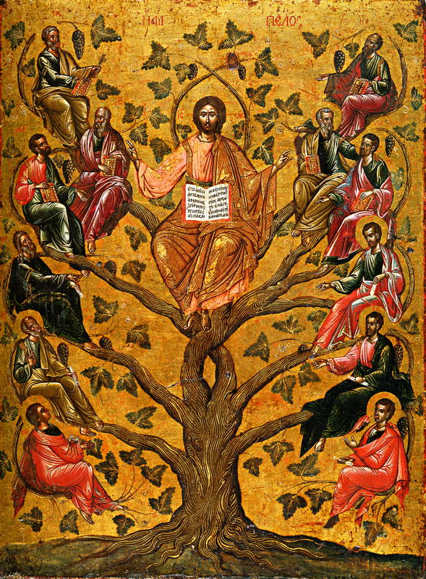
T
Christ the True Vine, icon, 16th century, Лоза Истинная (Виноградная лоза), Byzantine and Christian Museum, Athens.
MASS TIMES
Weekend Masses: YANCHEP: 6 p.m. Saturday Vigil, St James Anglican Church,
2 Lagoon Drive. GUILDERTON: 8 a.m. Sunday, Guilderton Community Hall, Wedge Street. LANCELIN: 9.45 a.m. Sunday, 33 Gingin Road, Lancelin.
Confessions: before Mass on request
Weekday Masses: Tuesday, Thursday, Friday 9 a.m. at the presbytery,
Wednesdays 3 p.m. at Bethanie Beachside Aged Care.
Priest: Fr Augustine Puthota, Presbytery: 3 Blaxland Avenue, Two Rocks, Western Australia 6037. Telephone: +61-8-9561 2172
Website: http://yanchepcatholic.org/ email: yanchepcatholic@gmail.com.
Please like us on Facebook: https://www.facebook.com/yanchepcatholicchurch
Page 4
Sunday Bulletin


We pray for the sick of our community, especially:
Pat Murphy, Ken and Toni Meek, Delores Servais, Michael Ford, Jim Walsh, Paula Cope, Pat Barone, Josephine del Bene, Len Sims and Nina Campbell.

We pray for all departed souls from this Pastoral area, and we ask them to pray for us.

Communion Antiphon ‡ John 15:1, 5
I am the true vine and you are the branches, says the Lord. Whoever remains in me, and I in him, bears fruit in plenty, alleluia.

Entrance Antiphon | cf.Ps 98 (97):1-2
O sing a new song to the Lord, for he has worked wonders; in the sight of the nations he has shown his deliverance, alleluia.

(Commentary continued)
My Father has prepared eternal life for all those who listen to me, this is why my words are the guide for the faithful but also the condemnation for the disobedient.
Those who do not listen, those who reject the voice of the Spirit and break the commandments without caring for the divine truth, do not produce any fruit, this is why my Father cuts those branches and allow them to wither and die without any hope of everlasting life.
Those who listen to me receive gifts, and in the same way that the vinedresser prunes his vine to embellish it, life is full of frustrations and crosses that my Father sends to the soul in order to prune it of self love, egoism, vanity and pride. These sufferings produce wisdom and bring perfection to the soul in humility. My words are purifying life for the soul that remains in me, they allow it to produce much fruit. He who integrates himself in my body, becomes part of me and I, part of him.
My Church is my mystical body, in which I am the head and you are my members, my blood is the Holy Eucharist that brings life to all cells, my word is the wisdom that brings the soul to perfection, he who listens to me, listens to the spirit, he who follows my word is walking in my way.
My heart beats incessantly, sending hope and life to those who listen to me, because I am the bridge between humanity and divinity. He who is not with me, separates and gets lost eternally in darkness, he who is humble understands that without me he is nothing.
He who remains in me, is in my Presence, I convert him into my disciple so that he may learn more of me and I make him my apostle so that he becomes my instrument; his prayer is always listened to.
The Glory of my Father is that all who are with me, produce much fruit for the prosperity of his Kingdom here on earth and for His Glory in all eternity.

First Reading ‡ Acts 9:26-31
He explained how the Lord appeared to Saul and spoke to him on his journey.
When Saul got to Jerusalem he tried to join the disciples, but they were all afraid of him: they could not believe he was really a disciple.
Barnabas, however, took charge of him, introduced him to the apostles, and explained how the Lord had appeared to Saul and spoken to him on his journey, and how he had preached boldly at Damascus in the name of Jesus. Saul now started to go round with them in Jerusalem, preaching fearlessly in the name of the Lord. But after he had spoken to the Hellenists, and argued with them, they became determined to kill him. When the brothers knew, they took him to Caesarea, and sent him off from there to Tarsus.
The churches throughout Judaea, Galilee and Samaria were now left in peace, building themselves up, living in the fear of the Lord, and filled with the consolation of the Holy Spirit.

The word of the Lord.
Thanks be to God.
Gospel Acclamation ‡ John 15: 4-5
Alleluia, Alleluia!
Live in me and let me live in you, says the Lord;
my branches bear much fruit.
Alleluia!
Gospel ‡ John 15:1-8
All who live in me, and I in them, bear much fruit.
Jesus said to his disciples:
‘I am the true vine,
and my Father is the vinedresser.
Every branch in me that bears no fruit he cuts away,
and every branch that does bear fruit
he prunes to make it bear even more.
You are pruned already,
by means of the word that I have spoken to you.
Make your home in me, as I make mine in you.
As a branch cannot bear fruit all by itself,
but must remain part of the vine,
neither can you unless you remain in me.
I am the vine, you are the branches.
Whoever remains in me, with me in him,
bears fruit in plenty; for cut off from me you can do nothing.
Anyone who does not remain in me
is like a branch that has been thrown away —
he withers; these branches are collected
and thrown on the fire, and they are burnt.
If you remain in me and my words remain in you,
you may ask what you will and you shall get it.
It is to the glory of my Father that you should bear much fruit,
and then you will be my disciples.’

The Gospel of the Lord.
Praise to you Lord Jesus Christ.

Responsorial Psalm ‡ Ps 21: 26-28, 30-32
R. I will praise you, Lord, in the assembly of your people.

My vows I will pay before those who fear him.
The poor shall eat and shall have their fill.
They shall praise the Lord, those who seek him.
May their hearts live for ever and ever! R.

All the earth shall remember and return to the Lord,
all families of the nations worship before him.
They shall worship him, all the mighty of the earth;
before him shall bow all who go down to the dust. R.

And my soul shall live for him, my children serve him.
They shall tell of the Lord to generations yet to come,
declare his faithfulness to peoples yet unborn:
‘These things the Lord has done.’ R.

Second Reading ‡ 1 John 3: 18-24
His commandments are these: that we believe and that we love one another.
My children,
our love is not to be just words or mere talk,
but something real and active;
only by this can we be certain
that we are the children of the truth
and be able to quieten our conscience in his presence,
whatever accusations it may raise against us,
because God is greater than our conscience
and he knows everything.

My dear people,
if we cannot be condemned by our own conscience,
we need not be afraid in God’s presence,
and whatever we ask him,
we shall receive,
because we keep his commandments
and live the kind of life that he wants.
His commandments are these:
that we believe in the name of his Son Jesus Christ
and that we love one another as he told us to.
Whoever keeps his commandments
lives in God and God lives in him.
We know that he lives in us by the Spirit that he has given us.

Page 2
Page 3

Commentary from Br. Joseph of Jesus and Mary at http://www.theworkofgod.org/Devotns/Euchrist/HolyMass/gospels.asp?key=9
I am the tree of life that my Father has planted in the world, he who wants to become part of me eternally, must become part of this tree, he must convert into one of my branches and take sap from me. My Father and I touch the hearts of all human beings and call them to come, because I am the Way, the Truth and the Life, no one can come to my Father except through me.

