Fourth Sunday of Lent Year B
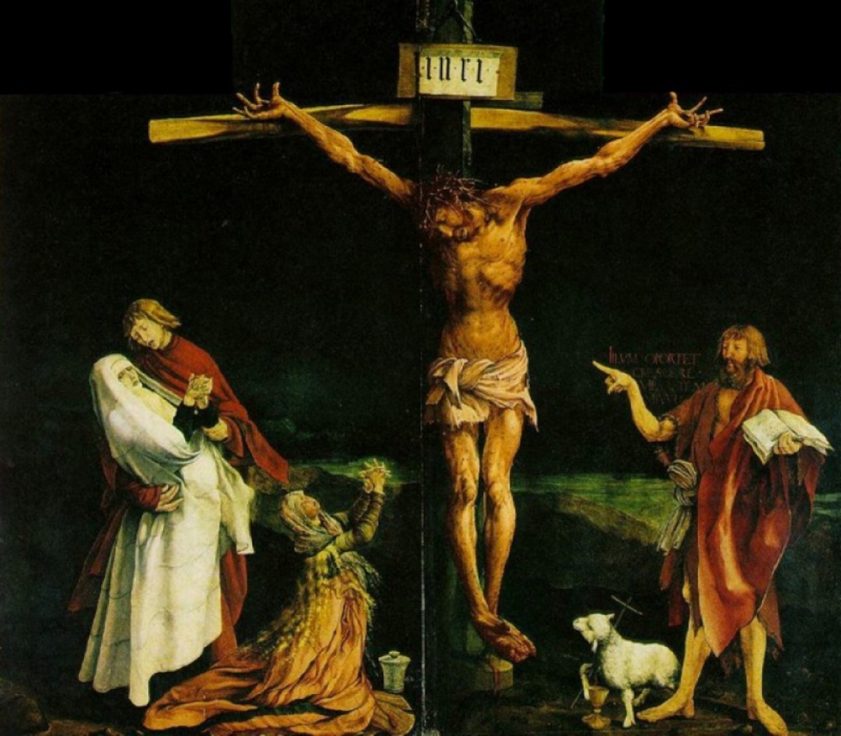
T
MASS TIMES
Weekend Masses: YANCHEP: 6 p.m. Saturday Vigil, St James Anglican Church,
2 Lagoon Drive. GUILDERTON: 8 a.m. Sunday, Guilderton Community Hall, Wedge Street. LANCELIN: 9.45 a.m. Sunday, 33 Gingin Road, Lancelin.
Confessions: before Mass on request
Weekday Masses: Tuesday, Thursday, Friday 9 a.m. at the presbytery,
Wednesdays 3 p.m. at Bethanie Beachside Aged Care.
Priest: Fr Augustine Puthota, Presbytery: 3 Blaxland Avenue, Two Rocks, Western Australia 6037. Telephone: +61-8-9561 2172
Website: http://yanchepcatholic.org/ email: yanchepcatholic@gmail.com.
Page 4
Sunday Bulletin

We pray for the sick of our community, especially:
Pat Murphy, Ken and Toni Meek, Delores Servais, Michael Ford, Jim Walsh, Paula Cope, Pat Barone, Josephine del Bene, Len Sims and Nina Campbell.

We pray for all departed souls from this Pastoral area, and we ask them to pray for us.
Mary Crawford, Des Elliot, Barry Murphy, Jim and Marion Ferguson, Pat O’Prey, John Sheahan, Carmen Germann, Yvonne Wytenburg, Frank and Netje Walser, Ian Kinner, Dennis Galora, Tom Cox, Alice Greig, John Bird, Ray Knapp, Giuseppe Del Bene, Bruno Rogalski, Bill Fleming, Ronnie Spratling and Mavis Gagiano.

Communion Antiphon ‡ Cf. Ps 122 (121): 3-4
Jerusalem is built as a city bonded as one together. It is there that the tribes go up, the tribes of the Lord, to praise the name of the Lord.

Homily from http://www.sacerdos.org/english/articulos/articulo.phtml?id=13924
How can we reconcile the "angry" God of certain Old Testament passages with the God of mercy preached by Jesus? Some early Christians did not and created a heresy that believed in a vengeful Old Testament God and a merciful God of the New Testament. In much more recent times, some Christians have, in practice at least, believed in a God whose righteous anger was more prominent than his merciful love. Guided by the Holy Spirit, the Church has always maintained the divine inspiration and the harmony of the two Testaments, which cannot contradict one another. The revelation they contain come from God; it is his word, we may not pick and choose passages we ´approve´, and reject others. It is gradual and reaches its perfection with Christ; God´s ways are so different from ours that we cannot grasp them in a moment; they dawn on us through the centuries and we should not expect the Old Testament to offer us a finished revelation. If we understood God´s love, and how we separate ourselves from it by sin, we would weep as bitterly as the exiles in Babylon (Psalm). God cannot oblige us to seek the light, for he cannot simultaneously create us as creatures who are free and not free (our creation is not something that happened in the past, it is ongoing). But he does not want us to have to weep; Christ raised up on the cross before us constitutes the ultimate effort of his love, his ultimate appeal to our free response to his love. The vision of Jesus crucified for our sins is the antidote that, like the Israelites bitten by the serpents (Numbers 21:4-9), every generation of Christians has found to the poison of selfishness and sin. Praying the stations of the cross – every day or at least once or twice a week until Easter – would be a great way to apply this remedy.

The Crucifixion, Isenheim Altarpiece, centre panel, Matthias Grünewald, 1512-1516, chapel of the Hospital of Saint Anthony, Isenheim, Germany, c. 1510-15, oil on wood, 9' 9 1/2" x 10' 9" (Unterlinden Museum, Colmar, France).

Entrance Antiphon | Isaiah 66:10-11
Rejoice, Jerusalem, and all who love her. Be joyful, all who were in mourning; exult and be satisfied at her consoling breast.

First Reading ‡ 2 Chronicles 36:14-16, 19-23
The wrath and the mercy of the Lord are revealed in the exile and liberation of his people.
All the heads of the priesthood, and the people too, added infidelity to infidelity, copying all the shameful practices of the nations and defiling the Temple that the Lord had consecrated for himself in Jerusalem. The Lord, the God of their ancestors, tirelessly sent them messenger after messenger, since he wished to spare his people and his

Second Reading ‡ Ephesians 2:4-10
When we were dead through sins, he brought us to life.
God loved us with so much love that he was generous with his mercy: when we were dead through our sins, he brought us to life with Christ — it is through grace that you have been saved — and raised us up with him and gave us a place with him in heaven, in Christ Jesus.
This was to show for all ages to come, through his goodness towards us in Christ Jesus, how infinitely rich he is in grace. Because it is by grace that you have been saved, through faith; not by anything of your own, but by a gift from God; not by anything that you have done, so that nobody can claim the credit. We are God’s work of art, created in Christ Jesus to live the good life as from the beginning he had meant us to live it.
The word of the Lord.
Thanks be to God.
Gospel Acclamation ‡ John 3:16
Glory and praise to you, Lord Jesus Christ!
God loved the world so much, he gave us his only Son,
that all who believe in him might have eternal life.
Glory and praise to you, Lord Jesus Christ!

Gospel ‡ John 3:14-21
God sent his Son into the world that we might be saved through him.
Jesus said to Nicodemus:
‘The Son of Man must be lifted up
as Moses lifted up the serpent in the desert,
so that everyone who believes may have eternal life in him.
Yes, God loved the world so much
that he gave his only Son,
so that everyone who believed in him
may not be lost but may have eternal life.
For God sent his Son into the world not to condemn the world,
but so that through him the world might be saved.
No one who believes in him will be condemned;
but whoever refuses to believe is condemned already,
because he has refused to believe in the name of God’s only Son.
On these grounds is sentence pronounced:
that though the light has come into the world men have shown they prefer darkness to the light because their deeds were evil.
And indeed, everybody who does wrong hates the light and avoids it,
for fear his actions should be exposed;
but the man who lives by the truth comes out into the light,
so that it may be plainly seen that what he does is done in God.’
The Gospel of the Lord.
Praise to you Lord Jesus Christ.
Page 2
Page 3

house. But they ridiculed the messengers of God, they despised his words, they laughed at his prophets, until at last the wrath of the Lord rose so high against his people that there was no further remedy.
Their enemies burned down the Temple of God, demolished the walls of Jerusalem, set fire to all its palaces, and destroyed everything of value in it. The survivors were deported by Nebuchadnezzar to Babylon; they were to serve him and his sons until the kingdom of Persia came to power. This is how the word of the Lord was fulfilled that he spoke through Jeremiah, ‘Until this land has enjoyed its sabbath rest, until seventy years have gone by, it will keep sabbath throughout the days of its desolation.’
And in the first year of Cyrus king of Persia, to fulfil the word of the Lord that was spoken through Jeremiah, the Lord roused the spirit of Cyrus king of Persia to issue a proclamation and to have it publicly displayed throughout his kingdom: ‘Thus speaks Cyrus king of Persia, “The Lord, the God of heaven, has given me all the kingdoms of the earth; he has ordered me to build him a Temple in Jerusalem, in Judah. Whoever there is among you of all his people, may his God be with him! Let him go up.”’
The word of the Lord.
Thanks be to God.

Responsorial Psalm ‡ Psalm 136.
R. Let my tongue be silenced, if I ever forget you.

By the rivers of Babylon there we sat and wept,
remembering Zion;
on the poplars that grew there
we hung up our harps. R.

For it was there that they asked us,
our captors, for songs,
our oppressors, for joy.
‘Sing to us,’ they said,
‘one of Zion’s songs.’ R.

O how could we sing the song of the Lord
on alien soil?
If I forget you, Jerusalem,
let my right hand wither! R.

O let my tongue cleave my mouth
if I remember you not,
if I prize not Jerusalem
above all my joys! R.

