Third Sunday of Lent Year B
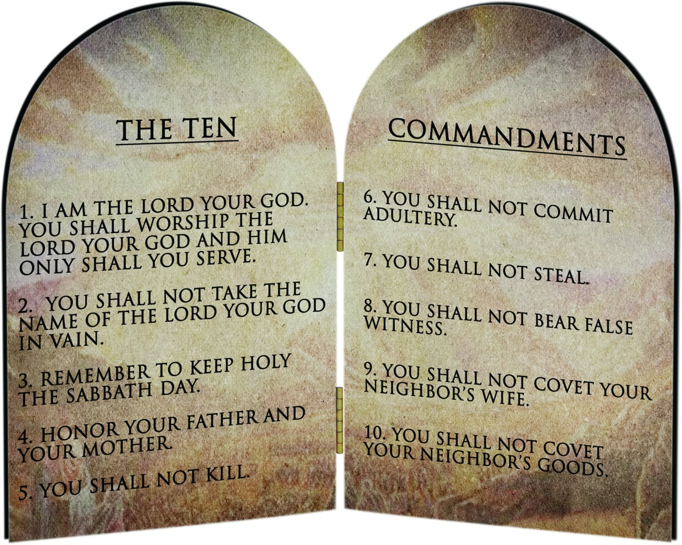
T
MASS TIMES
Weekend Masses: YANCHEP: 6 p.m. Saturday Vigil, St James Anglican Church,
2 Lagoon Drive. GUILDERTON: 8 a.m. Sunday, Guilderton Community Hall, Wedge Street. LANCELIN: 9.45 a.m. Sunday, 33 Gingin Road, Lancelin.
Confessions: before Mass on request
Weekday Masses: Tuesday, Thursday, Friday 9 a.m. at the presbytery,
Wednesdays 3 p.m. at Bethanie Beachside Aged Care.
Priest: Fr Augustine Puthota, Presbytery: 3 Blaxland Avenue, Two Rocks, Western Australia 6037. Telephone: +61-8-9561 2172
Website: http://yanchepcatholic.org/ email: yanchepcatholic@gmail.com.
Page 4
Sunday Bulletin

We pray for the sick of our community, especially:
Pat Murphy, Ken and Toni Meek, Delores Servais, Michael Ford, Jim Walsh, Paula Cope, Pat Barone, Josephine del Bene, Len Sims and Nina Campbell.

We pray for all departed souls from this Pastoral area, and we ask them to pray for us.
Mary Crawford, Des Elliot, Barry Murphy, Jim and Marion Ferguson, Pat O’Prey, John Sheahan, Carmen Germann, Yvonne Wytenburg, Frank and Netje Walser, Ian Kinner, Dennis Galora, Tom Cox, Alice Greig, John Bird, Ray Knapp, Giuseppe Del Bene, Bruno Rogalski, Bill Fleming and Ronnie Spratling.

Communion Antiphon ‡ Psalm 84 (83): 4-5
The sparrow finds a home, and the swallow a nest for her young: by your altars, O Lord of hosts, my King and my God. Blessed are they who dwell in your house, for ever singing your praise.

24 HOURS FOR THE LORD – When was the last time you went to confession?
Do you spend your time complaining about this crazy world? Now is the time to do something about it! Pope Francis has invited churches around the world to participate in “24 Hours for the Lord” on Friday 13 to Saturday 14 March 2015: Adoration, Confession / Penance / Reconciliation, Stations of the Cross.
Unfortunately, Fr Augustine will be away at a Baptism in Melbourne on these days; however – all is not lost - there are a number of events in the northern suburbs that you can participate in.
Joondalup Holy Spirit Chapel: Adoration and Confession from 00h00 (midnight) Friday until midnight Saturday. Mass: 12:10 Friday. Please put your name on the adoration roster in the front porch.
Our Lady of the Mission, Whitfords: Exposition of the Blessed Sacrament: Friday 09.30 a.m. to 7.00 p.m., Mass Friday 9 a.m, Saturday 08.30. Confession: Saturday 12.00 to 13:00and 17:30 – 18:00.
St Simon Peter, Ocean Reef: Blessed Sacrament Adoration Friday 9:00 to 18:50. Mass: Friday 19:00, Saturday 8:30, Reconciliation: Friday 18:30-18:50, Saturday 17:00-17:45.
St Andrew’s, Clarkson: Mass: Friday and Saturday 08:00, Reconciliation: Saturday 17:00 to 17:30, Exposition of the Blessed Sacrament and Benediction: Friday 15:00 to 17:00.

Entrance Antiphon | Cf. Ps 25 (24):15-16
My eyes are always on the Lord, for he rescues my feet from the snare. Turn to me and have mercy on me, for I am alone and poor.

First Reading ‡ Exodus 20:1-17.
The Law was given through Moses.
The Lord spoke all these words. He said, ‘I am the Lord your God who brought you out of the house of slavery. ‘You shall have no gods except me.
‘You shall not make yourself a carved image or any likeness of anything in heaven or earth beneath or in the waters under the earth; you shall not bow down to them or serve them. For I, the Lord your God am a jealous God and I punish the father’s fault in the sons, the grandsons, and the great-grandsons of those who hate me; but I show kindness to thousands of those who love me and keep my commandments.

Second Reading ‡ 1 Corinthians 1:22-25
We are preaching a crucified Christ, a scandal to many, but to those who have been called, the wisdom of God.
While the Jews demand miracles and the Greeks look for wisdom, here are we preaching a crucified Christ; to the Jews an obstacle that they cannot get over, to the pagans madness, but to those who have been called, whether they are Jews or Greeks, a Christ who is the power and the wisdom of God. For God’s foolishness is wiser than human wisdom, and God’s weakness is stronger than human strength.

The word of the Lord.
Thanks be to God.

Gospel Acclamation ‡ John 3:16

Praise to you, Lord Jesus Christ, king of endless glory!
God loved the world so much, he gave us his only Son,
that all who believe in him might have eternal life.
Praise to you, Lord Jesus Christ, king of endless glory!

Gospel ‡ John 2:13-25
Destroy this sanctuary, and in three days I will raise it up.
Just before the Jewish Passover Jesus went up to Jerusalem, and in the Temple he found people selling cattle and sheep and pigeons, and the money changers sitting at their counters there. Making a whip out of some cord, he drove them all out of the Temple, cattle and sheep as well, scattered the money changers’ coins, knocked their tables over and said to the pigeon-sellers, ‘Take all this out of here and stop turning my Father’s house into a market.’
Then his disciples remembered the words of scripture: Zeal for your house will devour me. The Jews intervened and said, ‘What sign can you show us to justify what you have done?’ Jesus answered, ‘Destroy this sanctuary, and in three days I will raise it up.’
The Jews replied, ‘It has taken forty-six years to build this sanctuary: are you going to raise it up in three days?’ But he was speaking of the sanctuary that was his body, and when Jesus rose from the dead, his disciples remembered that he had said this, and they believed the scripture and the words he had said.
During his stay in Jerusalem for the Passover many believed in his name when they saw the signs that he gave, but Jesus knew them all and did not trust himself to them; he never needed evidence about any man; he could tell what a man had in him.

The Gospel of the Lord.
Praise to you Lord Jesus Christ.
Page 2
Page 3

‘You shall not utter the name of the Lord your God to misuse it, for the Lord will not leave unpunished the man who utters his name to misuse it.
‘Remember the sabbath day and keep it holy. For six days you shall labour and do all your work, but the seventh day is a sabbath for the Lord your God. You shall do no work on that day, neither you nor your animals nor the stranger who lives with you. For in six days the Lord made the heavens and the earth and the sea and all that these hold, but on the seventh day he rested; that is why the Lord has blessed the sabbath day and made it sacred.
‘Honour your father and your mother so that you may have a long life in the land that the Lord your God has given to you.
‘You shall not kill.
‘You shall not commit adultery.
‘You shall not steal.
‘You shall not bear false witness against your neighbour.
‘You shall not covet your neighbour’s house.
You shall not covet your neighbour’s wife, or his servant, man or woman, or his ox, or his donkey, or anything that is his.’

The word of the Lord.
Thanks be to God.

Responsorial Psalm ‡ Psalm 18:8-11.
R. Lord, you have the words of everlasting life.

The law of the Lord is perfect,
it revives the soul.
The rule of the Lord is to be trusted,
it gives wisdom to the simple. R.

The precepts of the Lord are right,
they gladden the heart.
The command of the Lord is clear,
it gives light to the eyes. R.

The fear of the Lord is holy,
abiding for ever.
The decrees of the Lord are truth
and all of them just. R.

They are more to be desired than gold,
than the purest of gold
and sweeter are they than honey,
than honey from the comb. R.

