Second Sunday of Lent Year B
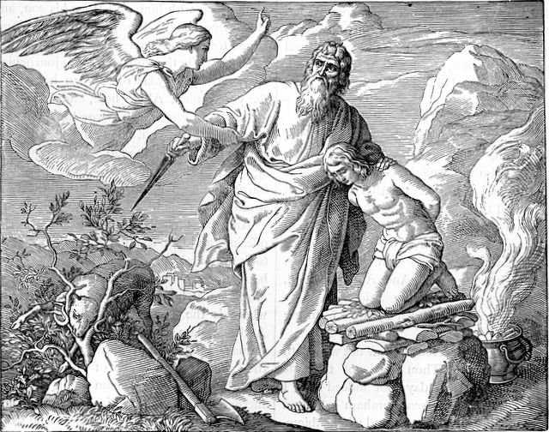
T
MASS TIMES
Weekend Masses: YANCHEP: 6 p.m. Saturday Vigil, St James Anglican Church,
2 Lagoon Drive. GUILDERTON: 8 a.m. Sunday, Guilderton Community Hall, Wedge Street. LANCELIN: 9.45 a.m. Sunday, 33 Gingin Road, Lancelin.
Confessions: before Mass on request
Weekday Masses: Tuesday, Thursday, Friday 9 a.m. at the presbytery,
Wednesdays 3 p.m. at Bethanie Beachside Aged Care.
Priest: Fr Augustine Puthota, Presbytery: 3 Blaxland Avenue, Two Rocks, Western Australia 6037. Telephone: +61-8-9561 2172
Website: http://yanchepcatholic.org/ email: yanchepcatholic@gmail.com.
Page 4
Sunday Bulletin

We pray for the sick of our community, especially:
Pat Murphy, Ken and Toni Meek, Delores Servais, Michael Ford, Jim Walsh, Paula Cope, Pat Barone, Josephine del Bene, Len Sims and Nina Campbell.

We pray for all departed souls from this Pastoral area, and we ask them to pray for us.
Mary Crawford, Des Elliot, Barry Murphy, Jim and Marion Ferguson, Pat O’Prey, John Sheahan, Carmen Germann, Yvonne Wytenburg, Frank and Netje Walser, Ian Kinner, Dennis Galora, Tom Cox, Alice Greig, John Bird, Ray Knapp, Giuseppe Del Bene, Bruno Rogalski, Bill Fleming and Ronnie Spratling.

Communion Antiphon ‡ Matthew 17:5
This is my beloved Son, with whom I am well pleased; listen to him.

World Day of Prayer
Please join us when the Christian Churches of Yanchep and Two Rocks unite for the World Day of Prayer at 10.30 a.m. on Friday, 6 March at St James Church, Yanchep. Please bring a small (non-meat) plate to share afterwards. Guest speaker: Sr Lucy Van Kessell, P.B.V.M. (Presentation Sister).

Abraham and Isaac, Henry Davenport Northrop, 1894, Treasures of the Bible, illustration.
Reflection by Fr Robert Barron (continued)
of Abraham's sacrifice with the story of the Transfiguration.
In the account of the Transfiguration, we hear of another father and son: "A voice came from the cloud saying, 'This is my beloved Son, with whom I am well pleased; listen to him.'" Isaac was Abraham's beloved son, and Jesus is God the Father's beloved son.
What is the dynamic between this divine father and divine son? It is a play of giver and gift, sacrificer and sacrificed.
On Calvary, God the Father will lay wood upon the shoulders of his son and lead him up a hill where he will allow him to be sacrificed. The anguish in the heart of Abraham is nothing compared to the anguish in the heart of God the Father. He gave away what was dearest to him. And the result? The result is the law of the gift. When Jesus went into godforsakenness, when he was sacrificed by the Father, he brought back from the dead the gift of eternal life.
It is this awful and wonderful sacrifice that we celebrate at every Mass.
Entrance Antiphon | Cf. Ps 27 (26): 8-9
Of you my heart has spoken, Seek his face. It is your face, O Lord, that I seek; hide not your face from me.

First Reading ‡ Genesis 22: 1-2, 9-13, 15-18.
The sacrifice of Abraham, our father in faith.
God put Abraham to the test. ‘Abraham, Abraham’ he called. ‘Here I am’ he replied. ‘Take your son,’ God said ‘your only child Isaac, whom you love, and go to the land of Moriah. There you shall offer him as a burnt offering, on a mountain I will point out to you.’
When they arrived at the place God had pointed out to him, Abraham built an altar there and arranged the wood. Then he stretched out his hand and seized the knife to kill his son. But the angel of the Lord called to him from heaven, ‘Abraham, Abraham,’ he

Gospel Acclamation ‡ Matthew 17:5

Glory and praise to you, Lord Jesus Christ!
From the shining cloud, the Father’s voice is heard:
this is my beloved Son, hear him.
Glory and praise to you, Lord Jesus Christ!

Gospel ‡ Mark 9:2-10
This is my Son, the beloved, listen to him.

Jesus took with him Peter and James and John and led them up a high mountain where they could be alone by themselves. There in their presence he was transfigured: his clothes became dazzlingly white, whiter than any earthly bleacher could make them. Elijah appeared to them with Moses; and they were talking with Jesus. Then Peter spoke to Jesus. ‘Rabbi,’ he said ‘it is wonderful for us to be here; so let us make three tents, one for you, one for Moses and one for Elijah.’
He did not know what to say; they were so frightened. And a cloud came, covering them in shadow; and there came a voice from the cloud, ‘This is my Son, the Beloved. Listen to him.’ Then suddenly, when they looked round, they saw no one with them any more but only Jesus.
As they came down the mountain he warned them to tell no one what they had seen, until after the Son of Man had risen from the dead. They observed the warning faithfully, though among themselves they discussed what ‘rising from the dead’ could mean.

The Gospel of the Lord.
Praise to you Lord Jesus Christ.
Page 2
Page 3

said. ‘I am here’ he replied. ‘Do not raise your hand against the boy’ the angel said. ‘Do not harm him, for now I know you fear God. You have not refused me your son, your only son.’
Then looking up, Abraham saw a ram caught by its horns in a bush. Abraham took the ram and offered it as a burnt-offering in place of his son.
The angel of the Lord called Abraham a second time from heaven. ‘I swear by my own self — it is the Lord who speaks — because you have done this, because you have not refused me your son, your only son, I will shower blessings on you, I will make your descendants as many as the stars of heaven and the grains of sand on the seashore. Your descendants shall gain possession of the gates of their enemies. All the nations of the earth shall bless themselves by your descendants, as a reward for your obedience.’
The word of the Lord.
Thanks be to God.

Responsorial Psalm ‡ Psalm 115: 10, 15-19.
R. I will walk in the presence of the Lord, in the land of the living.

I trusted, even when I said:
‘I am sorely afflicted.’
O precious in the eyes of the Lord
is the death of his faithful. R.

Your servant, Lord, your servant am I;
you have loosened my bonds.
A thanksgiving sacrifice I make:
I will call on the Lord’s name. R.

My vows to the Lord I will fulfil
before all his people,
in the courts of the house of the Lord,
in your midst, O Jerusalem. R.

Second Reading ‡ Romans 8: 31-34
God did not spare his own son.
With God on our side who can be against us? Since God did not spare his own Son, but gave him up to benefit us all, we may be certain, after such a gift, that he will not refuse anything he can give. Could anyone accuse those that God has chosen? When God acquits, could anyone condemn? Could Christ Jesus? No! He not only died for us — he rose from the dead, and there at God’s right hand he stands and pleads for us.
The word of the Lord.
Thanks be to God.

Commentary on the First Reading by Fr Robert Barron. Sign up to his Lenten reflections here: http://www.lentreflections.com/
The story of Abraham forces us to come to grips with the deepest and most terrible truths of our faith. In this story, the most terrible moment is undoubtedly when Isaac observes that there is fuel and there is fire, but no lamb for the sacrifice. "God will provide," Abraham says, obviously devastated. As he raises the knife for the kill, an angel interrupts him and he is rewarded for his display of faith.
So what do we make of this? The story offers one of the most vivid literary displays of a principle that is found from beginning to end of the Bible: the law of the gift. The law of the gift says that the more you give your being away, the more your being increases; the more you cling to your being, the more your being decreases. What is Abraham willing to give away? That which he loves the most. What is the result? The increase of his being. Now when the first Christians looked back at this archetypal story from their Jewish tradition, they found a remarkable resonance with the story of Jesus. This early conviction of the Church is reflected in the juxtaposition (Continued over page.)

