First Sunday of Lent Year B
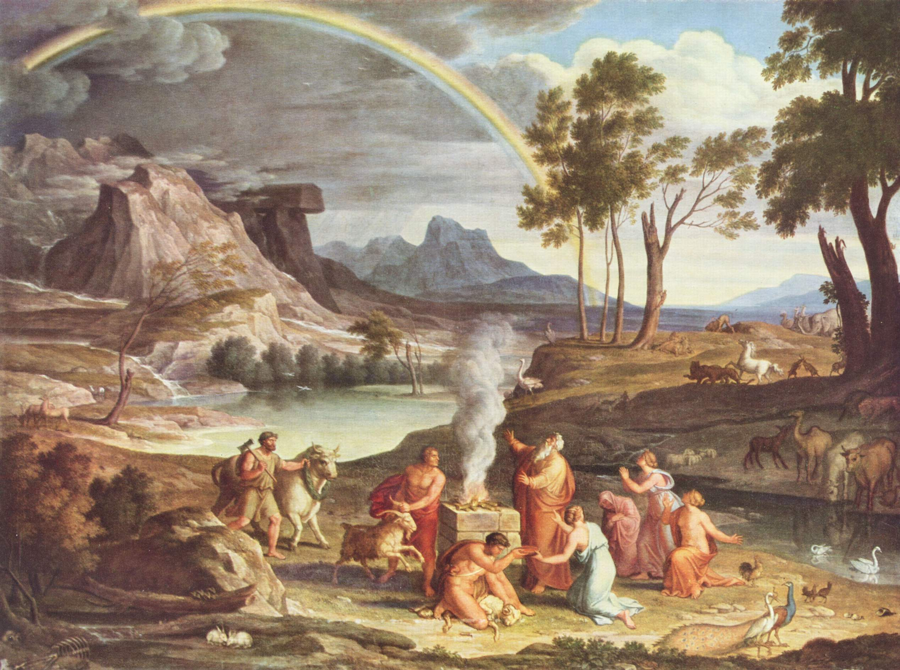
T
MASS TIMES
Weekend Masses: YANCHEP: 6 p.m. Saturday Vigil, St James Anglican Church,
2 Lagoon Drive. GUILDERTON: 8 a.m. Sunday, Guilderton Community Hall, Wedge Street. LANCELIN: 9.45 a.m. Sunday, 33 Gingin Road, Lancelin.
Confessions: before Mass on request
Weekday Masses: Tuesday, Thursday, Friday 9 a.m. at the presbytery,
Wednesdays 3 p.m. at Bethanie Beachside Aged Care.
Priest: Fr Augustine Puthota, Presbytery: 3 Blaxland Avenue, Two Rocks, Western Australia 6037. Telephone: +61-8-9561 2172
Website: http://yanchepcatholic.org/ email: yanchepcatholic@gmail.com.
Page 4
Sunday Bulletin

We pray for the sick of our community, especially:
Pat Murphy, Ken and Toni Meek, Delores Servais, Michael Ford, Jim Walsh, Paula Cope, Pat Barone, Josephine del Bene, Len Sims and Nina Campbell.

We pray for all departed souls from this Pastoral area, and we ask them to pray for us.
Mary Crawford, Des Elliot, Barry Murphy, Jim and Marion Ferguson, Pat O’Prey, John Sheahan, Carmen Germann, Yvonne Wytenburg, Frank and Netje Walser, Ian Kinner, Dennis Galora, Tom Cox, Alice Greig, John Bird, Ray Knapp, Giuseppe Del Bene, Bruno Rogalski, Bill Fleming and Ronnie Spratling.

Communion Antiphon ‡ Matthew 4:4
One does not live by bread alone, but by every word that comes forth from the mouth of God.

World Day of Prayer
Please join us when the Christian Churches of Yanchep and Two Rocks unite for the World Day of Prayer at 10.30 a.m. on Friday, 6 March at St James Church, Yanchep. Please bring a small (non-meat) plate to share afterwards. Guest speaker: Sr Lucy Van Kessell, P.B.V.M. (Presentation Sister).

Reflection by Dr Michael Barber (continued)
What covenant is God renewing with Noah? The most likely answer is that Genesis here implies that God had already established a covenant with creation. God created the world in covenant relationship with himself. Noah, then, seems to be described as a new Adam figure. God appears to be recreating the world through him. The flood was necessary, we read in Genesis, because of sin. The deluge serves as God's judgment on a faithless world. It represents a kind of "re-set". Yet the flood is sadly not the end of sin in the world. Far from it! Indeed, the story of what happened after the flood once again parallels the creation narrative. Whereas Adam had been in a garden, Noah finds himself in a vineyard. As Adam consumed the forbidden fruit, Noah consumes too much of the fruit of the vine. As curses followed the sin of Adam and Eve, curses are pronounced by Noah. From the perspective of the New Testament, sin is shown to be a power at work in Adam's descendants. Human effort will not be enough to overcome it. Victory over the power of sin and a true new creation will only be fully realized in Christ.
Landscape with Noah’s Thank Offering, Joseph Anton Koch, ca. 1803, oil on canvas, Pinakoteck, Munich.

Entrance Antiphon | Cf. Ps 91 (90): 15-16
When he calls on me, I will answer him; I will deliver him and give him glory, I will grant him length of days.

First Reading ‡ Genesis 9: 8-15
I will recall the covenant between myself and you. The waters shall never again become a flood to destroy all flesh.
God spoke to Noah and his sons, ‘See, I establish my Covenant with you, and with your descendants after you; also with every living creature to be found with you, birds, cattle and every wild beast with you: everything that came out of the ark, everything that lives on the earth. I establish my Covenant with you: nothing of flesh shall be swept away again by the waters of the flood. There shall be no flood to destroy the earth again.’

Gospel Acclamation ‡ Matthew 4:4

Praise to you, Lord Jesus Christ, king of endless glory!
No one lives on bread alone,
but on every word that comes from the mouth of God.
Praise to you, Lord Jesus Christ, king of endless glory!

Gospel ‡ Mark 1:12-15
He was tempted by Satan, and the angels looked after him.

The Spirit drove Jesus out into the wilderness and he remained there for forty days, and was tempted by Satan. He was with the wild beasts, and the angels looked after him.
After John had been arrested, Jesus went into Galilee. There he proclaimed the Good News from God. ‘The time has come’ he said ‘and the kingdom of God is close at hand. Repent, and believe the Good News.’

The Gospel of the Lord.
Praise to you Lord Jesus Christ.
Page 2
Page 3

God said, ‘Here is the sign of the Covenant I make between myself and you and every living creature with you for all generations: I set my bow in the clouds and it shall be a sign of the Covenant between me and the earth. When I gather the clouds over the earth and the bow appears in the clouds, I will recall the Covenant between myself and you and every living creature of every kind. And so the waters shall never again become a flood to destroy all things of flesh.’
The word of the Lord.
Thanks be to God.

Responsorial Psalm ‡ Psalm 24:4-9.

R. Your ways, O Lord, are love and truth to those who keep your covenant.

Lord, make me know your ways.
Lord, teach me your paths.
Make me walk in your truth, and teach me:
for you are God my saviour. R.

Remember your mercy, Lord,
and the love you have shown from of old.
In your love remember me,
because of your goodness, O Lord. R.

The Lord is good and upright.
He shows the path to those who stray,
he guides the humble in the right path;
he teaches his way to the poor. R.

Second Reading ‡ 1 Peter 3:18-22
The water of the flood is a type of the baptism which saves you now.
Christ himself, innocent though he was, died once for sins, died for the guilty, to lead us to God. In the body he was put to death, in the spirit he was raised to life, and, in the spirit, he went to preach to the spirits in prison. Now it was long ago, when Noah was still building that ark which saved only a small group of eight people ‘by water’, and when God was still waiting patiently, that these spirits refused to believe. That water is a type of the baptism which saves you now, and which is not the washing off of physical dirt but a pledge made to God from a good conscience, through the resurrection of Jesus Christ, who has entered heaven and is at God’s right hand, now that he has made the angels and Dominations and Powers his subjects.
The word of the Lord.
Thanks be to God.

Commentary on the First Reading by Dr Michael Barber from http://www.thesacredpage.com/2015/02/the-flood-christ-in-wilderness-and-new.html#more.
In Christian tradition, the season of Lent is associated with death and new life--specifically, to borrow Pauline language, it is a time to "put to death" attachments to sin (cf. Col. 3:5) in anticipation of the celebration of Christ's resurrection, which opens up for us "new life".
In the liturgy, the flood of Noah is frequently used as an apt image of new creation--through the waters of death, new life emerges. In short, in the flood, Noah is portrayed as a new Adam. Through him, we have God bringing forth a kind of new creation. Many parallels could be mentioned:
- Out of the waters, a new creation emerges (Genesis 1:2; 7:11)
- The flood begins after “seven” days, evoking the seven days of creation (Gen. 2:2; 7:10)
- As the Lord rested on the seventh day, the ark comes to a rest in the “seventh” month (Gen. 2:2-3; 8:4)
- Like Adam, Noah is told to be “fruitful and multiply” (Gen. 2:28; 9:1)
- Also, like Adam, Noah is given dominion over the creatures of the earth (Gen. 2:28; 9:2)
Moreover, the term that is usually used in Hebrew for establishing a covenant is kārat, which means, literally, to "cut". (It is likely the language refers to the sacrificial act that typically accompanied covenant-making.) However, the term used in Genesis 9 is not kārat but hēqîm, which has the connotation of "renew". (Continued over page.)

