Baptism of the Lord Year B
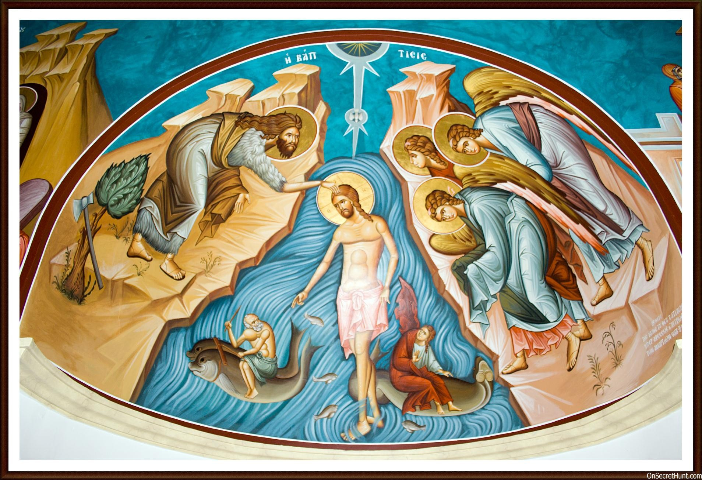
MASS TIMES
Weekend Masses: YANCHEP: 6 p.m. Saturday Vigil, St James Anglican Church,
2 Lagoon Drive. GUILDERTON: 8 a.m. Sunday, Guilderton Community Hall, Wedge Street. LANCELIN: 9.45 a.m. Sunday, 33 Gingin Road, Lancelin.
Confessions: before Mass on request
Weekday Masses: Tuesday, Thursday, Friday 9 a.m. at the presbytery,
Wednesdays 3 p.m. at Bethanie Beachside Aged Care.
Priest: Fr Augustine Puthota, Presbytery: 3 Blaxland Avenue, Two Rocks, Western Australia 6037. Telephone: +61-8-9561 2172
Website: http://yanchepcatholic.org/ email: yanchepcatholic@gmail.com.
Page 4
Sunday Bulletin

We pray for the sick of our community, especially:
Pat Murphy, Ken and Toni Meek, Delores Servais, Michael Ford, Jim Walsh, Paula Cope, Pat Barone, Josephine del Bene and Len Sims.

We pray for all departed souls from this Pastoral area, and we ask them to pray for us.
Mary Crawford, Des Elliot, Barry Murphy, Jim and Marion Ferguson, Pat O’Prey, John Sheahan, Carmen Germann, Yvonne Wytenburg, Frank and Netje Walser, Ian Kinner, Dennis Galora, Tom Cox, Alice Greig, John Bird, Ray Knapp, Giuseppe Del Bene, Bruno Rogalski, Bill Fleming and Ronnie Spratling.

(Gospel continued)
torn apart and the Spirit, like a dove, descending on him. And a voice came from heaven, ‘You are my Son, the Beloved; my favour rests on you.’

The Gospel of the Lord.
Praise to you, Lord Jesus Christ!

The Baptism of Jesus, fresco, Orthodox Church of St John the Baptist, Bethany-beyond-the-Jordan, Jordan.

Communion Antiphon ‡ Jn 1:32, 34
Behold the One of whom John said: I have seen and testified that this is the Son of God.
Entrance Antiphon | Cf. Mt. 3:16-17
After the Lord was baptised, the heavens were opened, and the Spirit descended upon him like a dove, and the voice of the Father thundered: This is my beloved Son, with whom I am well pleased.

ICEL (2014-01-11T04:16:54+00:00). Roman Missal 3m (Kindle Locations 3943-3944). Fr Richard Healey. Kindle Edition.
ICEL (2014-01-11T04:16:54+00:00). Roman Missal 3m (Kindle Locations 3578-3579). Fr Richard Healey. Kindle Edition.

Reflection by Dr John Bergsma at http://www.thesacredpage.com/2014/01/why-was-jesus-baptized-feast-of-baptism.html.
Knowing that one of the primary reasons for baptism was to publicly signify one’s repentance from sin, and that Jesus had no sin from which to repent, John objects to Jesus’ baptism: “I need to be baptized by you, yet you are coming to me?”
But repentance from sin is only one significance of baptism. There are others equally or more important. In the Old Testament, we see that when the Son of David replaced his father as king over Israel, he was taken to sacred water, anointed, and then began his reign. First Kings 1:32-40 records this ritual for us. For Jesus, baptism means something different than it does for us. For Jesus, his baptism represents his ritual anointing in order to begin his kingly reign. This is why the voice of God the Father booms from heaven, saying “This is my beloved Son, in whom I am well pleased.”

First Reading ‡ Isaiah 55:1-11
Come to the water; listen to my words and you shall have life.

Oh, come to water all you who are thirsty;
though you have no money, come!
Buy corn without money, and eat,
and, at no cost, wine and milk.

Why spend money on what is not bread,
your wages on what fails to satisfy?
Listen, listen to me, and you will have good things to eat
and rich food to enjoy.

Sing a psalm to the Lord
for he has done glorious deeds,
make them known to all the earth!
People of Zion, sing and shout for joy
for great in your midst is the Holy One of Israel. R.

Second Reading ‡ 1 John 5:1-9
The spirit, the water and the blood give witness.

Whoever believes that Jesus is the Christ has been begotten by God; and whoever loves the Father that begot him loves the child whom he begets.
We can be sure that we love God’s children
if we love God himself and do what he has commanded us;
this is what loving God is — keeping his commandments;
and his commandments are not difficult,
because anyone who has been begotten by God
has already overcome the world;
this is the victory over the world — our faith.
Who can overcome the world?
Only the man who believes that Jesus is the Son of God:
Jesus Christ who came by water and blood,
not with water only, but with water and blood;
with the Spirit as another witness — since the Spirit is the truth — so that there are three witnesses, the Spirit, the water and the blood,
and all three of them agree.
We accept the testimony of human witnesses,
but God’s testimony is much greater,
and this is God’s testimony,
given as evidence for his Son.

Gospel Acclamation ‡ cf. John 1:29
Alleluia, alleluia!
John saw Jesus approaching him, and said:
This is the Lamb of God who takes away the sins of the world.
Alleluia!
Gospel ‡ Mark 1:7-11.
You are my beloved Son, in whom I am well pleased.
In the course of his preaching John the Baptist said, ‘Someone is following me, someone who is more powerful than I am, and I am not fit to kneel down and undo the strap of his sandals. I have baptised you with water, but he will baptise you with the Holy Spirit’.
It was this time that Jesus came from Nazareth in Galilee and was baptised in the Jordan by John. No sooner had he come up out of the water than he saw the heavens
Page 2
Page 3

Pay attention, come to me; listen, and your soul will live.
With you I will make an everlasting covenant
out of the favours promised to David.
See, I have made of you a witness to the peoples,
a leader and a master of the nations.
See, you will summon a nation you never knew,
those unknown will come hurrying to you,
for the sake of the Lord your God,
of the Holy One of Israel who will glorify you.
Seek the Lord while he is still to be found,
call to him while he is still near.
Let the wicked man abandon his ways,
the evil man his thoughts.
Let him turn back to the Lord who will take pity on him,
to our God who is rich in forgiving;
for my thoughts are not your thoughts,
my ways not your ways — it is the Lord who speaks.
Yes, the heavens are as high above earth
as my ways are above your ways,
my thoughts above your thoughts.
Yes, as the rain and the snow come down from the heavens and do not return without watering the earth, making it yield and giving growth to provide seed for the sower and bread for the eating, so the word that goes from my mouth does not return to me empty, without carrying out my will and succeeding in what it was sent to do.

The word of the Lord.
Thanks be to God.

Responsorial Psalm ‡ Isaiah 12:2-6

R. You will draw water joyfully from the springs of salvation.

Truly, God is my salvation,
I trust, I shall not fear.
For the Lord is my strength, my song,
he became my saviour.
With joy you will draw water
from the wells of salvation. R.

Give thanks to the Lord, give praise to his name!
Make his mighty deeds known to the peoples!
Declare the greatness of his name. R.

https://yanchepcatholic.wordpress.com/wp-admin/admin.php?pag

