Fourth Sunday Year B
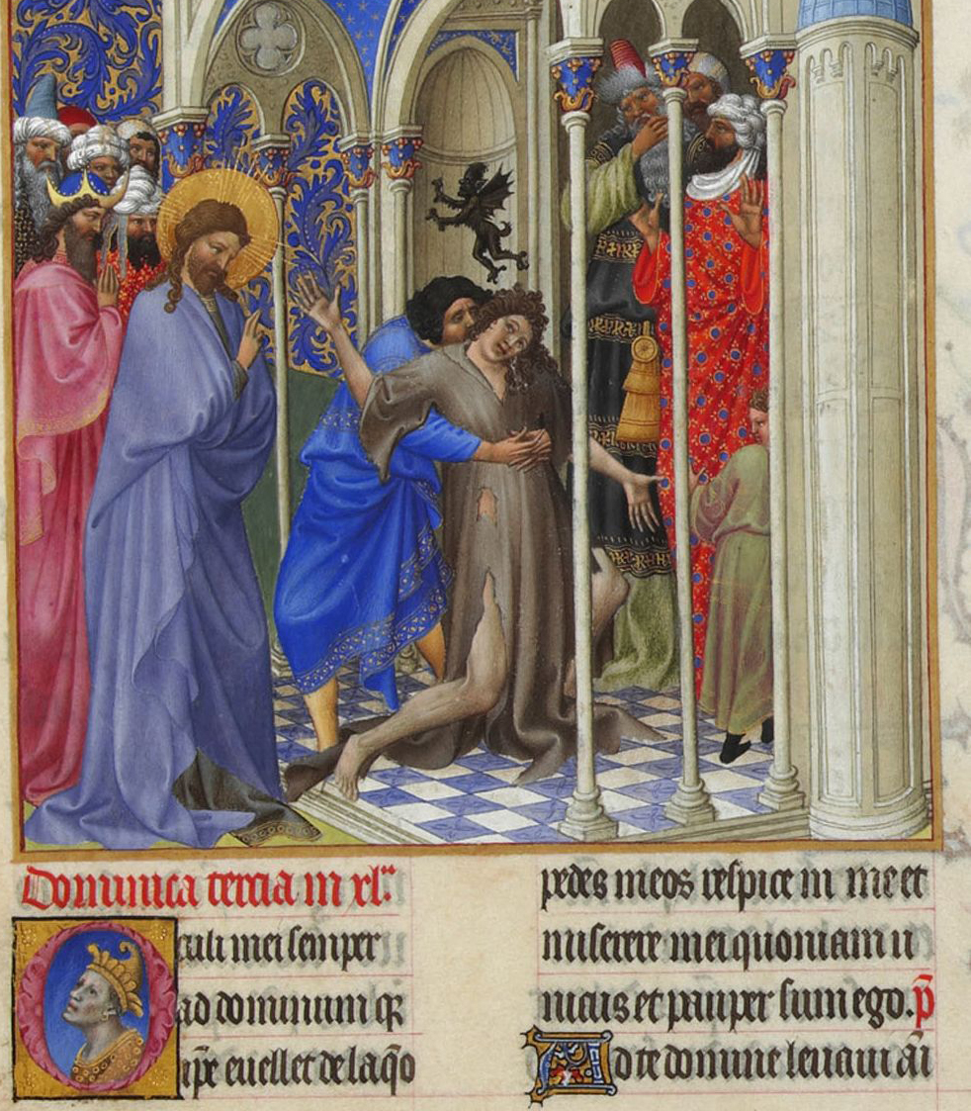
MASS TIMES
Weekend Masses: YANCHEP: 6 p.m. Saturday Vigil, St James Anglican Church,
2 Lagoon Drive. GUILDERTON: 8 a.m. Sunday, Guilderton Community Hall, Wedge Street. LANCELIN: 9.45 a.m. Sunday, 33 Gingin Road, Lancelin.
Confessions: before Mass on request
Weekday Masses: Tuesday, Thursday, Friday 9 a.m. at the presbytery,
Wednesdays 3 p.m. at Bethanie Beachside Aged Care.
Priest: Fr Augustine Puthota, Presbytery: 3 Blaxland Avenue, Two Rocks, Western Australia 6037. Telephone: +61-8-9561 2172
Website: http://yanchepcatholic.org/ email: yanchepcatholic@gmail.com.
Page 4
Sunday Bulletin

Jesus casts out an Unclean Spirit, illuminated manuscript, folio 166R, Tres Riches Heures du Duc du Berry, Limbourg Brothers, 1412-1416, Musee Condee, Chantilly, France.

We pray for the sick of our community, especially:
Pat Murphy, Ken and Toni Meek, Delores Servais, Michael Ford, Jim Walsh, Paula Cope, Pat Barone, Josephine del Bene and Len Sims.

We pray for all departed souls from this Pastoral area, and we ask them to pray for us.
Mary Crawford, Des Elliot, Barry Murphy, Jim and Marion Ferguson, Pat O’Prey, John Sheahan, Carmen Germann, Yvonne Wytenburg, Frank and Netje Walser, Ian Kinner, Dennis Galora, Tom Cox, Alice Greig, John Bird, Ray Knapp, Giuseppe Del Bene, Bruno Rogalski, Bill Fleming and Ronnie Spratling.

Communion Antiphon ‡ Ps 31 (30): 17-18
Let your face shine on your servant. Save me in your merciful love. O Lord, let me never be put to shame, for I call on you.

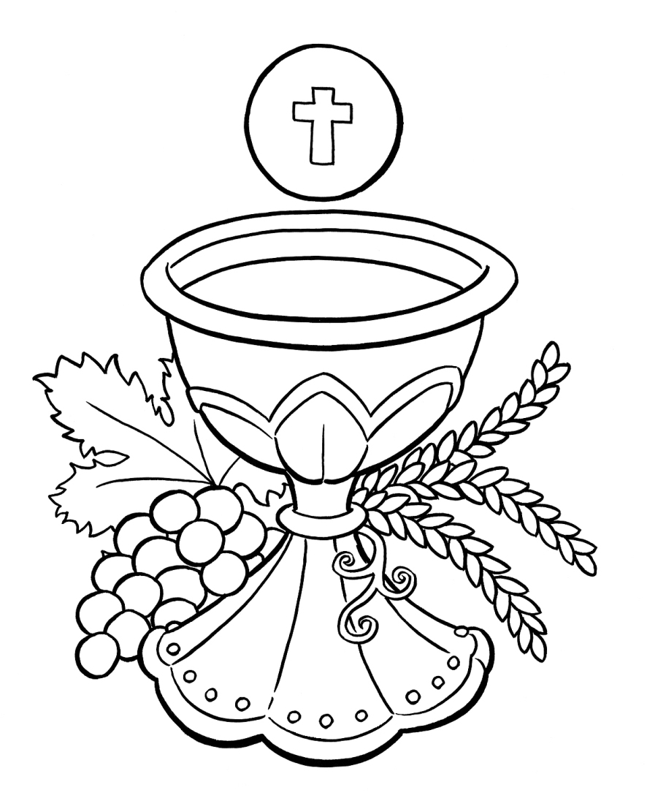
Reflection by Dr John Bergsma (continued)
They mean, "Are you the Prophet like Moses of Deuteronomy 18?" Also, the Samaritans, since they did not accept as canonical anything but the Pentateuch, had no other Messianic expectation than for the “Prophet like Moses.” So when the Samaritan woman at the well says, “I know that the Messiah is coming” (John 4:25), her understanding of the Messiah would have been shaped almost solely in Mosaic terms.
The one catch was, when the “Prophet like Moses” did come, everyone had to listen to him, or else face the judgment of God. The Psalm ties closely to the First Reading. It urges us to listen to the voice of God—something that the Israelite tribes didn’t want to do. Not only did they not want to hear God’s voice directly (see the First Reading) but time and again they rebelled against God’s Word given to them through Moses (there are nine rebellions recorded in the Book of Numbers). With the coming of Jesus, we have a new chance, a new start, a New Covenant. Let’s listen to the new Prophet like Moses and obey his words while we have the opportunity. The Gospel continues our journey through Mark. We find that Jesus, viral You Tube videos notwithstanding, does not disdain the practices of “religion,” but participates in the study, prayer, and worship of the local synagogue along with his fellow Jews. His manner of teaching shocks people: he teaches “with authority” unlike the scribes. (Continue reading online: http://www.thesacredpage.com/2012/01/hearing-voice-of-ultimate-prophet.html#more.)

Entrance Antiphon | Cf. Ps 106 (105): 47
Save us, O Lord our God! And gather us from the nations, to give thanks to your holy name, and make it our glory to praise you.

First Reading ‡ Deuteronomy 18:15-20
I will put my words into the prophet’s mouth, and he will tell them all I command.
Moses said to the people: ‘Your God will raise up for you a prophet like myself, from among yourselves, from your own brothers; to him you must listen. This is what you yourselves asked of the Lord your God at Horeb on the day of the Assembly. “Do not let me hear again,” you said, “the voice of the Lord my God, nor look any longer on

The word of the Lord.
Thanks be to God.
Gospel Acclamation ‡ Matthew 4:16.
Alleluia, alleluia!
A people in darkness have seen a great light:
a radiant dawn shines on those lost in death.
Alleluia!
Gospel ‡ Mark 1:21-28
This is a new kind of teaching that speaks with authority.

Jesus and his followers went as far as Capernaum, and as soon as the Sabbath came Jesus went to the synagogue and began to teach. And his teaching made a deep impression on them because, unlike the scribes, he taught them with authority.
In their synagogue just then there was a man possessed by an unclean spirit, and it shouted, ‘What do you want with us, Jesus of Nazareth? Have you come to destroy us? I know who you are: the Holy One of God.’ But Jesus said sharply, ‘Be quiet! Come out of him!’ And the unclean spirit threw the man into convulsions and with a loud cry went out of him. The people were so astonished that they started asking each other what it all meant. ‘Here is a teaching that is new’ they said ‘and with authority behind it: he gives orders even to unclean spirits and they obey him.’ And his reputation rapidly spread everywhere, through all the surrounding Galilean countryside.

The Gospel of the Lord.
Praise to you Lord Jesus Christ.
Page 2
Page 3

this great fire, or I shall die”; and the Lord said to me, “All they have spoken is well said. I will raise up a prophet like yourself for them from their own brothers; I will put my words into his mouth and he shall tell them all I command him. The man who does not listen to my words that he speaks in my name, shall be held answerable to me for it. But the prophet who presumes to say in my name a thing I have not commanded him to say, or who speaks in the name of other gods, that prophet shall die.”’

The word of the Lord.
Thanks be to God.

Responsorial Psalm ‡ Psalm 94:1-2, 6-9.

R. If today you hear his voice, harden not your hearts.

Come, ring out our joy to the Lord;
hail the rock who saves us.
Let us come before him, giving thanks,
with songs let us hail the Lord. R.

Come in, let us kneel and bend low;
let us kneel before the God who made us
for he is our God and we
the people who belong to his pasture,
the flock that is led by his hand. R.

O that today you would listen to his voice!
‘Harden not your hearts as at Meribah,
as on that day at Massah in the desert
when your fathers put me to the test;
when they tried me, though they saw my work.’ R.

Second Reading ‡ 1 Corinthians 7:32-35.
The unmarried woman dedicates herself to the things of the Lord, that she might be holy.
I would like to see you free from all worry. An unmarried man can devote himself to the Lord’s affairs, all he need worry about is pleasing the Lord; but a married man has to bother about the world’s affairs and devote himself to pleasing his wife: he is torn two ways. In the same way an unmarried woman, like a young girl, can devote herself to the Lord’s affairs; all she need worry about is being holy in body and spirit. The married woman, on the other hand, has to worry about the world’s affairs and devote herself to pleasing her husband. I say this only to help you, not to put a halter round your necks, but simply to make sure that everything is as it should be, and that you give your undivided attention to the Lord.

https://yanchepcatholic.wordpress.com/wp-admin/admin.php?pag

Reflection by Dr John Bergsma at http://www.thesacredpage.com/2012/01/hearing-voice-of-ultimate-prophet.html#more.
Hearing the Voice of the Ultimate Prophet
In the Readings for this Sunday, we are following 1 Corinthians and the Gospel of Mark ad seriatim, so there is less cohesion between the Second Reading and the Gospel than on a high feast day. Nonetheless, the Readings this week can be linked by the theme of “hearing the voice of the prophet.”
The First Reading is a very famous passage from the Book of Deuteronomy that should be familiar to every Catholic student of biblical theology. The context: at the end of his life, Moses is giving his valedictory speech to the people of Israel (which is basically the whole Book of Deuteronomy), and amongst his various warnings and promises, he prophesies that God will one day send the people of Israel a prophet like himself, to whom they will need to listen in order to be saved. On the basis of this prophecy in Deuteronomy 18, the “Prophet like Moses” became one of the standard anticipated eschatological figures in Judaism, along with the prophet Elijah (based on Malachi 4:5) and the Son of David (based on Ezek 37:24-25 and many other texts). This is necessary background information for understanding what the priests and Levites mean when they ask John the Baptist, “Are you the Prophet?” in John 1:21.

