Second Sunday Year B
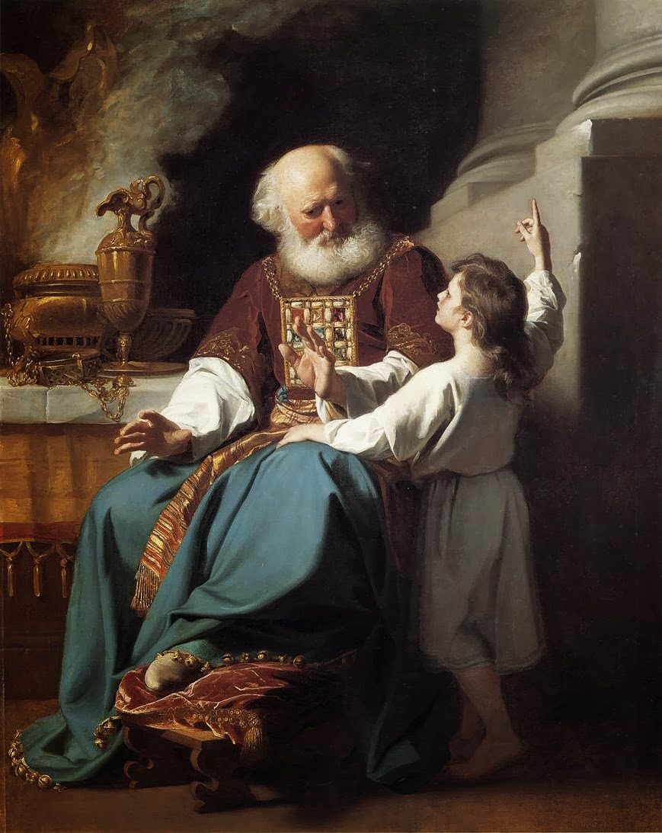
MASS TIMES
Weekend Masses: YANCHEP: 6 p.m. Saturday Vigil, St James Anglican Church,
2 Lagoon Drive. GUILDERTON: 8 a.m. Sunday, Guilderton Community Hall, Wedge Street. LANCELIN: 9.45 a.m. Sunday, 33 Gingin Road, Lancelin.
Confessions: before Mass on request
Weekday Masses: Tuesday, Thursday, Friday 9 a.m. at the presbytery,
Wednesdays 3 p.m. at Bethanie Beachside Aged Care.
Priest: Fr Augustine Puthota, Presbytery: 3 Blaxland Avenue, Two Rocks, Western Australia 6037. Telephone: +61-8-9561 2172
Website: http://yanchepcatholic.org/ email: yanchepcatholic@gmail.com.
Page 4
Sunday Bulletin
Eli and Samuel, John Singleton Copley (1780), Wadsworth Atheneum, Hartford, Connecticut.

We pray for the sick of our community, especially:
Pat Murphy, Ken and Toni Meek, Delores Servais, Michael Ford, Jim Walsh, Paula Cope, Pat Barone, Josephine del Bene and Len Sims.


We pray for all departed souls from this Pastoral area, and we ask them to pray for us.
Mary Crawford, Des Elliot, Barry Murphy, Jim and Marion Ferguson, Pat O’Prey, John Sheahan, Carmen Germann, Yvonne Wytenburg, Frank and Netje Walser, Ian Kinner, Dennis Galora, Tom Cox, Alice Greig, John Bird, Ray Knapp, Giuseppe Del Bene, Bruno Rogalski, Bill Fleming and Ronnie Spratling.

Entrance Antiphon | Cf. Ps 66 (65): 4

All the earth shall bow down before you, O God, and shall sing to you, shall sing to your name, O Most High!

Communion Antiphon ‡ Ps 22 (23): 5
You have prepared a table before me, and how precious is the chalice that quenches my thirst.

Reflection by Dr John Bergsma (continued)
the image of God. In this Reading, Samuel provides us an example of growth in faith. Many of us are “cradle Catholics” or at least “cradle Christians”—we grew up raised in Christian homes, learning to pray and worship from childhood. Yet for each of us, there comes a time when we have to embrace a personal relationship with God, a direct relationship no longer mediated by our parents or others who may have raised us. We have to come to an awareness that God has a unique call and purpose for our lives, and we have to embrace that vocation. If we never make this transition, we end up losing the faith or simply “going through the motions” for the rest of our lives. At the beginning of this Reading, Samuel’s relationship to God is mediated through his adopted father, the priest Eli. But by the end of the narrative, Samuel has learned to hear God for himself and submit to God’s will for his life. In fact, the message that God delivers to Samuel (1 Samuel 3:11-18) actually concerns judgment on Samuel’s mentor, Eli. The Responsorial Psalm continues to pursue this theme. The traditional Hebrew text labels Psalm 40 “a psalm of David,” and we are to understand the Psalm as his words of prayer to God. David was remembered in Israel’s history for the intensity of his relationship with the LORD, an intensity captured in the deeply personal and emotional language of so many of the psalms. David uses strong language to emphasize that merely going through the formalities of worship does not satisfy God’s will for us.

First Reading ‡ 1 Samuel 3:3-10, 19.
Speak, O Lord, your servant is listening.

Samuel was lying in the sanctuary of the Lord where the ark of God was, when the Lord called, ‘Samuel! Samuel!’ He answered, ‘Here I am.’ Then he ran to Eli and said, ‘Here I am, since you called me’. Eli said, ‘I did not call. Go back and lie down.’ So he went and lay down. Once again the Lord called, ‘Samuel! Samuel!’ Samuel got up and went to Eli and said. ‘Here I am, since you called me.’ He replied, ‘I did not call you, my son; go back and lie down.’ Samuel had as yet no knowledge of the Lord and the word of the Lord had not yet been revealed to him. Once again the Lord called, the third time.

Keep away from fornication. All the other sins are committed outside the body; but to fornicate is to sin against your own body. Your body, you know, is the temple of the Holy Spirit, who is in you since you received him from God. You are not your own property; you have been bought and paid for. That is why you should use your body for the glory of God.

The word of the Lord.
Thanks be to God.
Gospel Acclamation ‡ John 1:41, 17.
Alleluia, alleluia!
We have found the Messiah:
Jesus Christ, who brings us truth and grace.
Alleluia!
Gospel ‡ John 1: 35-42.
They saw where Jesus lived and they stayed with him.

As John stood with two of his disciples, Jesus passed, and John stared hard at him and said, ‘Look, there is the lamb of God.’ Hearing this, the two disciples followed Jesus. Jesus turned round, saw them following and said, ‘What do you want?’ They answered, ‘Rabbi,’- which means Teacher — ‘where do you live?’ ‘Come and see’ he replied; so they went and saw where he lived, and stayed with him the rest of that day. It was about the tenth hour.
One of these two who became followers of Jesus after hearing what John had said was Andrew, the brother of Simon Peter. Early next morning, Andrew met his brother and said to him, ‘We have found the Messiah’ — which means the Christ — and he took Simon to Jesus. Jesus looked hard at him and said, ‘You are Simon son of John; you are to be called Cephas’ — meaning Rock.

The Gospel of the Lord.
Praise to you Lord Jesus Christ.
Page 2
Page 3

He got up and went to Eli and said, ‘Here I am, since you called me.’ Eli then understood that it was the Lord who was calling the boy, and he said to Samuel, ‘Go and lie down, and if someone calls say, “Speak Lord, your servant is listening”’. So Samuel went and lay down in his place.
The Lord then came and stood by, calling as he had done before, ‘Samuel! Samuel!’ Samuel answered, ‘Speak, Lord, your servant is listening.’
Samuel grew up and the Lord was with him and let no word of his fall to the ground.

The word of the Lord.
Thanks be to God.

Responsorial Psalm ‡ Psalm 39: 2, 4, 7-10

R. Here am I, Lord, I come to do your will.

I waited, I waited for the Lord
and he stooped down to me;
he heard my cry.
He put a new song into my mouth,
praise of our God. R.

You do not ask for sacrifice and offerings,
but an open ear.
You do not ask for holocaust and victim.
Instead, here am I. R.

In the scroll of the book it stands written
that I should do your will.
My God, I delight in your law
in the depth of my heart. R.

Your justice I have proclaimed
in the great assembly.
My lips I have not sealed;
you know it, O Lord. R.

Second Reading ‡ 1 Corinthians 6:13-15, 17-20.
Your bodies are members of the body of Christ.
The body is not meant for fornication; it is for the Lord, and the Lord for the body. God who raised the Lord from the dead, will by his power raise us up too.
You know, surely, that your bodies are members making up the body of Christ; anyone who is joined to the Lord is one spirit with him.

https://yanchepcatholic.wordpress.com/wp-admin/admin.php?pag

Reflection by Dr John Bergsma at http://www.thesacredpage.com/2012/01/is-god-person-or-force-readings-for-2nd.html#more.
Our First Reading recounts the call of Samuel, one of Israel’s greatest prophets, the one who would ultimately anoint Israel’s greatest king, David. The LORD calls Samuel by his name in an audible voice—a rare but not unheard-of privilege in salvation history. Nothing is more personal than a name. We all love to hear our name called, and perk up our ears when we hear it. We’ve all experienced the awkwardness of forgetting someone’s name—sometimes even the name of someone we know fairly well, but if we run into them after a lapse of a few years, or in a context where we don’t usually meet them (like at the grocery store), our memory temporary fails us. Unable to evoke their name, we can’t renew our relationship with the person. God knows us by name. He is personal, and knows us as persons. That’s part of what it means to be made in (continued overleaf)

