Fourth Sunday of Advent Year B
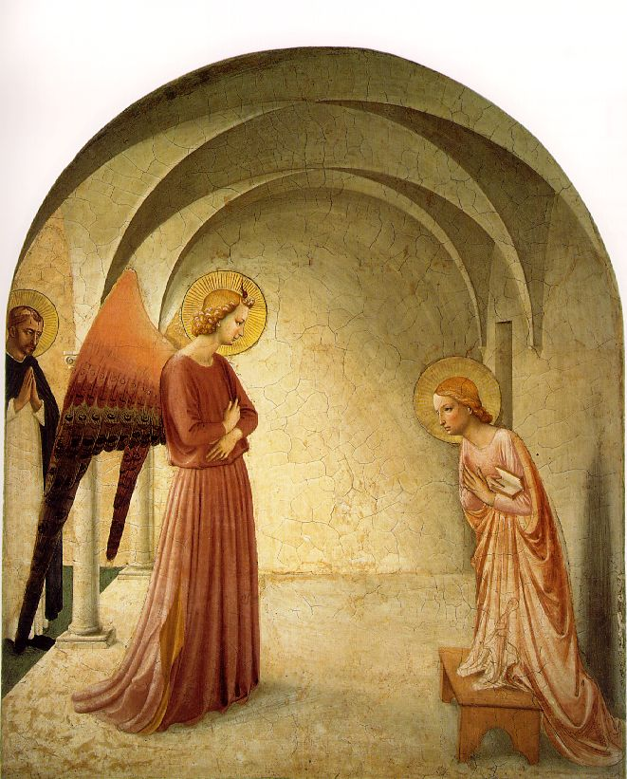
Entrance Antiphon | cf. Isaiah 45:8
Drop down dew from above, you heavens, and let the clouds rain down the Just One; let the earth be opened and bring forth a Saviour.
MASS TIMES
Weekend Masses: YANCHEP: 6 p.m. Saturday Vigil, St James Anglican Church,
2 Lagoon Drive. GUILDERTON: 8 a.m. Sunday, Guilderton Community Hall, Wedge Street. LANCELIN: 9.45 a.m. Sunday, 33 Gingin Road, Lancelin.
Confessions: before Mass on request
Weekday Masses: Tuesday, Thursday, Friday 9 a.m. at the presbytery,
Wednesdays 3 p.m. at Bethanie Beachside Aged Care.
Priest: Fr Augustine Puthota, Presbytery: 3 Blaxland Avenue, Two Rocks, Western Australia 6037. Telephone: +61-8-9561 2172
Website: http://yanchepcatholic.org/ email: yanchepcatholic@gmail.com.
Page 4
Sunday Bulletin

We pray for the sick of our community, especially:
Pat Murphy, Ken and Toni Meek, Delores Servais, Michael Ford, Jim Walsh, Paula Cope, Pat Barone, Josephine del Bene and Len Sims.

We pray for all departed souls from this Pastoral area, and we ask them to pray for us.
Mary Crawford, Des Elliot, Barry Murphy, Jim and Marion Ferguson, Pat O’Prey, John Sheahan, Carmen Germann, Yvonne Wytenburg, Frank and Netje Walser, Ian Kinner, Dennis Galora, Tom Cox, Alice Greig, John Bird, Ray Knapp, Giuseppe Del Bene, Bruno Rogalski, Bill Fleming and Ronnie Spratling.

First Reading ‡ 2 Samuel 7:1-5, 8-12, 14, 16.
The kingdom of David will be established for ever in the sight of the Lord.
Once David had settled into his house and the Lord had given him rest from all the enemies surrounding him, the king said to the prophet Nathan, ‘Look, I am living

Communion Antiphon ‡ Isaiah 7:14
Behold, a Virgin shall conceive and bear a son; and his name will be called Emmanuel.

Christmas Mass times: Yanchep: Vigil Mass 6 p.m. Lancelin and Guilderton: as for Sunday Masses.

Advent Day 18: A Waiting People by Fr Robert Barron
We've seen how Abraham and Joseph were compelled to wait on God, but today we turn to their descendants.
The people of Israel were miraculously delivered from slavery in Egypt, led across the Red Sea by the mighty hand of Moses - and then they waited. A journey that normally would have taken only a few weeks stretched to 40 years as they wandered rather aimlessly through the desert.
The book of Exodus frequently gives us indications of what this time of vigil was like: "The people grumbled against Moses, 'We are disgusted with this wretched food... Why did you lead us out into this desert to die? Were there not graves enough in Egypt?'" (Exodus 16:2-3) They were hardly models of patience.
Eventually, though, once their grumbling ceased and they developed a firm trust in God, their sojourn ended and they were welcomed to the Promised Land.
In the spiritual life, we often yearn to advance deeper in prayer or wisdom. Yet it's only when we cease grumbling about our shortcomings and difficulties that God answers our waiting with his presence.

The Annunciation with St Dominic, Fra Angelico (1395 – 1455), Cell No. 3, Fresco Cycle in the Dominican Convent of San Marco, Florence.

in a house of cedar while the ark of God dwells in a tent.’
Nathan said to the king, ‘Go and do all that is in your mind, for the Lord is with you.’
But that very night the word of the Lord came to Nathan: ‘Go and tell my servant David, “Thus the Lord speaks: Are you the man to build me a house to dwell in? I took you from the pasture, from following the sheep, to be leader of my people Israel; I have been with you on all your expeditions; I have cut off all your enemies before you. I will give you fame as great as the fame of the greatest on earth. I will provide a place for my people Israel; I will plant them there and they shall dwell in my people Israel; I will give them rest from all their enemies. The Lord will make you great; the Lord will make you a House. And when your days are ended and you are laid to rest with your ancestors, I will preserve the offspring of your body after you and make his sovereignty secure. I will be a father to him and he a son to me. Your House and your sovereignty will always stand secure before me and your throne be established for ever.”’

Gospel Acclamation ‡ Luke 1:38
Alleluia, alleluia!
I am the servant of the Lord:
may his will for me be done.
Alleluia!
Gospel ‡ Luke 1:26-38
You will conceive and bear a son.

The angel Gabriel was sent by God to a town in Galilee called Nazareth, to a virgin betrothed to a man named Joseph, of the House of David; and the virgin’s name was Mary. He went in and said to her, ‘Rejoice, so highly favoured! The Lord is with you.’
She was deeply disturbed by these words and asked herself what this greeting could mean, but the angel said to her, ‘Mary, do not be afraid; you have won God’s favour. Listen! You are to conceive and bear a son, and you must name him Jesus. He will be great and will be called Son of the Most High. The Lord God will give him the throne of his ancestor David; he will rule over the House of Jacob for ever and his reign will have no end.’
Mary said to the angel, ‘But how can this come about, since I am a virgin?’ ‘The Holy Spirit will come upon you’ the angel answered ‘and the power of the Most High will cover you with its shadow. And so the child will be holy and will be called Son of God. Know this too: your kinswoman Elizabeth has, in her old age, herself conceived a son, and she whom people called barren is now in her sixth month, for nothing is impossible to God.’
‘I am the handmaid of the Lord,’ said Mary
‘let what you have said be done to me.’
And the angel left her.

The Gospel of the Lord.
Praise to you, Lord Jesus Christ!
Page 2
Page 3

that place and never be disturbed again; nor shall the wicked continue to oppress them as they did, in the days when I appointed judges over my people Israel; I will give them rest from all their enemies. The Lord will make you great; the Lord will make you a House. And when your days are ended and you are laid to rest with your ancestors, I will preserve the offspring of your body after you and make his sovereignty secure. I will be a father to him and he a son to me. Your House and your sovereignty will always stand secure before me and your throne be established for ever.”’

The word of the Lord.
Thanks be to God.

Responsorial Psalm ‡ Psalm 88:2-5, 27, 29.

R. Forever I will sing the goodness of the Lord.

I will sing for ever of your love, O Lord;
through all ages my mouth will proclaim your truth.
Of this I am sure, that your love lasts for ever,
that your truth is firmly established as the heavens. R.

‘I have made a covenant with my chosen one;
I have sworn to David my servant:
I will establish your dynasty for ever
and set up your throne through all ages.’ R.

He will say to me: ‘You are my father,
my God, the rock who saves me.’
I will keep my love for him always;
for him my covenant shall endure. R.

Second Reading ‡ Romans 16:25-27
The mystery kept secret for endless ages is now revealed.
Be happy at all times; pray constantly; and for all things give thanks to God, Glory to him who is able to give you the strength to live according to the Good News I preach, and in which I proclaim Jesus Christ, the revelation of a mystery kept secret for endless ages, but now so clear that it must be broadcast to pagans everywhere to bring them to the obedience of faith. This is only what scripture has predicted, and it is all part of the way the eternal God wants things to be. He alone is wisdom; give glory therefore to him through Jesus Christ for ever and ever. Amen.
The word of the Lord.
Thanks be to God.

Advent Day 16: Abraham’s expectation by Fr Robert Barron.
From the beginning to end of Scripture we discover stories of people who are compelled to wait.
The patriarch Abraham received the promise that he would become, despite his old age, the father of a son and through that son the father of descendants more numerous than the stars in the night sky. But the fulfillment of that promise took a long time. Through many years, as he and his wife grew older and older, as the likelihood of their parenthood became increasingly remote, Abraham waited.
Did he doubt? Did he wonder whether he had misconstrued the divine promise? Did he waver in his faith? Did he endure the taunts of his enemies and the pitying glances of his friends? Probably. But he waited, and in time the promise came true.
The season of Advent reminds us that God sometimes completes his will only after a long period of time. So, like Abraham, we wait.

