Third Sunday of Advent Year B
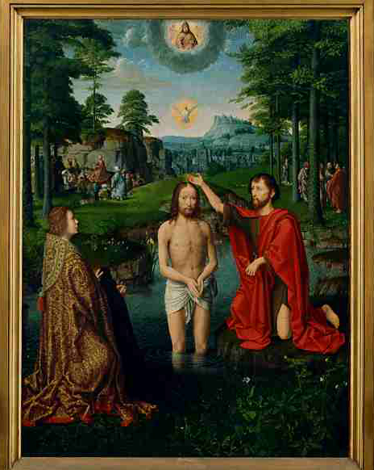
Entrance Antiphon | Phil. 4: 4-5

Rejoice in the Lord always; again I say, rejoice. Indeed, the Lord is near.
MASS TIMES
Weekend Masses: YANCHEP: 6 p.m. Saturday Vigil, St James Anglican Church,
2 Lagoon Drive. GUILDERTON: 8 a.m. Sunday, Guilderton Community Hall, Wedge Street. LANCELIN: 9.45 a.m. Sunday, 33 Gingin Road, Lancelin.
Confessions: before Mass on request
Weekday Masses: Tuesday, Thursday, Friday 9 a.m. at the presbytery,
Wednesdays 3 p.m. at Bethanie Beachside Aged Care.
Priest: Fr Augustine Puthota, Presbytery: 3 Blaxland Avenue, Two Rocks, Western Australia 6037. Telephone: +61-8-9561 2172
Website: http://yanchepcatholic.org/ email: yanchepcatholic@gmail.com.
Page 4
Sunday Bulletin

We pray for the sick of our community, especially:
Pat Murphy, Ken and Toni Meek, Delores Servais, Michael Ford, Jim Walsh, Paula Cope, Pat Barone, Josephine del Bene and Len Sims.

Baptism of Christ, altarpiece, triptych, oil on wood, centre panel, Gerard David, ca 1507, Groeninge-museum, Bruges, Belgium.
We pray for all departed souls from this Pastoral area, and we ask them to pray for us.
Mary Crawford, Des Elliot, Barry Murphy, Jim and Marion Ferguson, Pat O’Prey, John Sheahan, Carmen Germann, Yvonne Wytenburg, Frank and Netje Walser, Ian Kinner, Dennis Galora, Tom Cox, Alice Greig, John Bird, Ray Knapp, Giuseppe Del Bene, Bruno Rogalski, Bill Fleming and Ronnie Spratling.

Communion Antiphon ‡ cf. Isaiah 35:4
Say to the faint of heart: Be strong and do not fear. Behold, our God will come, and he will save us.

Christmas Mass times: Yanchep: Vigil Mass 6 p.m. Lancelin and Guilderton: as for Sunday Masses.
First Reading ‡ Isaiah 61:1-2, 10-11

I exult for joy in the Lord.
The spirit of the Lord has been given to me, for

Advent Day 11 - How Can We Fully Enter Into Advent? by Fr Robert Barron
I think one of the best ways to enter into Advent is to get reacquainted with the Bible. Many Catholics don't know the Bible very well. Vatican II called for a revival in biblical studies, but I don't think that's happened yet, at least among average Catholics.
We need to understand the great biblical story, beginning with Creation and the Fall, the formation of Israel, the coming of the prophets and patriarchs, and finally the formation of a people that leads to the coming of a saviour. It's only when we get the sweep of that whole story that we understand why the coming of the saviour matters, and what the coming of the savior even means.
When you extract Jesus from the biblical narrative, he becomes a mere guru, teacher, or philosopher. That's all our culture gives us: Jesus as another mystic, seer, or sage. But when you see Jesus against the backdrop of the great story of Israel, now you see that he's the saviour.
So this Advent, I would recommend to all Catholics, open up your Bible and get deeply immersed in the great biblical story.

the Lord has anointed me.
He has sent me to bring good news to the poor,
to bind up hearts that are broken;
to proclaim liberty to captives,
freedom to those in prison;
to proclaim a year of favour from the Lord.
‘I exult for joy in the Lord,
my soul rejoices in my God,
for he has clothed me in the garments of salvation,

Gospel Acclamation ‡ Isaiah 61:1
Alleluia, alleluia!
The Spirit of the Lord is upon me;
he sent me to bring Good News to the poor
Alleluia!
Gospel ‡ John 1: 6-8, 19-28
There stands among you, unknown to you, the one who is coming after me.

A man came, sent by God.
His name was John.
He came as a witness,
as a witness to speak for the light,
so that everyone might believe through him.
He was not the light,
only a witness to speak for the light.
This is how John appeared as a witness. When the Jews sent priests and Levites from Jerusalem to ask him, ‘Who are you?’ he not only declared, but he declared quite openly, ‘I am not the Christ.’
‘Well then,’ they asked ‘are you Elijah?’ ‘I am not’ he said.
‘Are you the Prophet?’ He answered, ‘No.’
So they said to him, ‘Who are you?
We must take back an answer to those who sent us.
What have you to say about yourself?’
So John said, ‘I am, as Isaiah prophesied:
a voice that cries in the wilderness:
Make a straight way for the Lord.’
Now these men had been sent by the Pharisees, and they put this further question to him, ‘Why are you baptising if you are not the Christ, and not Elijah, and not the prophet?’ John replied, ‘I baptise with water; but there stands among you unknown to you the one who is coming after me; and I am not fit to undo his sandal-strap.’
This happened at Bethany, on the far side of the Jordan, where John was baptising.

The Gospel of the Lord.
Praise to you, Lord Jesus Christ!
Page 2
Page 3

he has wrapped me in the cloak of integrity,
like a bridegroom wearing his wreath,
like a bride adorned in her jewels.
‘For as the earth makes fresh things grow,
as a garden makes seeds spring up,
so will the Lord make both integrity and praise
spring up in the sight of the nations.’

The word of the Lord.
Thanks be to God.

Responsorial Psalm ‡ Luke 1:46-50, 53-54

R. My soul rejoices in my God.

My soul glorifies the Lord,
my spirit rejoices in God, my Saviour.
He looks on his servant in her nothingness;
henceforth all ages will call me blessed. R.

The Almighty works marvels for me.
Holy his name!
His mercy is from age to age,
on those who fear him. R.

He fills the starving with good things,
sends the rich away empty.
He protects Israel, his servant,
remembering his mercy. R.

Second Reading ‡ 1 Thess. 5:16-24
May you all be kept blameless, spirit, soul and body, for the coming of our Lord Jesus Christ.
Be happy at all times; pray constantly; and for all things give thanks to God, because this is what God expects you to do in Christ Jesus.
Never try to suppress the Spirit or treat the gift of prophecy with contempt; think before you do anything — hold on to what is good and avoid every form of evil.
May the God of peace make you perfect and holy; and may you all be kept safe and blameless, spirit, soul and body, for the coming of our Lord Jesus Christ. God has called you and he will not fail you.

The word of the Lord.
Thanks be to God.

