First Sunday of Advent Year B
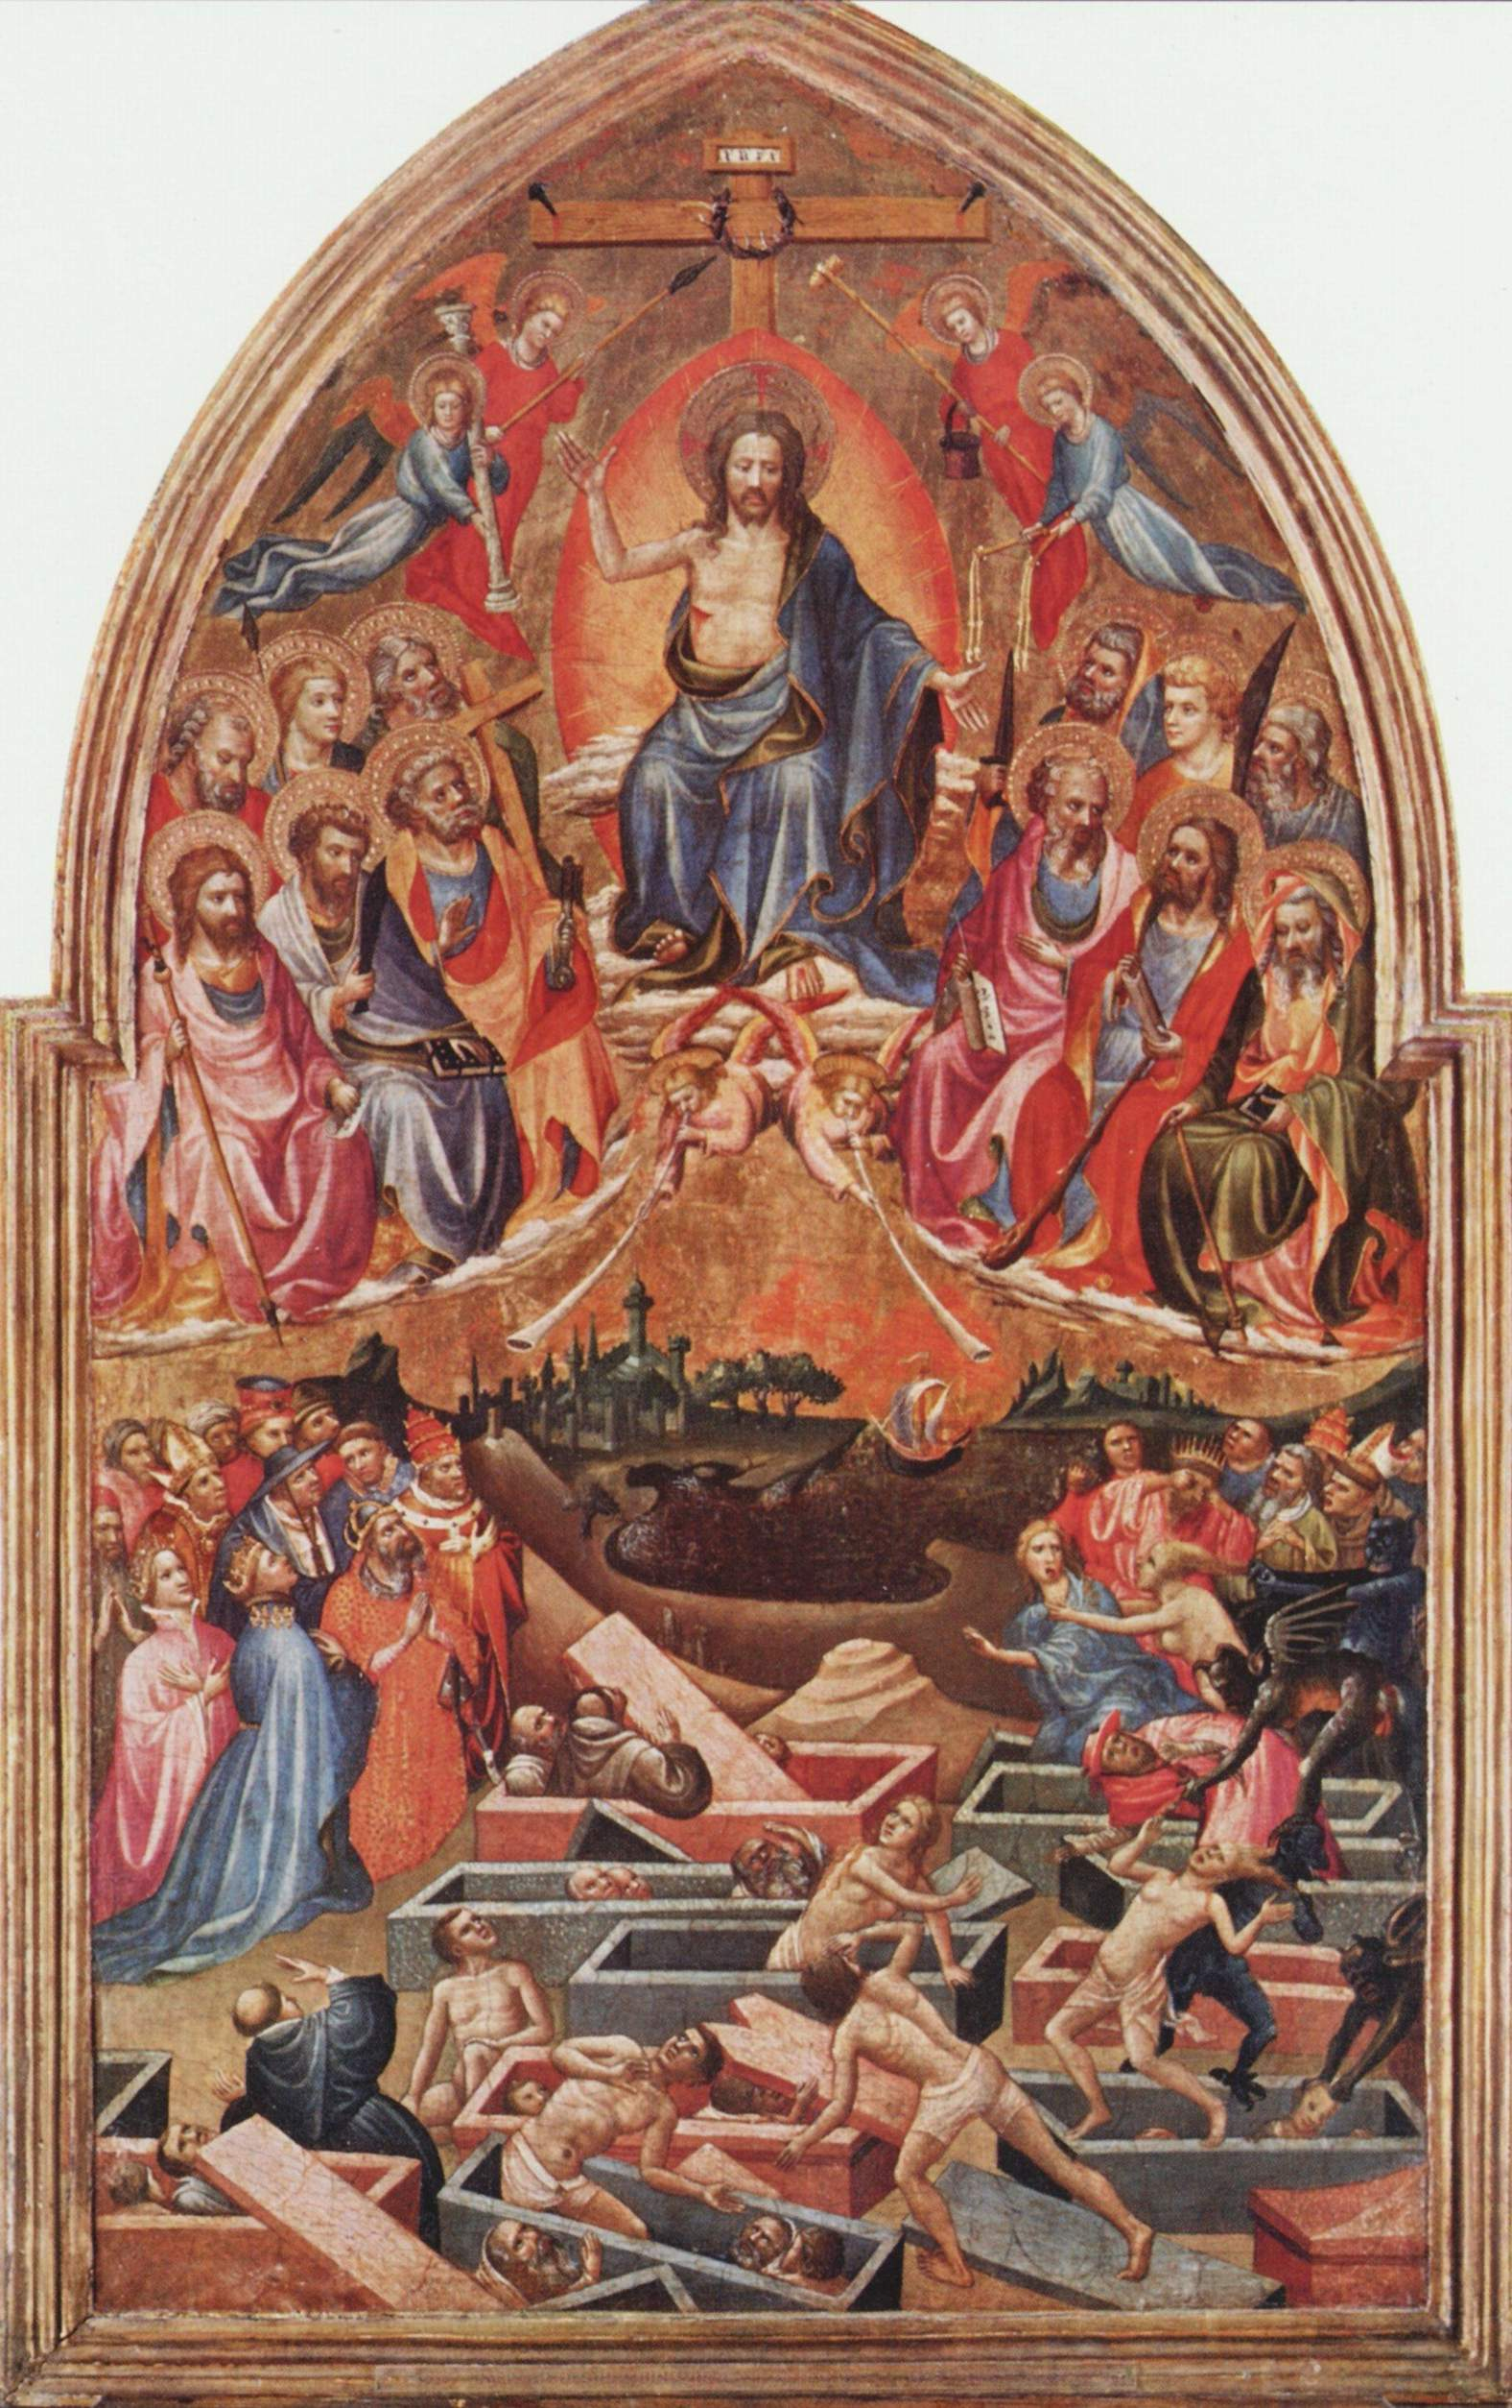
Entrance Antiphon | cf. Ps. 25 (24): 1-3

To you, I lift up my soul, O my God. In you, I have trusted; let me not be put to shame. Nor let my enemies exult over me; and let none who hope in you be put to shame.
MASS TIMES
Weekend Masses: YANCHEP: 6 p.m. Saturday Vigil, St James Anglican Church,
2 Lagoon Drive. GUILDERTON: 8 a.m. Sunday, Guilderton Community Hall, Wedge Street. LANCELIN: 9.45 a.m. Sunday, 33 Gingin Road, Lancelin.
Confessions: before Mass on request
Weekday Masses: Tuesday, Thursday, Friday 9 a.m. at the presbytery,
Wednesdays 3 p.m. at Bethanie Beachside Aged Care.
Priest: Fr Augustine Puthota, Presbytery: 3 Blaxland Avenue, Two Rocks, Western Australia 6037. Telephone: +61-8-9561 2172
Website: http://yanchepcatholic.org/ email: yanchepcatholic@gmail.com.
Page 4
Sunday Bulletin

We pray for the sick of our community, especially:
Pat Murphy, Ken and Toni Meek, Delores Servais, Michael Ford, Jim Walsh, Paula Cope, Pat Barone, Josephine del Bene and Len Sims.

We pray for all departed souls from this Pastoral area, and we ask them to pray for us.
Mary Crawford, Des Elliot, Barry Murphy, Jim and Marion Ferguson, Pat O’Prey, John Sheahan, Carmen Germann, Yvonne Wytenburg, Frank and Netje Walser, Ian Kinner, Dennis Galora, Tom Cox, Alice Greig, John Bird, Ray Knapp, Giuseppe Del Bene, Bruno Rogalski, Bill Fleming and Ronnie Spratling.

The Last Judgment, The Master of the Bambino Vispo, c. 1422, Alte Pinakothek, Munich, Germany.
We thank God for the recovery of Deanna Burge and Christina Even.

Communion Antiphon ‡ Psalm 85 (84): 13
The Lord will bestow his bounty, and our earth shall yield its increase.
Reflection (continued) For what the clay proposes may not be what God disposes and what common sense or conventional wisdom imagines to hear or see may very well not be what God has in mind doing for those who wait for him. God does rend the heavens and does come down: he becomes Emmanuel, God-with-us, and thus breaks “the dividing line between divinity and humanity by taking on human flesh in Christ”
With God so descending that we may ascend, our familiar world is now turned upside down and suddenly unfamiliar: the last becomes first, tax collectors and sinners receive justification, the least ends up the greatest, death means life, weakness is strength, foolishness surpasses wisdom, a barren wife and a virgin conceive and give birth, a daughter of David is conceived without sin, such silence as St. Catherine Labouré’s projects an eloquence that extends through all the earth, death leads to life, self-emptying makes for self-fulfilment, poverty spells rich blessings, poor Lazarus gets carried by angels to the bosom of Abraham while the nameless rich man finds himself in torment in the netherworld. It goes without saying that for one to be especially watchful and doubly alert in an upside-down world, one must have eyes and heart for the least of the brothers and sisters, so that one recognizes the Lord Jesus in them—in their thirst, in their hunger, in their loneliness, in their misfortune.

First Reading ‡ Isaiah 63:16-17; 64:1, 3-8.
Oh that you would tear the heavens apart and come down.
You, Lord, yourself are our Father, Our Redeemer is your

ancient name. Why, Lord, leave us to stray from your ways and harden our hearts against fearing you? Return, for the sake of your servants, the tribes of your inheritance. Oh, that you would tear the heavens open and come down — at your Presence the mountains would melt. No ear has heard, no eye has seen any god but you act like this for those who trust him.
by calling you has joined you to his Son, Jesus Christ; and God is faithful.

The word of the Lord.
Thanks be to God.

Gospel Acclamation ‡ Psalm 84:8.
Alleluia, alleluia!
Lord, show us your mercy and love,
and grant us your salvation.
Alleluia!

Gospel ‡ Mark 13:33-37
Stay awake! You never know when the Lord will come.

Jesus said to his disciples: ‘Be on your guard, stay awake, because you never know when the time will come. It is like a man travelling abroad: he has gone from home, and left his servants in charge, each with his own task; and he has told the doorkeeper to stay awake.
So stay awake, because you do not know when the master of the house is coming, evening, midnight, cockcrow, dawn; if he comes unexpectedly, he must not find you asleep. And what I say to you I say to all: Stay awake!’

The Gospel of the Lord.
Praise to you, Lord Jesus Christ!
Page 2
Page 3

You guide those who act with integrity and keep your ways in mind.
You were angry when we were sinners;
we had long been rebels against you.
We were all like men unclean,
all that integrity of ours is like filthy clothing.
We have all withered like leaves and our sins blew us away like the wind.
No one invoked your name or roused himself to catch hold of you.
For you hid your face from us and gave us up to the power of our sins.
And yet, Lord, you are our Father;
we the clay, you the potter,
we are all the work of your hand.

The word of the Lord.
Thanks be to God.

Responsorial Psalm ‡ Ps 79:2-3, 15-16, 18-19.

R. Lord, make us turn to you, let us see your face and we shall be saved.

O shepherd of Israel, hear us,
shine forth from your cherubim throne.
O Lord, rouse up your might,
O Lord, come to our help. R.

God of hosts, turn again, we implore,
look down from heaven and see,
Visit this vine and protect it,
the vine your right hand has planted. R.

May your hand be on the man you have chosen,
the man you have given your strength.
And we shall never forsake you again:
give us life that we may call upon your name. R.

Second Reading ‡ 1 Corinthians 1:3-9.
The revelation we looked for, Christ Jesus our Lord.
May God our Father and the Lord Jesus Christ send you grace and peace.
I never stop thanking God for all the graces you have received through Jesus Christ. I thank him that you have been enriched in so many ways, especially in your teachers and preachers; the witness to Christ has indeed been strong among you so that you will not be without any of the gifts of the Spirit while you are waiting for our Lord Jesus Christ to be revealed; and he will keep you steady and without blame until the last day, the day of our Lord Jesus Christ, because God

Reflection from the Vincentian Encyclopedia (http://famvin.org)
The humbling fact that we are clay does not at all mean that there is no uplifting possibility for us. If we confess humbly both our utter poverty and our glaring sinfulness and hand ourselves over with confidence to the Lord; if we acknowledge that God is our father and that we are the clay and he the potter:—we will experience that God, as the second reading affirms, is faithful and that he will see providentially to our being lifted up. By the power of his breath or spirit, the Divine Potter molds the clay that we are into living beings (cf. Gen. 2:7). By his surpassing power, he enables us jars of clay to contain his treasure (2 Cor. 4:7).
And when the Lord shall have done with the clay whatever he intends to do with it, whether for noble purposes or for common use (cf. Rom. 9:21), the result—the piece of pottery that, according to St. Augustine, is shaped in instruction and fired by tribulation (cf. the non-biblical reading in the Office of Readings for the Saturday of the Thirty-Fourth Week in Ordinary Time of the Liturgy of the Hours)—will be wholly unexpected, never heard or seen before. It is going to be nothing less than the fulfillment of our wish that God “would rend the heavens and come down”—though in a shocking and jolting way, most likely, and not necessarily in the pleasantly surprising and spectacular manner that we expect our wish to come true.

