33rd Sunday in Ordinary Time Year A
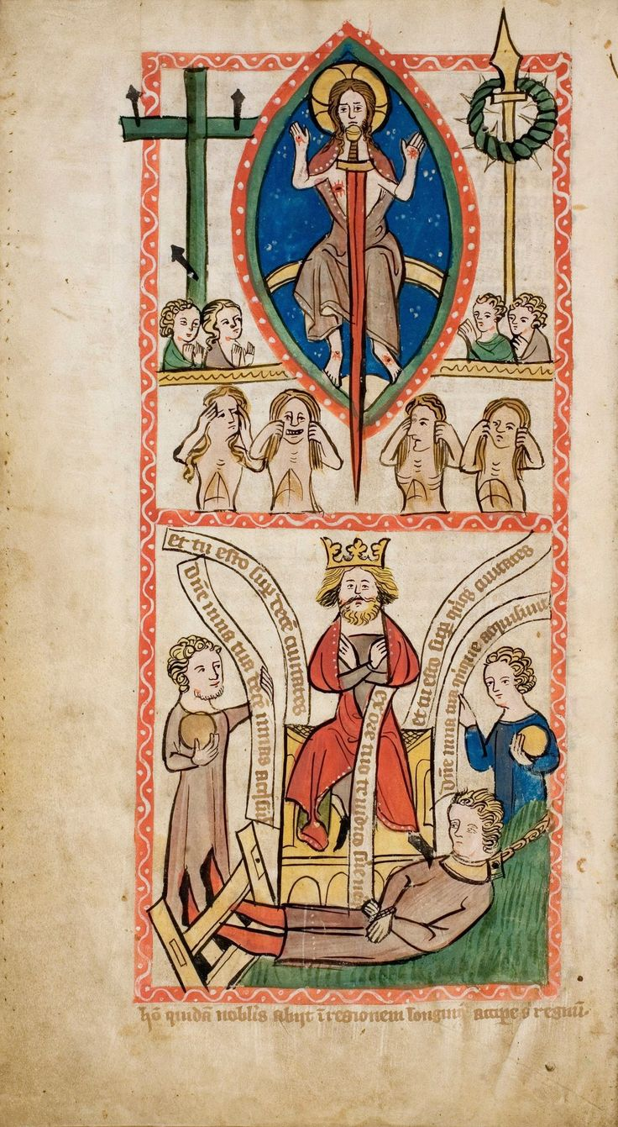
Parable of the Talents, Speculum Humanae Salvationis, c. 1360 Artist Unidentified, Universitäts- und Landesbibliothek Darmstadt Manuscript illumination, Darmstadt, Germany
MASS TIMES
Weekend Masses: YANCHEP: 6 p.m. Saturday Vigil, St James Anglican Church,
2 Lagoon Drive. GUILDERTON: 8 a.m. Sunday, Guilderton Community Hall, Wedge Street. LANCELIN: 9.45 a.m. Sunday, 33 Gingin Road, Lancelin.
Confessions: before Mass on request
Weekday Masses: Tuesday, Thursday, Friday 9 a.m. at the presbytery,
Wednesdays 3 p.m. at Bethanie Beachside Aged Care.
Priest: Fr Augustine Puthota, Presbytery: 3 Blaxland Avenue, Two Rocks, Western Australia 6037. Telephone: +61-8-9561 2172
Website: http://yanchepcatholic.org/ email: yanchepcatholic@gmail.com.
Page 4
Sunday Bulletin

We pray for the sick of our community, especially:
Pat Murphy, Ken and Toni Meek, Delores Servais, Michael Ford, Jim Walsh, Paula Cope, Pat Barone, Deanna Burge, Christina Even, Josephine del Bene and Len Sims.

Entrance Antiphon | Jer. 29:11,12,14.

The Lord said: I think thoughts of peace and not of affliction. You will call upon me, and I will answer you, and I will lead back your captives from every place.

We pray for all departed souls from this Pastoral area, and we ask them to pray for us.
Mary Crawford, Des Elliot, Barry Murphy, Jim and Marion Ferguson, Pat O’Prey, John Sheahan, Carmen Germann, Yvonne Wytenburg, Frank and Netje Walser, Ian Kinner, Dennis Galora, Tom Cox, Alice Greig, John Bird, Ray Knapp, Giuseppe Del Bene, Bruno Rogalski, Bill Fleming and Ronnie Spratling (died in Victoria, 29 October 2014).

Communion Antiphon | Psalm 73 (72):28
To be near God is my happiness, to place my hope in God the Lord.

Today with some sadness, we farewell Sophie Bird, who is moving to Launceston, Tasmania to join the rest of her family. Sophie and her brothers and sisters served our church in Yanchep over many years, as altar servers and helping with preparation for Mass. We wish her all of God’s blessings for the future and hope she is able to come back and visit one day!
First Reading ‡ Proverbs 31:10-13, 19-20, 30-31.
A perfect wife — who can find her?
She is far beyond the price of pearls.
Her husband’s heart has confidence in her,
from her he will derive no little profit.
Advantage and not hurt she brings him all the days of her life.

We also welcome nine new community members from East Timor. Thomas, Gil and the team are staying in Yanchep and working at Jason Neave’s vegetable and tomato farm in Carabooda for six months through the Pacific Nations Seasonal Workers Program. Bem-vindos! (Welcome!)

Archbishop Timothy Costelloe will celebrate a Mass in St Mary’s Cathedral to honour the dignity and wonder of human life on Saturday, 22 November at 10am, followed by a Festival of Life in the cathedral parish centre from 11.00am - 12.30pm. Please come along and give thanks for the gift of your life. Further info: 9444 5320 or respectlife@perthcatholic.org.au.

Young adults (18-35 year old) retreat weekend at Eagles’ Nest, Gidgegannup, 28 to 30 November. Phone Justin McGinnity on 0432 715 263 or email Natasha Oswald at natashaoswald1@gmail.com. Speakers include Catholics who have proven to be successful in business, academia and ministry.
She is always busy with wool and with flax,
she does her work with eager hands.
She sets her hands to the distaff,
her fingers grasp the spindle.
She holds out her hand to the poor,
Gospel Acclamation ‡ John 15:4, 5.
Alleluia, alleluia!
Live in me and let me live in you, says the Lord;
my branches bear much fruit.
Alleluia!
Gospel ‡ Matthew 25:14-30
Because you have been faithful over a few things, enter into the joy of the Lord.

Jesus spoke this parable to his disciples: ‘The kingdom of heaven is like a man on his way abroad who summoned his servants and entrusted his property to them. To one he gave five talents, to another two, to a third one; each in proportion to his ability. Then he set out.
The man who had received the five talents promptly went and traded with them and made five more. The man who had received two made two more in the same way. But the man who had received one went off and dug a hole in the ground and hid his master’s money.
Now a long time after, the master of those servants came back and went through his accounts with them. The man who had received the five talents came forward bringing five more. “Sir”, he said “you entrusted me with five talents; here are five more that I have made.”
His master said to him, “Well done, good and faithful servant; you have shown you can be faithful in small things, I will trust you with greater; come and join in your master’s happiness.” Next the man with the two talents came forward. “Sir,” he said “you entrusted me with two talents; here are two more that I have made.” His master said to him, “Well done, good and faithful servant; you have shown you can be faithful in small things, I will trust you with greater; come and join in your master’s happiness.” Last came forward the man who had the one talent. “Sir,” said he “I had heard you were a hard man, reaping where you have not sown and gathering where you have not scattered; so I was afraid, and I went off and hid your talent in the ground. Here it is; it was yours, you have it back.” But his master answered him, “You wicked and lazy servant! So you knew that I reap where I have not sown and gather where I have not scattered? Well then, you should have deposited my money with the bankers, and on my return I would have recovered my capital with interest. So now, take the talent from him and give it to the man who has the five talents. For to everyone who has will be given more, and he will have more than enough; but from the man who has not, even what he has will be taken away. As for this good-for-nothing servant, throw him out into the dark, where there will be weeping and grinding of teeth.”’

The Gospel of the Lord.
Praise to you, Lord Jesus Christ!
Page 2
Page 3
she opens her arms to the needy.
Charm is deceitful, and beauty empty;
the woman who is wise is the one to praise.
Give her a share in what her hands have worked for,
and let her works tell her praises at the city gates.

The word of the Lord.
Thanks be to God.

Responsorial Psalm ‡ Ps 127:1-5

R. Happy are those who fear the Lord.

O blessed are those who fear the Lord
and walk in his ways!
By the labour of your hands you shall eat.
You will be happy and prosper. R.

Your wife like a fruitful vine
in the heart of your house;
your children like shoots of the olive,
around your table. R.

Indeed thus shall be blessed
the man who fears the Lord.
May the Lord bless you from Zion
in a happy Jerusalem
all the days of your life. R.

Second Reading ‡ 1 Thessalonians 5:1-6
The day of the Lord is going to come like a thief in the night.

You will not be expecting us to write anything to you, brothers, about ‘times and seasons,’ since you know very well that the Day of the Lord is going to come like a thief in the night. It is when people are saying, ‘How quiet and peaceful it is,’ that the worst suddenly happens, as suddenly as labour pains come on a pregnant woman; and there will be no way for anybody to evade it.
But it is not as if you live in the dark, my brothers, for that Day to overtake you like a thief. No, you are all sons of light and sons of the day: we do not belong to the night or to darkness, so we should not go on sleeping, as everyone else does, but stay wide awake and sober.

The word of the Lord.
Thanks be to God.

