Dedication of St John Lateran 9 November
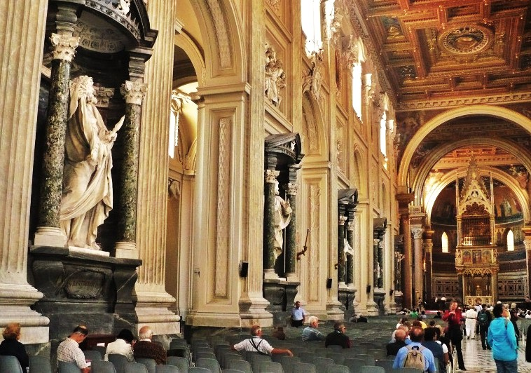
MASS TIMES
Weekend Masses: YANCHEP: 6 p.m. Saturday Vigil, St James Anglican Church,
2 Lagoon Drive. GUILDERTON: 8 a.m. Sunday, Guilderton Community Hall, Wedge Street. LANCELIN: 9.45 a.m. Sunday, 33 Gingin Road, Lancelin.
Confessions: before Mass on request
Weekday Masses: Tuesday, Thursday, Friday 9 a.m. at the presbytery,
Wednesdays 3 p.m. at Bethanie Beachside Aged Care.
Priest: Fr Augustine Puthota, Presbytery: 3 Blaxland Avenue, Two Rocks, Western Australia 6037. Telephone: +61-8-9561 2172
Website: http://yanchepcatholic.org/ email: yanchepcatholic@gmail.com.
Page 4
Sunday Bulletin

We pray for the sick of our community, especially:
Pat Murphy, Ken and Toni Meek, Delores Servais, Michael Ford, Jim Walsh, Paula Cope, Pat Barone, Deanna Burge, Christina Even, Josephine del Bene and Len Sims.

We pray for all departed souls from this Pastoral area, and we ask them to pray for us.
Mary Crawford, Des Elliot, Barry Murphy, Jim and Marion Ferguson, Pat O’Prey, John Sheahan, Carmen Germann, Yvonne Wytenburg, Frank and Netje Walser, Ian Kinner, Dennis Galora, Tom Cox, Alice Greig, John Bird, Ray Knapp, Giuseppe Del Bene, Bruno Rogalski, Bill Fleming and Ronnie Spratling (died in Victoria, 29 October 2014).
(Please email me if I have forgotten anyone.)

Communion Antiphon | Cf. 1 Peter 2:5
Be built up like living stones, into a spiritual house, a holy priesthood.

Archbasilica of St John Lateran (San Giovanni in Laterano), part of the nave with statues of the twelve apostles, in front of the baldacchino (canopy) over the altar containing the heads of Sts Peter and Paul. The papal cathedra is in the apse beyond.
(continued from previous page)
- who had fallen away from the faith during the persecution of Diocletian, could not be forgiven and go on to become priests dispensing valid sacraments.)
- The name Lateran comes from the land which was owned by the family of the Laterani in Imperial Rome.
But it’s only a building. Don’t we know that the people are the church?
Yes, Paul tells us in the second reading that we are God’s temple, God’s building. But Scripture is interpreted at several levels. Churches are also meant to be earthly models of heavenly realities, places where we can offer right praise to God. Jesus is also seen in the Gospel as cleansing the old temple, and becoming in his person the new temple, from which blood and water (Holy Eucharist and Baptism) flowed out. It is in the Church building that we receive these sacraments. It is in the church building that priests, acting in the person of Christ, offer the sacrifice that Jesus began at the Last Supper and ended on the cross (‘Do this in remembrance (anamnesis)of me.’) The church building has four functions: (a) It is the place of ‘right praise’, containing the sacred species within the tabernacle. (b) It symbolises the New Jerusalem described in Revelation 21. (c) The church building symbolises Noah’s Ark, protecting us from the chaos of sin and providing a place preserving a right relationship with God. (d) The church symbolises the mystical body of Jesus. It grafts us into Jesus during baptism, and feeds and nurtures us throughout our lives until we pass into a higher reality.

Entrance Antiphon | Cf. 1 Rev. 21:2
I saw the holy city, a new Jerusalem, coming down out of heaven from God, prepared like a bride adorned for her husband.

ICEL (2014-01-11T04:16:54+00:00). Roman Missal 3m (Kindle Location 21278). Fr Richard Healey. Kindle Edition.

First Reading ‡ Ezekiel 47:1-2, 8-9, 12
I see water flowing from the temple and all who were touched by it were saved.
The angel brought me to the entrance of the Temple, where a stream came out from under the Temple threshold and flowed eastwards, since the Temple faced east. The water flowed from under the right side of the Temple, south of the altar. He took me out by the north gate and led me right round outside as far as the outer east gate where the water flowed out on the right-hand side. He said, ‘This water flows east down to the Arabah and to the sea; and flowing into the sea it makes its waters wholesome.

Gospel Acclamation ‡ 2 Chronicles 7:16.
Alleluia, alleluia!
I have chosen and sanctified this house, says the Lord,
that my name may remain in it for all time.
Alleluia!
Gospel ‡ John 2:13-22.
He spoke about the temple of his own body.

Just before the Jewish Passover Jesus went up to Jerusalem, and in the Temple he found people selling cattle and sheep and pigeons, and the money changers sitting at their counters there. Making a whip out of some cord, he drove them all out of the Temple, cattle and sheep as well, scattered the money changers’ coins, knocked their tables over and said to the pigeon-sellers, ‘Take all this out of here and stop turning my Father’s house into a market’. Then his disciples remembered the words of scripture: Zeal for your house will devour me. The Jews intervened and said, ‘What sign can you show us to justify what you have done?’ Jesus answered, ‘Destroy this sanctuary, and in three days I will raise it up’. The Jews replied, ‘It has taken forty-six years to build this sanctuary: are you going to raise it up in three days?’ But he was speaking of the sanctuary that was his body, and when Jesus rose from the dead, his disciples remembered that he had said this, and they believed the scripture and the words he had said.

The Gospel of the Lord.
Praise to you, Lord Jesus Christ!
Page 2
Page 3
Wherever the river flows, all living creatures teeming in it will live.
Fish will be very plentiful, for wherever the water goes it brings health, and life teems wherever the river flows. Along the river, on either bank, will grow every kind of fruit tree with leaves that never wither and fruit that never fails; they will bear new fruit every month, because this water comes from the sanctuary. And their fruit will be good to eat and the leaves medicinal.’

The word of the Lord.
Thanks be to God.

Responsorial Psalm ‡ Ps 45:2-3, 5-6, 8-9

R. The waters of the river gladden the city of God.

God is for us a refuge and strength,
a helper close at hand, in time of distress:
so we shall not fear though the earth should rock,
though the mountains fall into the depths of the sea. R.

The waters of a river give joy to God’s city,
the holy place where the Most High dwells.
God is within, it cannot be shaken;
God will help it at the dawning of the day. R.

The Lord of hosts is with us:
the God of Jacob is our stronghold.
Come, consider the works of the Lord,
the redoubtable deeds he has done on the earth. R.

Second Reading ‡ 1 Corinthians 3:9-11, 16-17.
You are the temple of God.

You are God’s building. By the grace God gave me, I succeeded as an architect and laid the foundations, on which someone else is doing the building. Everyone doing the building must work carefully. For the foundation, nobody can lay any other than the one which has already been laid, that is Jesus Christ.
Didn’t you realise that you were God’s temple and that the Spirit of God was living among you? If anybody should destroy the temple of God, God will destroy him, because the temple of God is sacred; and you are that temple.

The word of the Lord.
Thanks be to God.

Why is there a feast to honour the dedication of a church?
- St John Lateran is the oldest of all the Roman Basilicas.
- It is the mother church of all Catholics. The dedication plaque describes the church as: Omnium urbis et orbis ecclesiarum mater, et caput or, “of all the churches of the city and the world, the mother and head”.
- Enclosed inside the stone and marble altar, is an ancient wooden altar which tradition says is the altar used by St Peter when he was leader of the Church in Rome. It was brought by Constantine and Sylvester from the church of Santa Pudenziana which was built in 140-155 A.D. during the pontificate of the 10th pope, Pius I. Santa Pudenziana is the oldest place of Christian worship in Rome, and was the residence of the Pope prior to the move to the Lateran.
- Inside the canopy above the altar are reliquaries containing the heads of the Apostles Peter and Paul. Paul was beheaded in the year 64-67.
- It was consecrated in 324 A.D. by the 33rd Pope, St Sylvester I.
- In the apse of the church is the cathedra of the bishop of Rome, that is the teaching chair of our spiritual father, the Pope.
- The land was donated by Constantine to the then bishop of Rome, the 32nd Pope Miltiades who presided over the Lateran Synod in 313, which declared Donatism to be a heresy. (The Donatists held that people (continued overleaf)

