30th Sunday in Ordinary Time Year A
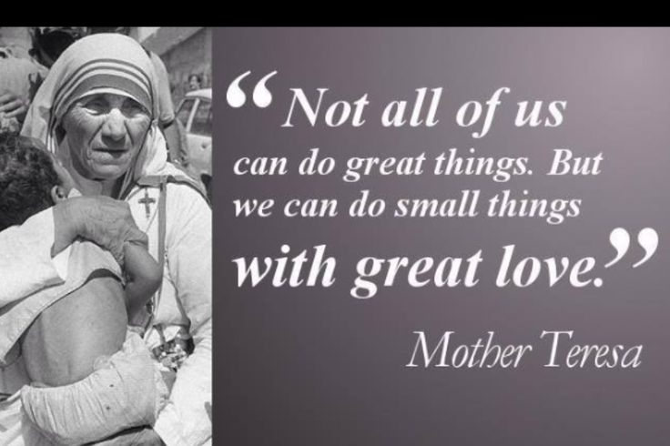
MASS TIMES
Weekend Masses: YANCHEP: 6 p.m. Saturday Vigil, St James Anglican Church,
2 Lagoon Drive. GUILDERTON: 8 a.m. Sunday, Guilderton Community Hall, Wedge Street. LANCELIN: 9.45 a.m. Sunday, 33 Gingin Road, Lancelin.
Confessions: before Mass on request
Weekday Masses: Tuesday, Thursday, Friday 9 a.m. at the presbytery,
Wednesdays 3 p.m. at Bethanie Beachside Aged Care.
Priest: Fr Augustine Puthota, Presbytery: 3 Blaxland Avenue, Two Rocks, Western Australia 6037. Telephone: +61-8-9561 2172
Website: http://yanchepcatholic.org/ email: yanchepcatholic@gmail.com.
Page 4
Sunday Bulletin

We pray for the sick of our community, especially:
Pat Murphy, Ken and Toni Meek, Delores Servais, Michael Ford, Jim Walsh, Paula Cope, Pat Barone, Deanna Burge, Christina Even, Josephine del Bene and Len Sims.

Communion Antiphon | Cf. Ps 20 (19): 6
We will ring out our joy at your saving help and exult in the name of our God.

ANNOUNCEMENTS:
On All Souls’ Day, Sunday 2 November, Fr Augustine will conduct the All Souls’ Liturgy at Pinnaroo Valley Memorial Park, Whitfords Avenue, Padbury between 2.30 and 3.30 p.m.
Australian Christian Lobby: Please pray for the ACL National Conference 2014 which occurs this weekend in Canberra. It is coming under attack. From the Director, Lyle Shelton, “I’m grieved to be called a hater. It is not true. It is not true of ACL staff or our families. Yet post after post on the Hyatt Canberra’s Facebook page on Tuesday was filled with bitter bile and obscenity directed at ACL. Pearl clutching, haters, bigots, faeces, racist, and cult were just some of the vile insults urging the Hyatt to cancel our booking to hold our National Conference there this weekend. We have a view about marriage that is the same as a strong majority of federal parliamentarians and yet it seems that this is what is causing the outpouring of hate against us on Facebook.
We are distressed about being likened to the Ku Klux Klan and neo Nazis. The overwhelming majority of posts, which included posts from some well-known same-sex marriage activists, were slurs and insults.

Entrance Antiphon | Cf. Ps 105 (104): 3-4
Let the hearts that seek the Lord rejoice; turn to the Lord and his strength; constantly seek his face.

First Reading ‡ Exodus 22:20-26
If you are harsh with the widow or the orphan, my anger will rage against you.

The Lord said to Moses, ‘Tell the sons of Israel this, “You must not molest the stranger or oppress him, for you lived as strangers in the land of Egypt. You must not be harsh with the widow, or with the orphan; if you are harsh with them, they will surely cry out to me, and be sure I shall hear their cry; my anger will flare and I shall kill you with the sword, your own wives will be widows, your own children orphans.
“If you lend money to any of my people, to any poor man among you, you must not play the usurer with him: you must not demand interest from him.
“If you take another’s cloak as a pledge, you must give it back to him before sunset. It is all the covering he has; it is the cloak he wraps his body in; what else would he sleep in? If he cries to me, I will listen, for I am full of pity.”’
The word of the Lord.
Thanks be to God.

(continued from previous page)
I will end with a quote from an unlikely source on this topic. It is taken from a modern British writer called Doughlas Coupland and the novel his called ‘Life after God’.
He writes: ‘Now here is my secret: I tell it to you with an openness of heart that I doubt I shall ever achieve again…My secret is that I need God – that I am sick and can no longer make it alone. I need God to help me give, because I am no longer capable of giving; to help me be kind, as I no longer seem capable of kindness; to help me love, as I seem beyond being able to love.’ There is no doubt that modern women and men are in need of God more than ever. There are a lot of people like Doughlas Coupland around.

Gospel ‡ Matthew 22:34-40
You shall love the Lord your God and your neighbour as yourself.

When the Pharisees heard that Jesus had silenced the Sadducees they got together and, to disconcert him, one of them put a question, ‘Master, which is the greatest commandment of the Law?’ Jesus said, ‘You must love the Lord your God with all your heart, with all your soul, and with all your mind. This is the greatest and the first commandment. The second resembles it: You must love your neighbour as yourself. On these two commandments hang the whole Law, and the Prophets also.’

The Gospel of the Lord.
Praise to you, Lord Jesus Christ!

Page 3
Page 2
Responsorial Psalm ‡ Ps 17:2-4, 47, 51.

R. I love you, Lord, my strength.

I love you. Lord, my strength,
my rock, my fortress, my saviour.
My God is the rock where I take refuge;
my shield, my mighty help, my stronghold.
The Lord is worthy of all praise:
when I call I am saved from my foes. R.

Long life to the Lord, my rock!
Praised be the God who saves me.
He has given great victories to his king
and shown his love for his anointed. R.

Second Reading ‡ 1 Thessalonians 1:5-10
You turned away from idols to serve God and await his Son.

You observed the sort of life we lived when we were with you, which was for your instruction, and you were led to become imitators of us, and of the Lord; and it was with the joy of the Holy Spirit that you took to the gospel, in spite of the great opposition all round you.
This has made you the great example to all believers in Macedonia and Achaia since it was from you that the word of the Lord started to spread — and not only throughout Macedonia and Achaia, for the news of your faith in God has spread everywhere. We do not need to tell other people about it: other people tell us how we started the work among you, how you broke with idolatry when you were converted to God and became servants of the real, living God; and how you are now waiting for Jesus, his Son, whom he raised from the dead, to come from heaven to save us from the retribution which is coming.
The word of the Lord.
Thanks be to God.

Gospel Acclamation ‡ John 14:23.
Alleluia, alleluia!
All who love me will keep my words,
and my Father will love them and we will come to them.
Alleluia!

Commentary on today’s readings by the Discalced Carmelite Friars of Infant Jesus Parish, Morley. (http://www.infantjesusparish.org.au/?p=1575)

Let’s look briefly at the significance of God`s word addressed to us today – and it’s certainly from a bygone age. Here in the Old or First Testament – the Book of Exodus completed approx. 3,000 years ago - you find a marvellous sense of human solidarity. ‘Welcome the stranger and look after the powerless.’ Why? Well the question again is why would you exploit your brother of sister, the text asks. Even if you have a cloak as a surety give it back to the person in the evening – in those days a cloak was part of mobile sleeping arrangements. What we have here is simply the sacred writer in the tradition of Moses interpreting the mind of that great love which is at the heart of the world and which we call God.

Now move on another thousand years from that moment and two thousand years looking back! Matthew presents us with Jesus as the new Moses communicating God’s love for the world afresh. When Jesus Christ spoke the Father’s word on earth as we heard in the Gospel scene today – he was quizzed by one of the Pharisees on what people’s priorities should be. And Jesus said ‘You must love the Lord your God with all your heart and with all your mind. This is the first, the second resembles you must love your neighbour as yourself.’

This is why if a Moslem or anyone else says they are honouring God by killing or injuring their brother or sister, their religion is false – or at least their individual interpretation of it. The way we access this God of love is by turning towards prayer of the heart. For St. Teresa of Avila, prayer is the way into relationship with God and it is also a crucial ingredient in our love for others. People with a deep interior life are deeply sensitive to the needs of those around them.

Love of God overflows into love of neighbour – think of Mother Teresa, Mary MacKillop or Padre Pio.
(continued over page)

