28th Sunday in Ordinary Time Year A
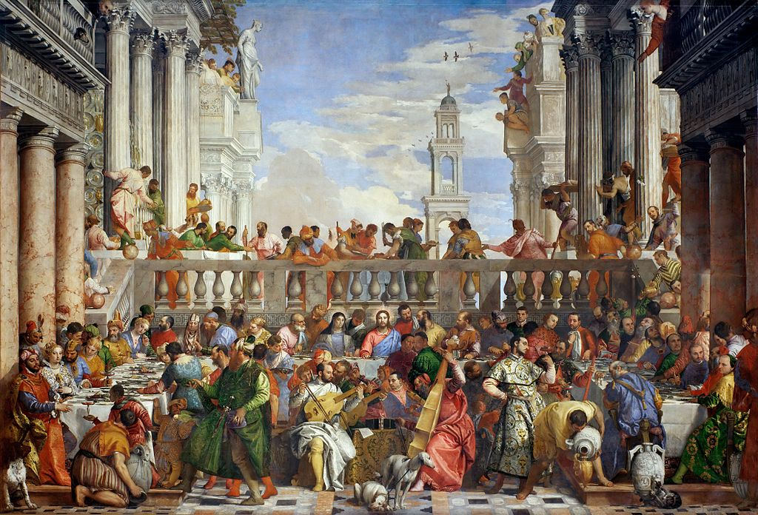
MASS TIMES
Weekend Masses: YANCHEP: 6 p.m. Saturday Vigil, St James Anglican Church,
2 Lagoon Drive. GUILDERTON: 8 a.m. Sunday, Guilderton Community Hall, Wedge Street. LANCELIN: 9.45 a.m. Sunday, 33 Gingin Road, Lancelin.
Confessions: before Mass on request
Weekday Masses: Tuesday, Thursday, Friday 9 a.m. at the presbytery,
Wednesdays 3 p.m. at Bethanie Beachside Aged Care.
Priest: Fr Augustine Puthota, Presbytery: 3 Blaxland Avenue, Two Rocks, Western Australia 6037. Telephone: +61-8-9561 2172
Website: http://yanchepcatholic.org/ email: yanchepcatholic@gmail.com.
Page 4
Sunday Bulletin

We pray for the sick of our community, especially:
Pat Murphy, Ken and Toni Meek, Delores Servais, Michael Ford, Jim Walsh, Paula Cope, Pat Barone, Deanna Burge, Christina Even and Jenny McGuire.

Meditation by Don Schwager What can a royal wedding party tell us about God's kingdom? One of the most beautiful images of heaven in the scriptures is the banquet and wedding celebration given by the King for his son. We, in fact, have been invited to the most important banquet of all! The last book in the bible ends with an invitation to the wedding feast of the Lamb and his Bride, the church: The Spirit and the Bride say, Come! (Rev. 22:17). Why does Jesus' parable seem to focus on an angry king who ends up punishing those who refused his invitation and who mistreated his servants? Jesus' parable contains two stories. The first has to do with the original guests invited to the feast. The king had sent out invitations well in advance to his subjects, so they would have plenty of time to prepare for coming to the feast. How insulting for the invited guests to then refuse when the time for celebrating came! They made light of the King's request because they put their own interests above his. They not only insulted the King but the heir to the throne as well. The king's anger is justified because they openly refused to give the king the honor he was due. Jesus directed this warning to the Jews of his day, both to convey how much God wanted them to share in the joy of his kingdom, but also to give a warning about the consequences of refusing his Son, their Messiah and Savior. The second part of the story focuses on those who had no claim on the king and who would never have considered getting such an invitation. The "good and the bad" along the highways certainly referred to the Gentiles and to sinners. This is certainly an invitation of grace -- undeserved, unmerited favor and kindness! But this invitation also contains a warning for those who refuse it or who approach the wedding feast unworthily. Grace is a free gift, but it is also an awesome responsibility. Dieterich Bonhoeffer contrasts "cheap grace" and "costly grace". "Cheap grace is the grace we bestow on ourselves ..the preaching of forgiveness without requiring repentance ..grace without discipleship, grace without the cross, grace without Jesus Christ, living and incarnate. ..Costly grace is the gospel which must be sought again and again, the gift which must be asked for, the door at which a man must knock. Such grace is costly because it calls us to follow Jesus Christ. It is costly because it costs a man his life, and it is grace because it gives a man the only true life." God invites each of us to his banquet that we may share in his joy. Are you ready to feast at the Lord's banquet table?

Entrance Antiphon | Ps 130 (129): 3-4
If you, O Lord, should mark iniquities, Lord, who could stand? But with you is found forgiveness, O God of Israel.
The Wedding Feast at Cana, Paolo Veronese (1563), Oil on Canvas, Louvre, Paris.

First Reading ‡ Isaiah 25: 6-10
The Lord will prepare a feast and will wipe away the tears from every cheek.

On this mountain,
the Lord of hosts will prepare for all peoples
a banquet of rich food, a banquet of fine wines,
of food rich and juicy, of fine strained wines.
On this mountain he will remove
the mourning veil covering all peoples,
and the shroud enwrapping all nations,
he will destroy Death for ever.

empty stomach, poverty or plenty. There is nothing I cannot master with the help of the One who gives me strength. All the same, it was good of you to share with me in my hardships. In return my God will fulfil all your needs, in Christ Jesus, as lavishly as only God can. Glory to God, our Father, for ever and ever. Amen.

The word of the Lord.
Thanks be to God

Gospel Acclamation ‡ Cf. Ephesians 1: 17, 18.
Alleluia, alleluia!
May the Father of our Lord Jesus Christ enlighten the eyes of our heart that we might see how great is the hope to which we are called.
Alleluia!

Gospel ‡ Matthew 22:1-14
Whomsoever you find invite to the wedding.
Jesus said to the chief priests and elders of the people: ‘The kingdom of heaven may be compared to a king who gave a feast for his son’s wedding. He sent his servants to call those who had been invited, but they would not come. Next he sent some more servants.
“Tell those who have been invited,” he said, “that I have my banquet all prepared, my oxen and fattened cattle have been slaughtered, everything is ready. Come to the wedding.” But they were not interested: one went off to his farm, another to his business, and the rest seized his servants, maltreated them and killed them. The king was furious. He dispatched his troops, destroyed those murderers and burnt their town. Then he said to his servants, “The wedding is ready; but as those who were invited proved to be unworthy, go to the crossroads in the town and invite everyone you can find to the wedding.” So these servants went out on to the roads and collected together everyone they could find, bad and good alike; and the wedding hall was filled with guests.
When the king came in to look at the guests he noticed one man who was not wearing a wedding garment, and said to him, “How did you get in here, my friend, without a wedding garment?” And the man was silent. Then the king said to the attendants, “Bind him hand and foot and throw him out into the dark, where there will be weeping and grinding of teeth.” For many are called, but few are chosen.’

The Gospel of the Lord.
Praise to you, Lord Jesus Christ!

Page 3
Page 2
The Lord will wipe away the tears from every cheek;
he will take away his people’s shame everywhere on earth,
for the Lord has said so.
That day, it will be said:
See, this is our God in whom we hoped for salvation;
the Lord is the one in whom we hoped.
We exult and we rejoice that he has saved us;
for the hand of the Lord rests on this mountain.

The word of the Lord.
Thanks be to God

Responsorial Psalm ‡ Ps 22.

R. I shall live in the house of the Lord all the days of my life.

The Lord is my shepherd;
there is nothing I shall want.
Fresh and green are the pastures
where he gives me repose.
Near restful waters he leads me,
to revive my drooping spirit. R.

He guides me along the right path;
he is true to his name,
If I should walk in the valley of darkness
no evil would I fear.
You are there with your crook and your staff;
with these you give me comfort. R.

You have prepared a banquet for me
in the sight of my foes.
My head you have anointed with oil;
my cup is overflowing. R.

Surely goodness and kindness
shall follow me all the days of my life.
In the Lord’s own house shall I dwell
for ever and ever. R.

Second Reading ‡ Phillipians 4:12-14, 19-20
I am able to do all things in him who strengthens me.
I know how to be poor and I know how to be rich too. I have been through my initiation and now I am ready for anything anywhere; full stomach or empty

Communion Antiphon | Cf. Psalm 34 (33): 11
The rich suffer want and go hungry, but those who seek the Lord lack no blessing.

