27th Sunday in Ordinary Time Year A
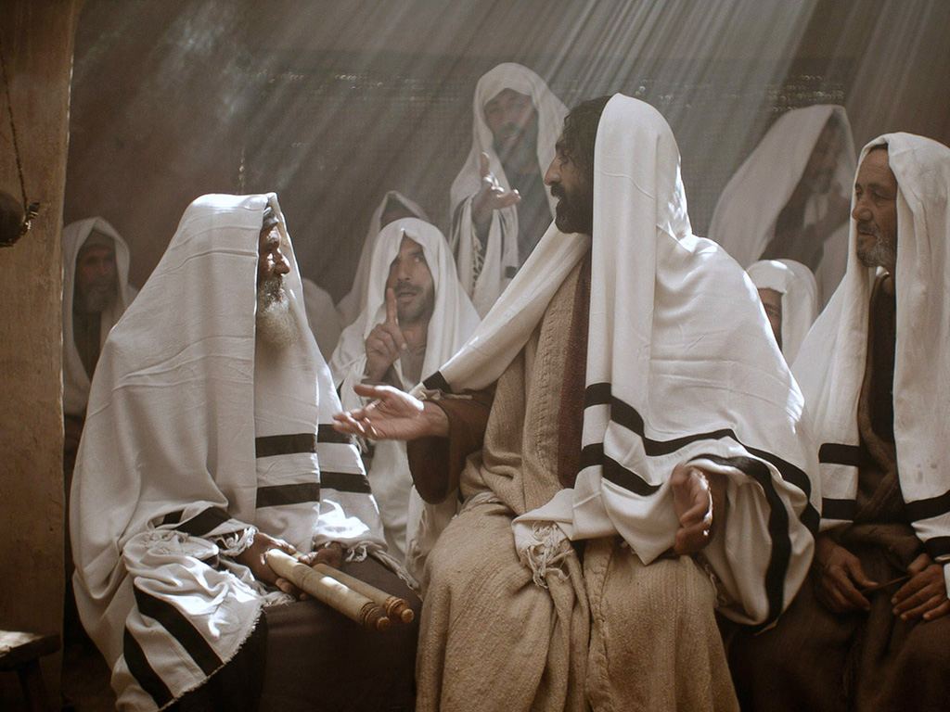
MASS TIMES
Weekend Masses: YANCHEP: 6 p.m. Saturday Vigil, St James Anglican Church,
2 Lagoon Drive. GUILDERTON: 8 a.m. Sunday, Guilderton Community Hall, Wedge Street. LANCELIN: 9.45 a.m. Sunday, 33 Gingin Road, Lancelin.
Confessions: before Mass on request
Weekday Masses: Tuesday, Thursday, Friday 9 a.m. at the presbytery,
Wednesdays 3 p.m. at Bethanie Beachside Aged Care.
Priest: Fr Augustine Puthota, Presbytery: 3 Blaxland Avenue, Two Rocks, Western Australia 6037. Telephone: +61-8-9561 2172
Website: http://yanchepcatholic.org/ email: yanchepcatholic@gmail.com.
Welcome and thank you to Fr Thomas Zureich and Fr Roy Pereira who are filling in for Fr Augustine while he is away in Melbourne.
Page 4
Sunday Bulletin

We pray for the sick of our community, especially:
Pat Murphy, Ken and Toni Meek, Delores Servais, Michael Ford, Jim Walsh, Paula Cope, Pat Barone, Deanna Burge, Christina Even and Jenny McGuire.

Communion Antiphon | Cf. 1 Cor. 10:17
Though many, we are one bread, one body, for we all partake of the one Bread and one Chalice.

Homily by Fr John Speekman, Howlong Parish, Diocese of Wagga Wagga
A vineyard wakes to new life in Spring. Tiny buds appear on the bare branches and before long the whole vineyard is a blaze of delicate green soaking up sunlight and air. Deep in the soil the roots drink in the rain and search for the minerals needed to form the rich fruit of the harvest. The vineyard belongs to the Master. It is to his glory that it yields a bountiful harvest. You are the vineyard. Yes, you! And me!
One day the Master will send his servants, the angels, to gather in the produce of the vineyard. That will be a day of intense joy for some and a day of shame for others.
Yes, we are the Master's vineyard. And the vine he wishes to grow in us is Christ, his Son. This is the harvest he desires to find in us on that day. To put it simply we must 'bear' Christ in ourselves; Jesus must become himself in us so that all may become one in him. What a wonderful thought!
Through Baptism Jesus was 'planted' in us. Through the other Sacraments (Confirmation, Eucharist, Holy Orders, Matrimony, Anointing of the Sick) his life, his presence, is strengthened in us. Through Reconciliation we are restored to this life should it be weakened or destroyed by sin. The Master has thought of everything and he looks forward to the harvest.
Still there is more we can do: prayer, penance, almsgiving, fasting, spiritual reading, service of neighbour, evangelisation of our culture. The tenant's work is never done.
In the time remaining I wish to be very practical and offer you an implement, a 'gardening tool', for your work in the vineyard. It is a Bible. Not so long ago Pope Benedict said '…I would like in particular to recall and recommend the ancient tradition of "Lectio divina": "the diligent reading of Sacred Scripture accompanied by prayer …" If it is effectively promoted, this practice will bring to the Church -- I am convinced of it -- a new spiritual springtime.'
Read more at http://homiliesfromaustralia.blogspot.com.au/2011/09/27th-sunday-in-ordinary-time-year.html.

Jesus rejected by the Scribes and Pharisees, downloaded from www.freebibleimages.org.
Entrance Antiphon | Cf. Est. 4:17
Within your will, O Lord, all things are established, and there is none that can resist your will. For you have made all things, the heaven and the earth, and all that is held within the circle of heaven; you are the Lord of all.

ICEL (2014-01-11T04:16:54+00:00). Roman Missal 3m (Kindle Locations 10415-10417). Fr Richard Healey. Kindle Edition.

First Reading ‡ Isaiah 5:1-7
The vineyard of the Lord God of Hosts is the house of Israel.
Let me sing to my friend the song of his love for his vineyard.
My friend has a vineyard on a fertile hillside.
He dug the soil, cleared it of stones,
and planted choice vines in it.
In the middle he built a tower,
he dug a press there too.
He expected it to yield grapes,
but sour grapes were all that it gave.

Second Reading ‡ Phillipians 4:6-9.
Do these things and the God of peace will be with you.
There is no need to worry; but if there is anything you need, pray for it, asking God for it with prayer and thanksgiving, and that peace of God, which is so much greater than we can understand, will guard your hearts and your thoughts, in Christ Jesus. Finally, brothers, fill your minds with everything that is true, everything that is noble, everything that is good and pure, everything that we love and honour, and everything that can be thought virtuous or worthy of praise. Keep doing all the things that you learnt from me and have been taught by me and have heard or seen that I do. Then the God of peace will be with you.

The word of the Lord.
Thanks be to God

Gospel Acclamation ‡ Cf. John 15:15
Alleluia, alleluia!
I call you friends, says the Lord,
because I have made known to you everything I have learnt from my Father.
Alleluia!

Gospel ‡ Matthew 21: 33-43
He leased his vineyard to other farmers.
Jesus said to the chief priests and the elders of the people: ‘Listen to another parable. There was a man, a landowner, who planted a vineyard; he fenced it round, dug a winepress in it and built a tower; then he leased it to tenants and went abroad. When vintage time drew near he sent his servants to the tenants to collect his produce. But the tenants seized his servants, thrashed one, killed another and stoned a third. Next he sent some more servants, this time a larger number, and they dealt with them in the same way. Finally he sent his son to them. “They will respect my son,” he said. But when the tenants saw the son, they said to each other, “This is the heir.
Come on, let us kill him and take over his inheritance.” So they seized him and threw him out of the vineyard and killed him. Now when the owner of the vineyard comes, what will he do to those tenants?’ They answered, ‘He will bring those wretches to a wretched end and lease the vineyard to other tenants who will deliver the produce to him when the season arrives.’ Jesus said to them, ‘Have you never read in the scriptures:
It was the stone rejected by the builders
that became the keystone.
This was the Lord’s doing and it is wonderful to see?
‘I tell you, then, that the kingdom of God will be taken from you and given to a people who will produce its fruit.’

The Gospel of the Lord.
Praise to you, Lord Jesus Christ!

Page 3
Page 2
And now, inhabitants of Jerusalem and men of Judah,
I ask you to judge between my vineyard and me.
What could I have done for my vineyard that I have not done?
I expected it to yield grapes.
Why did it yield sour grapes instead?
Very well, I will tell you what I am going to do to my vineyard:
I will take away its hedge for it to be grazed on,
and knock down its wall for it to be trampled on.
I will lay it waste, unpruned, undug;
overgrown by the briar and the thorn.
I will command the clouds to rain no rain on it.
Yes, the vineyard of the Lord of hosts is the House of Israel,
and the men of Judah that chosen plant.
He expected justice, but found bloodshed,
integrity, but only a cry of distress.
The word of the Lord.
Thanks be to God

Responsorial Psalm ‡ Ps 79:9, 12-16, 19-20. R. v. 6

R. The vineyard of the Lord is the house of Israel.

You brought a vine out of Egypt;
to plant it you drove out the nations.
It stretched out its branches to the sea,
to the Great River it stretched out its shoots. R.

Then why have you broken down its walls?
It is plucked by all who pass by.
It is ravaged by the boar of the forest,
devoured by the beasts of the field. R.

God of hosts, turn again, we implore,
look down from heaven and see.
Visit this vine and protect it,
the vine your right hand has planted. R.

And we shall never forsake you again:
give us life that we may call upon your name.
God of hosts, bring us back;
let your face shine on us and we shall be saved. R.

