The Exaltation of the Cross Year A
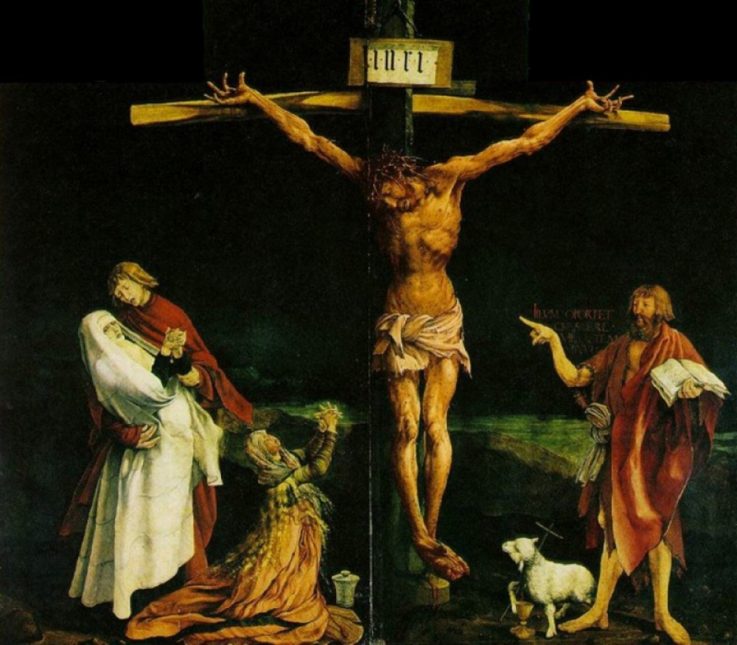
MASS TIMES
Weekend Masses: YANCHEP: 6 p.m. Saturday Vigil, St James Anglican Church,
2 Lagoon Drive. GUILDERTON: 8 a.m. Sunday, Guilderton Community Hall, Wedge Street. LANCELIN: 9.45 a.m. Sunday, 33 Gingin Road, Lancelin.
Confessions: before Mass on request
Weekday Masses: Tuesday, Thursday, Friday 9 a.m. at the presbytery,
Wednesdays 3 p.m. at Bethanie Beachside Aged Care.
Priest: Fr Augustine Puthota, Presbytery: 3 Blaxland Avenue, Two Rocks, Western Australia 6037. Telephone: +61-8-9561 2172
Website: http://yanchepcatholic.org/ email: yanchepcatholic@gmail.com.
Sunday Bulletin

We pray for the sick of our community, especially:
Pat Murphy, Ken and Toni Meek, Delores Servais, Michael Ford, Jim Walsh, Paula Cope, Pat Barone, Joy Jackson, Anita Pitcher, Deanna Burge and Christina Even.

Communion Antiphon | John 12:32
When I am lifted up from the earth, I will draw everyone to myself, says the Lord.

Commentary by Fr Robert Barron, Catholicism: A Journey to the Heart of the Faith (2011)
"But what did Jesus love on the cross? He loved the will of his Father. His Father had sent him, as we saw, into the farthest reaches of godforsakenness in order to bring the divine love even to that darkest place, and Jesus loved that mission to the very end. And it was precisely his detachment from the four great temptations that enabled him to walk that walk. What he loved and what he despised were in a strange balance on the cross. Poor in spirit, meek, mourning, and persecuted, he was able to be pure of heart, to seek righteousness utterly, to become the ultimate peacemaker, and to be the perfect conduit of the divine mercy to the world. Though it is supremely paradoxical to say so, the crucified Jesus is the man of beatitude, a truly happy man. And if we recall our discussion of freedom, we can say that Jesus nailed to the cross is the very icon of liberty, for he is free from those attachments that would prevent him from attaining the true good, which is doing the will of the Father.
One of the most brutally realistic and spiritually powerful depictions of the crucifixion is the central panel of the Isenheim Altarpiece painted in the late fifteenth century by the German artist Matthias Grunewald. Jesus's body is covered with sores and wounds, his head is surrounded by a particularly brutal crown of thorns, his hands and feet are pierced, not with tiny nails, but with enormous spikes, and, perhaps most terribly, his mouth is agape in wordless agony. The viewer is spared none of the horror of this most horrible of deaths. To the right of the figure of Jesus, Grunewald has painted, in an eloquent anachronism, John the Baptist, the herald and forerunner of the Messiah. John is indicating Jesus as the Lamb of God, but he does so in the most pecular way. Instead of pointing directly at the Lord, John's arm and hand are oddly twisted, as though he had to contort himself in order to perform this task. One wonders whether Grunewald was suggesting that our distorted expectations of what constitutes a joyful and free life have to be twisted out of shape (and hence back into proper shape) in order for us to grasp the strange truth revealed in the crucified Christ."

The Isenheim Altarpiece, Matthias Grunewald, 1512-1516, Unterlinden Museum, Colmar, Alsace, France.
Entrance Antiphon | Cf. Ga 6:14
We should glory in the Cross of our Lord Jesus Christ,
in whom is our salvation, life and resurrection,
through whom we are saved and delivered.

First Reading ‡ Numbers 21:4-9
When those that were afflicted looked upon it, they were healed.
On the way through the wilderness the people lost patience. They spoke
against God and against Moses, ‘Why did you bring us out of Egypt to die in
this wilderness? For there is neither bread nor water here; we are sick of this
unsatisfying food.’
to assume the condition of a slave,
and became as men are;
and being as all men are,
he was humbler yet,
even to accepting death,
death on a cross.
But God raised him high
and gave him the name
which is above all other names
so that all beings
in the heavens, on earth and in the underworld,
should bend the knee at the name of Jesus
and that every tongue should acclaim
Jesus Christ as Lord,
to the glory of the Father.
The word of the Lord.
Thanks be to God.

Gospel Acclamation
Alleluia, alleluia!
We adore you, O Christ, and we praise you,
because by your cross you have redeemed the world.
Alleluia!

Gospel ‡ John 3:13-17
The Son of Man must be lifted up.
Jesus said to Nicodemus:
‘No one has gone up to heaven
except the one who came down from heaven,
the Son of Man who is in heaven;
and the Son of Man must be lifted up
as Moses lifted up the serpent in the desert,
so that everyone who believes may have eternal life in him.
Yes, God loved the world so much
that he gave his only Son,
so that everyone who believes in him may not be lost
but may have eternal life.
For God sent his Son into the world
not to condemn the world,
but so that through him the world might be saved.’

The Gospel of the Lord.
Praise to you, Lord Jesus Christ!

At this God sent fiery serpents among the people; their bite brought death to
many in Israel. The people came and said to Moses, ‘We have sinned by
speaking against the Lord and against you. Intercede for us with the Lord to
save us from these serpents.’ Moses interceded for the people, and the Lord
answered him, ‘Make a fiery serpent and put it on a standard. If anyone is
bitten and looks at it, he shall live.’ So Moses fashioned a bronze serpent
which he put on a standard, and if anyone was bitten by a serpent, he looked
at the bronze serpent and lived.

The word of the Lord.
Thanks be to God.

Responsorial Psalm ‡ Ps 77:1-2, 34-38

R. Do not forget the works of the Lord.

Give heed, my people, to my teaching;
turn your ear to the words of my mouth.
I will open my mouth in a parable
and reveal hidden lessons of the past. R.

When he slew them then they would seek him,
return and seek him in earnest.
They would remember that God was their rock,
God the Most High their redeemer. R.

But the words they spoke were mere flattery;
they lied to him with their lips.
For their hearts were not truly with him;
they were not faithful to his covenant. R.

Yet he who is full of compassion
forgave their sin and spared them.
So often he held back his anger
when he might have stirred up his rage. R.

Second Reading ‡ Phillipians 2:6-11
He humbled himself, therefore God has exalted him.

The state of Jesus was divine,
yet he did not cling
to his equality with God
but emptied himself

