26th Sunday in Ordinary Time Year A
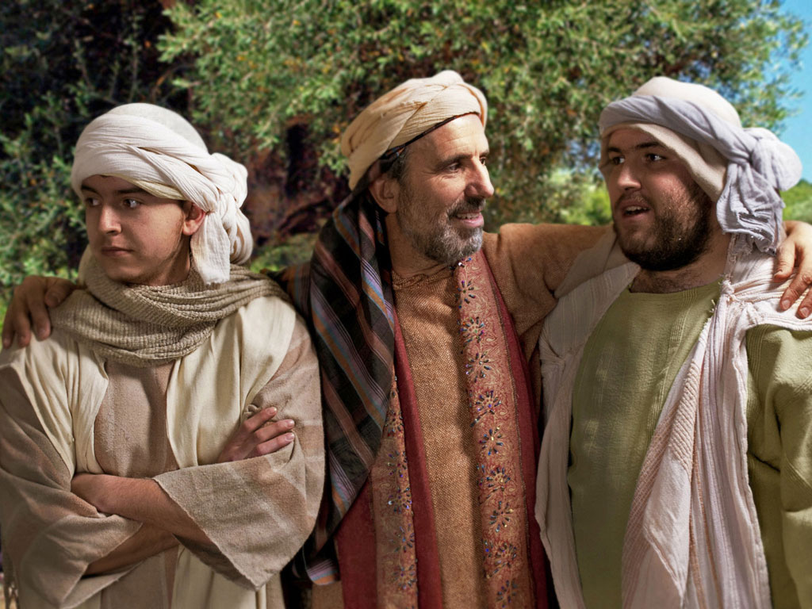
Page 4
MASS TIMES
Weekend Masses: YANCHEP: 6 p.m. Saturday Vigil, St James Anglican Church,
2 Lagoon Drive. GUILDERTON: 8 a.m. Sunday, Guilderton Community Hall, Wedge Street. LANCELIN: 9.45 a.m. Sunday, 33 Gingin Road, Lancelin.
Confessions: before Mass on request
Weekday Masses: Tuesday, Thursday, Friday 9 a.m. at the presbytery,
Wednesdays 3 p.m. at Bethanie Beachside Aged Care.
Priest: Fr Augustine Puthota, Presbytery: 3 Blaxland Avenue, Two Rocks, Western Australia 6037. Telephone: +61-8-9561 2172
Website: http://yanchepcatholic.org/ email: yanchepcatholic@gmail.com.
Sunday Bulletin

We pray for the sick of our community, especially:
Pat Murphy, Ken and Toni Meek, Delores Servais, Michael Ford, Jim Walsh, Paula Cope, Pat Barone, Deanna Burge, Christina Even and Jenny McGuire.

Communion Antiphon | 1 John 3:16
By this we came to know the love of God: that Christ laid down his life for us;
so we ought to lay down our lives for one another.

(… continued) Jesus is making clear that those who turn from their sins will be welcomed into the Kingdom of God, yet those who begin on the path of obedience but turn away will be held accountable for their sins.
Salvation comes to those who believe through the empowerment of divine grace, a gift which actually brings about the obedience that God requires, in particular, full conformity to the cross of Christ.
However, this gift is profoundly counter-cultural, for it is not granted on the basis of worth but on the basis of need. In this gift, sinners are transformed and empowered to walk in the way of the Lord and are able to do the “graced works” requisite to enter into the life of the world to come. In the end, we return to the question: is God just? In these four passages put forward by the Church for the Twenty-Sixth Sunday in Ordinary Time, the answer is yes, but in a way that is inseparable from his mercy. In being faithful to his promises, God offers humanity the ability to be just through his mercy, for through his empowering grace, both Jews and Gentiles are offered both the forgiveness and transformation they need to enter the Kingdom of God. However, while it is true that grace is unconditioned, it is not thereby unconditional, nor is it for those who fail to receive the gift by denying their need for salvation. Instead, grace is for all those who stand in need of the salvation-creating power of God, and in accepting this grace are transformed to be made like Jesus. In coming to offer God our worship this Sunday, we might ask ourselves: do we come as those who stand in need of his transforming power available through sharing in the body and blood of Christ (I Cor 10:16-17), or do we simply assume that we are righteous on our own? The Church calls us this Sunday to be truthful about ourselves, knowing that God is faithful to his promises to demonstrate his merciful justice in our lives and by means of his empowering grace, conform us to Christ crucified and lead us to a full participation in the Kingdom of God.

Entrance Antiphon | Dn 3: 31, 29, 30, 43, 42
All that you have done to us, O Lord, you have done with true judgment, for we have sinned against you and not obeyed your commandments. But give glory to your name and deal with us according to the bounty of your mercy.

ICEL (2014-01-11T04:16:54+00:00). Roman Missal 3m (Kindle Locations 10369-10371). Fr Richard Healey. Kindle Edition.
Parable of the Two Sons, downloaded from www.freebibleimages.org.

First Reading ‡ Ezekiel 18: 25-28
The sinner who decides to turn against sinfulness deserves to live.
The word of the Lord was addressed to me as follows: ‘You object, “What the Lord does is unjust.” Listen, you House of Israel: is what I do unjust? Is it not what you do that is unjust? When the upright man renounces his integrity to commit sin and dies because of this, he dies because of the evil that he himself has committed. When the sinner renounces sin to become law- abiding and honest, he deserves to live. He has chosen to renounce all his previous sins; he shall certainly live; he shall not die.’
The word of the Lord.
Thanks be to God

Page 3
Page 2
and that every tongue should acclaim Jesus Christ as Lord,
to the glory of God the Father.
The word of the Lord.
Thanks be to God

Gospel Acclamation ‡ John 10:27
Alleluia, alleluia!
My sheep listen to my voice, says the Lord;
I know them, and they follow me.
Alleluia!

Gospel ‡ Matthew 21: 28-32
He went out moved by regret. The tax collectors and prostitutes will precede you into the kingdom of God.
Jesus said to the chief priests and the elders of the people, ‘What is your opinion? A man had two sons. He went and said to the first, “My boy, you go and work in the vineyard today.” He answered, “I will not go”, but afterwards thought better of it and went. The man then went and said the same thing to the second who answered, “Certainly, sir”, but did not go.
Which of the two did the father’s will?’ ‘The first’ they said. Jesus said to them, ‘I tell you solemnly, tax collectors and prostitutes are making their way into the kingdom of God before you. For John came to you, a pattern of true righteousness, but you did not believe him, and yet the tax collectors and prostitutes did. Even after seeing that, you refused to think better of it and believe in him.’

The Gospel of the Lord.
Praise to you, Lord Jesus Christ!

Responsorial Psalm ‡ Ps 24: 4-9 R. v. 6

R. Remember your mercies, O Lord.

Lord, make me know your ways.
Lord, teach me your paths.
Make me walk in your truth, and teach me:
for you are God my saviour. R.

Remember your mercy, Lord,
and the love you have shown from of old.
Do not remember the sins of my youth.
In your love remember me,
because of your goodness, O Lord. R.

The Lord is good and upright.
He shows the path to those who stray,
he guides the humble in the right path;
he teaches his way to the poor. R.

Second Reading ‡ Phillipians 2:1-11.
In your minds you must be the same as Christ Jesus.

If our life in Christ means anything to you, if love can persuade at all, or the Spirit that we have in common, or any tenderness and sympathy, then be united in your convictions and united in your love, with a common purpose and a common mind. That is the one thing which would make me completely happy. There must be no competition among you, no conceit; but everybody is to be self- effacing. Always consider the other person to be better than yourself, so that nobody thinks of his own interests first but everybody thinks of other people’s interests instead. In your minds you must be the same as Christ Jesus:
His state was divine,
yet he did not cling to his equality with God
but emptied himself to assume the condition of a slave,
and became as men are;
and being as all men are,
he was humbler yet,
even to accepting death,
death on a cross.
But God raised him high and gave him the name
which is above all other names
so that all beings in the heavens,
on earth and in the underworld,
should bend the knee at the name of Jesus

The word of the Lord.
Thanks be to God.

Commentary on today’s Gospel by John Kincaid, Prof. Theology, John Paul the Great University, Escondido, California, abridged and downloaded from
http://www.thesacredpage.com/2014/09/the-faithfulness-of-god-where-justice.html#more
In this rather short parable, Jesus serves to explain the preceding question he asked regarding the nature of John the Baptist’s authority, for in Matt 21:25 Jesus asks whether John’s baptism was from heaven or from men. Here in Matt 21:28-32, Jesus expands on the rationale behind this question by differentiating two kinds of people and their relationship to the dawning kingdom of God.
The first group of people are the tax collectors and harlots represented by the first son, for at first they refuse to obey the will of God, yet at the preaching of John they turned and repented. As a result, Jesus is clear that this group will enter the Kingdom of God before the second group.
So who are the members of the second group? They appear to be the leaders of Israel who at first stated that they will obey the will of God, but have not been obedient to God in embracing the message of the Kingdom of God as announced by John.

