25th Sunday in Ordinary Time Year A
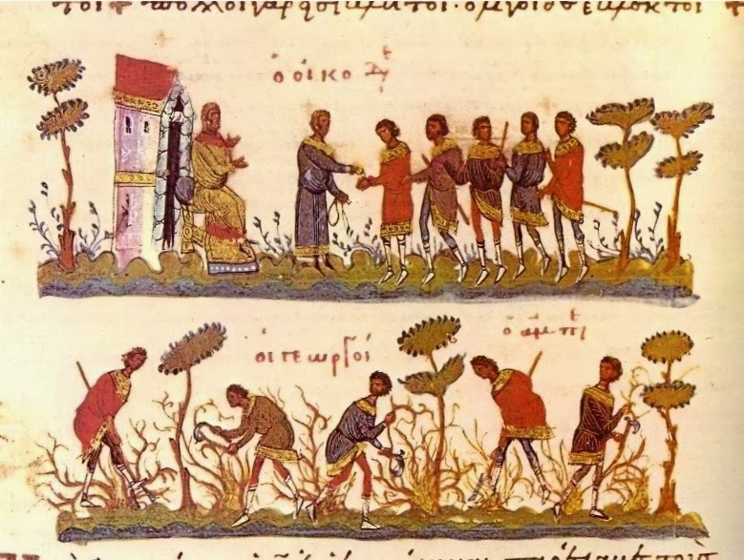
MASS TIMES
Weekend Masses: YANCHEP: 6 p.m. Saturday Vigil, St James Anglican Church,
2 Lagoon Drive. GUILDERTON: 8 a.m. Sunday, Guilderton Community Hall, Wedge Street. LANCELIN: 9.45 a.m. Sunday, 33 Gingin Road, Lancelin.
Confessions: before Mass on request
Weekday Masses: Tuesday, Thursday, Friday 9 a.m. at the presbytery,
Wednesdays 3 p.m. at Bethanie Beachside Aged Care.
Priest: Fr Augustine Puthota, Presbytery: 3 Blaxland Avenue, Two Rocks, Western Australia 6037. Telephone: +61-8-9561 2172
Website: http://yanchepcatholic.org/ email: yanchepcatholic@gmail.com.
THE PHOTOS FROM LAST WEEK HAVE BEEN UPLOADED TO OUR WEBSITE.
Sunday Bulletin

We pray for the sick of our community, especially:
Pat Murphy, Ken and Toni Meek, Delores Servais, Michael Ford, Jim Walsh, Paula Cope, Pat Barone, Joy Jackson, Anita Pitcher, Deanna Burge and Christina Even.

Communion Antiphon | Ps 118:4-5
You have laid down your precepts to be carefully kept;
may my ways be firm in keeping your statutes.

(… continued) Kingdom manifest as the Church, even if the only member of that body we ever are able to “help” or “cultivate” is our own self. The message of the parable then is clear: all who are called to work with the Lord to care for his Kingdom will receive the same reward: the “denarius” (“usual wage” in our Mass translation). The Fathers generally held that this “denarius” represents eternal life, the basic “pay” of all who heed the Master’s call to come into his vineyard. All workers will receive this reward equally. In other words, heaven is granted to everyone who is in Christ, but the more virtuous will derive greater pleasure from it. Who are the grumbling workers who bore the heat of the day and are dissatisfied with the pay? In one sense, they may represent any Christian who misconstrues the nature of the vineyard, the nature of the Lord, and the purpose for their labour. This first wave of workers has a legalistic conception of their relationship with the Lord. They bargained and agreed on a certain reward for a certain amount of work. The workers called later are working on trust. They have no contract with the Lord. The simply have faith that the Lord will indeed give them a salary that “is just.” They must believe that the Lord is a man of his word; they have faith in him. The first wave of workers also fail to see that it is a privilege to work in the vineyard, and take part in the labour of the Lord. Being in the vineyard means being close to the Lord of the vineyard; this in itself is a privilege. They should be glad that more workers have come (see Matt 9:37-38). Their joy should increase that others, even though lately come, can share the same joy they experience (see John 4:36; 1 John 1:3-4). In sum, the first wave of workers are persons who heed God’s call but just don’t understand God’s self-giving nature, and haven’t assimilate that nature within themselves. God’s thoughts (especially of mercy and grace) are far above their thoughts. If they really understood the nature of the Lord of the vineyard, they would have been overjoyed that so many could share in the same reward they themselves received. Let’s not be like them. Let’s rejoice that we have a gracious God overflowing in grace and mercy, and let’s imitate his character in our own lives.

Parable of the Labourers in the Vineyard, Greek Manuscript, downloaded from http://fatherdirector.blogspot.com.au/
Entrance Antiphon | Cf. Ga 6:14
I am the salvation of the people, says the Lord.
Should they cry to me in any distress,
I will hear them, and I will be their Lord for ever.

First Reading ‡ Isaiah 55:6-9
My thoughts are not your thoughts.
Seek the Lord while he is still to be found,
call to him while he is still near.
Let the wicked man abandon his way,
the evil man his thoughts.
Let him turn back to the Lord who will take pity on him,
to our God who is rich in forgiving;
for my thoughts are not your thoughts,
my ways not your ways — it is the Lord who speaks.

Gospel ‡ Matthew 20: 1-16
Why are you jealous because I am generous?

Jesus said to his disciples: ‘The kingdom of heaven is like a landowner going out at daybreak to hire workers for his vineyard. He made an agreement with the workers for one denarius a day, and sent them to his vineyard. Going out at about the third hour he saw others standing idle in the market place and said to them, “You go to my vineyard too and I will give you a fair wage.” So they went. At about the sixth hour and again at about the ninth hour, he went out and did the same. Then at about the eleventh hour he went out and found more men standing round, and he said to them, “Why have you been standing here idle all day?” “Because no one has hired us” they answered. He said to them, “You go into my vineyard too.”
In the evening, the owner of the vineyard said to his bailiff, “Call the workers and pay them their wages, starting with the last arrivals and ending with the first.” So those who were hired at about the eleventh hour came forward and received one denarius each. When the first came, they expected to get more, but they too received one denarius each. They took it, but grumbled at the landowner. “The men who came last” they said “have done only one hour, and you have treated them the same as us, though we have done a heavy day’s work in all the heat.” He answered one of them and said, “My friend, I am not being unjust to you; did we not agree on one denarius? Take your earnings and go. I choose to pay the last-comer as much as I pay you. Have I no right to do what I like with my own? Why be envious because I am generous?” Thus the last will be first, and the first, last.’
The Gospel of the Lord.
Praise to you, Lord Jesus Christ!

Yes, the heavens are as high above earth
as my ways are above your ways,
my thoughts above your thoughts.

The word of the Lord.
Thanks be to God.

Responsorial Psalm ‡ Ps 144:2-3, 8-9, 17-18. R. v.18

R. The Lord is near to all who call him.

I will bless you day after day
and praise your name for ever.
The Lord is great, highly to be praised,
his greatness cannot be measured. R.

The Lord is kind and full of compassion,
slow to anger, abounding in love.
How good is the Lord to all,
compassionate to all his creatures. R.

The Lord is just in all his ways
and loving in all his deeds.
He is close to all who call him,
who call on him from their hearts. R.

Second Reading ‡ Phillipians 1:20-24, 27.
For me to live is Christ.
Christ will be glorified in my body, whether by my life or by my death. Life to me, of course, is Christ, but then death would bring me something more; but then again, if living in this body means doing work which is having good results — I do not know what I should choose. I am caught in this dilemma: I want to be gone and be with Christ, which would be very much the better, but for me to stay alive in this body is a more urgent need for your sake. Avoid anything in your everyday lives that would be unworthy of the gospel of Christ.
The word of the Lord.
Thanks be to God.

Gospel Acclamation ‡ cf. Acts 16:14
Alleluia, alleluia!
Open our hearts, O Lord,
to listen to the words of your Son.
Alleluia!

Commentary for today by John Bergsma, Assoc. Prof. Theology at Franciscan University of Steubenville, Ohio. http://www.thesacredpage.com/2014/09/does-god-reward-his-workers-25th-sunday.html
The vineyard in this parable can be identified as “Israel,” based on Old Testament texts (Isa 5:1-7). Jesus’ choice of twelve apostles makes clear that in his ministry he is establishing a New Israel, a new community of God’s people. This community will consist as one people made up of both Jews and Gentiles (Matt 28:19; Eph 2:11-16). This new community is the manifestation on earth of the Kingdom of God, and it is also the “vineyard” of this parable. It comes to be called the ekklesia, the “gathering,” the Church.
The Parable of the Workers in the Vineyard comes immediately after Peter’s request to know what the reward for the apostles will be (Matt 19:27). Thus it can be interpreted as a warning against thinking of the Kingdom of Heaven in terms of personal reward: “What’s in it for me?”
In the first sense, then, the vineyard is God’s Kingdom on earth, in our own age manifested as the Church. The workers in the vineyard are those the Lord calls to assist him in his labors: the apostles first, but in later generations their successors and others who work to “cultivate” and care for God’s Kingdom. A secondary application can be made to all Christians, for we are all called to care for and cultivate the

