22nd Sunday in Ordinary Time Year A
MASS TIMES
Weekend Masses: YANCHEP: 6 p.m. Saturday Vigil, St James Anglican Church,
2 Lagoon Drive. GUILDERTON: 8 a.m. Sunday, Guilderton Community Hall, Wedge Street. LANCELIN: 9.45 a.m. Sunday, 33 Gingin Road, Lancelin.
Confessions: before Mass on request
Weekday Masses: Tuesday, Thursday, Friday 9 a.m. at the presbytery,
Wednesdays 3 p.m. at Bethanie Beachside Aged Care.
Priest: Fr Augustine Puthota, Presbytery: 3 Blaxland Avenue, Two Rocks, Western Australia 6037. Telephone: +61-8-9561 2172
Website: http://yanchepcatholic.org/ email: yanchepcatholic@gmail.com.
Sunday Bulletin
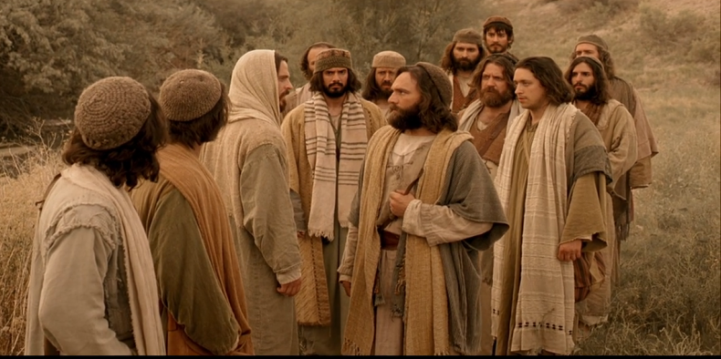

We pray for the sick of our community, especially:
Pat Murphy, Ken and Toni Meek, Delores Servais, Michael Ford, Jim Walsh, Paula Cope, Pat Barone, Joy Jackson, Anita Pitcher, Deanna Burge.

Communion Antiphon | Ps 30:20
How great is the goodness, Lord,
that you keep for those who fear you.

(…continued) Heaven preserve you, Lord ... this must not happen to you, Peter had said - and the stress, the emphasis, would have been heavily on the word - you. He had lost sight of the divine he had only just now affirmed and, for one fatal moment, his horizon was narrowed to human sentiment - a most common mistake. Why, for example, do so many mothers counsel their pregnant teenage daughters to have an abortion? Is it not because they see in their mind's eye the difficulties their daughters will undergo as single parents; the career opportunities they will have to forego; the disadvantage they will suffer in finding a suitable partner in life? Mothers want good things for their children and when faced with these imagined bleak prospects will often lose sight of the larger picture and see only the immediate needs of their child - will see only the you. 'Heaven preserve you, daughter ... this must not happen to you!' Of course, we could multiply examples. Parents of homosexually active children; children of elderly parents who are suffering; Catholics who see the misbehaviour of their bishops and priests; and countless other human situations. All of the solutions we apply to them depend on our 'way of thinking' and if it is a human way of thinking we will decide in favour of the immediate human circumstances. The here-and-now you becomes more important than the invisible God.
- How could I tell my lesbian daughter that she cannot try to find happiness with her partner?'
- How can I allow my mother to go on suffering when I can so easily stop it.'
- How can I be part of an institution that has sinners in its leadership?'
The human way of thinking leaves God out every time. It sees only with the human eye and decides only according to human logic.
My mother is suffering.
Suffering is not good.
The loving thing to do is to end the suffering.
As Jesus says: the way you think is not God’s way but man’s.
Read more at: http://homiliesfromaustralia.blogspot.com.au/2014/08/22nd-sunday-in-ordinary-time-year-a.html

Whover loses his life for my sake will find it, downloaded from The Life of Jesus Christ Bible Videos at https://www.lds.org/bible-videos/videos/whosoever-will-lose-his-life-for-my-sake-shall-find-it?lang=eng
Entrance Antiphon |Cf. Ps 85: 3,5

Have mercy on me, O Lord,
for I cry to you all the day long.
O Lord, you are good and forgiving,
full of mercy to all who call to you.

First Reading Jeremiah 20:7-9
The word of the Lord God has meant derision for me.

You have seduced me, Lord, and I have let myself be seduced;
you have overpowered me: you were the stronger.
I am a daily laughing-stock,
everybody’s butt.
Each time I speak the word, I have to howl
and proclaim: ‘Violence and ruin!’
The word of the Lord has meant for me
insult, derision, all day long.
I used to say, ‘I will not think about him,
I will not speak in his name any more.’
Then there seemed to be a fire burning in my heart,

Gospel Acclamation ‡ cf. Ep 1:17-18

Alleluia, alleluia!
May the Father of our Lord Jesus Christ enlighten the eyes of our heart,
that we might see how great is the hope to which we are called.
Alleluia!

Gospel ‡ Matthew 16:21-27
Whoever wishes to come after me, must deny himself.

Jesus began to make it clear to his disciples that he was destined to go to Jerusalem and suffer grievously at the hands of the elders and chief priests and scribes, to be put to death and to be raised up on the third day. Then, taking him aside, Peter started to remonstrate with him. ‘Heaven preserve you, Lord,’ he said. ‘This must not happen to you.’ But he turned and said to Peter, ‘Get behind me, Satan! You are an obstacle in my path, because the way you think is not God’s way but man’s.’
Then Jesus said to his disciples, ‘If anyone wants to be a follower of mine, let him renounce himself and take up his cross and follow me. For anyone who wants to save his life will lose it; but anyone who loses his life for my sake will find it. What, then, will a man gain if he wins the whole world and ruins his life? Or what has a man to offer in exchange for his life?
‘For the Son of Man is going to come in the glory of his Father with his angels, and, when he does, he will reward each one according to his behaviour.’

The Gospel of the Lord.
Praise to you, Lord Jesus Christ!

imprisoned in my bones.
The effort to restrain it wearied me,
I could not bear it.

The word of the Lord.
Thanks be to God.

Responsorial Psalm ‡ Ps 62:2-6, 8-9. R. v.2

R. My soul is thirsting for you, O Lord my God.

O God, you are my God, for you I long;
for you my soul is thirsting.
My body pines for you
like a dry, weary land without water. R.

So I gaze on you in the sanctuary
to see your strength and your glory.
For your love is better than life,
my lips will speak your praise. R.

So I will bless you all my life,
in your name I will lift up my hands.
My soul shall be filled as with a banquet,
my mouth shall praise you with joy. R.

For you have been my help;
in the shadow of your wings I rejoice.
My soul clings to you;
your right hand holds me fast. R.

Second Reading ‡ Romans 12:1-2
May you present your bodies as a living sacrifice.

Think of God’s mercy, my brothers, and worship him, I beg you, in a way that is worthy of thinking beings, by offering your living bodies as a holy sacrifice, truly pleasing to God. Do not model yourselves on the behaviour of the world around you, but let your behaviour change, modelled by your new mind. This is the only way to discover the will of God and know what is good, what it is that God wants, what is the perfect thing to do.

The word of the Lord.
Thanks be to God.

Commentary on today’s readings by Fr John Speekman,
Administrator of Howlong Parish, Diocese of Wagga Wagga.
Last week Jesus posed a question which Peter, under the inspiration of the Holy Spirit, answered correctly. This week, when Jesus makes clear to his disciples God’s will for him, Peter stupidly takes that most dangerous and not-to-be-recommended initiative – he proposes an alternative to God’s will. Why would Peter do such a silly thing? What was his motive? How could he bring himself to think he could correct the Lord and improve on God's plan? What prompted him? Jesus himself gives the answer when he rebukes Peter; he tells him it's: the way you think.
The way we think determines absolutely everything we do and don’t do; what we like and what we dislike; what we run away from and what we are prepared to die for. And so, without fear of contradiction I can state categorically that the way we think is just about the most important thing in life to get right. But let's go back to Peter. What precisely was wrong with his way of thinking? He had heard Jesus was to die a horrible death at the hands of his enemies and he, like most caring, loving, charitable people wanted to spare his friend this calamity.

