21st Sunday in Ordinary Time Year A
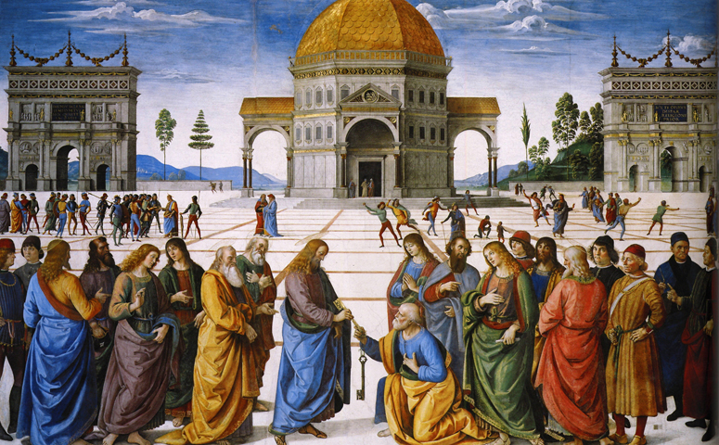
MASS TIMES
Weekend Masses: YANCHEP: 6 p.m. Saturday Vigil, St James Anglican Church,
2 Lagoon Drive. GUILDERTON: 8 a.m. Sunday, Guilderton Community Hall, Wedge Street. LANCELIN: 9.45 a.m. Sunday, 33 Gingin Road, Lancelin.
Confessions: before Mass on request
Weekday Masses: Tuesday, Thursday, Friday 9 a.m. at the presbytery,
Wednesdays 3 p.m. at Bethanie Beachside Aged Care.
Priest: Fr Augustine Puthota, Presbytery: 3 Blaxland Avenue, Two Rocks, Western Australia 6037. Telephone: +61-8-9561 2172
Website! http://yanchepcatholic.org/ email: yanchepcatholic@gmail.com.
Sunday Bulletin

We pray for the sick of our community, especially:
Pat Murphy, Ken and Toni Meek, Delores Servais, Michael Ford, Jim Walsh, Paula Cope, Pat Barone, Joy Jackson, Anita Pitcher, Deanna Burge.

Communion Antiphon | Jn 6: 54
I am the living bread from heaven, says the Lord.
If anyone eats this bread he will live for ever.

(…continued) The role of “master of the palace,” literally “the one over the house” (Heb. ‘asher ‘al-habayith), was the Number Two position of authority after the King (observe the dynamic in 1 Kings 18:1-5, for example). The office was first established by Solomon (1 Kings 4:6). Apparently the badge of his office was the wearing of the key to the palace on his shoulder (Isa 22:22). He controlled access to the king, either by unlocking or locking the palace doors to those who sought the king’s presence. This is what the text means by “what he opens, none shall shut, etc.” This statement will be paralleled in the Gospel: “what you bind on earth will be bound in heaven, etc.”
Michael Barber has done work showing that the royal steward was understood as a priestly character. In summary, the Kingdom of David included the office of the Royal Steward (‘asher ‘al-habayit), a position associated with priesthood and second only to the king in authority. Let’s not forget, too, that this was an office: a continuing role that was filled by one man succeeding another, as opposed to a charism given to one person that ceases with his death.
Even some non-Catholic commentators (most notably, W.F. Albright, father of American biblical archaeology and Old Testament studies) recognize that, in Matt 16, Jesus is investing Peter with role of royal steward in the Kingdom that Jesus is establishing. Isaiah 22 is clearly the background for the promise of the “keys to the Kingdom.” Aside from Judges 3:23-25, which has no thematic parallels, Isaiah 22 is the only passage of the Old Testament where the word “key” even occurs. The thematic parallels are strong: the promise to Eliakim concerning “opening” and “shutting” is repeated to Peter, although using the terms “binding” and “loosing.” “Binding” and “loosing” were technical terms in first century Judaism referring to the authority to decide matters of halakhah (lit. “the walk”, i.e. “the behavior” or “how one behaves”), that is, the practical application of divine law.
Read more at http://www.thesacredpage.com/2014/08/peter-and-popes-21st-sunday-of-ot.html#more

Entrance Antiphon |Cf. Ps 86 (85): 1-3
Turn your ear, O Lord, and answer me; save the servant who trusts in you, my God. Have mercy on me, O Lord, for I cry to you all the day long.
Christ Handing the Keys to St Peter, Pietro Perugino (1481-82), Fresco, Sistine Chapel, Vatican.

First Reading Isaiah 22:19-23
I place the key of the House of David upon his shoulder.

Thus says the Lord of hosts to Shebna, the master of the palace:
I dismiss you from your office,
I remove you from your post,
and the same day I call on my servant
Eliakim son of Hilkiah.
I invest him with your robe,
gird him with your sash,
entrust him with your authority;
and he shall be a father to the inhabitants of Jerusalem
and to the House of Judah.

Gospel Acclamation ‡ Matthew 16:18

Alleluia, alleluia!
You are Peter, the rock on which I will build my Church;
the gates of hell will not hold out against it.
Alleluia, alleluia!

Gospel ‡ Matthew 16:13-20
You are Peter, to you I will give the keys of the kingdom of heaven.

When Jesus came to the region of Caesarea Philippi he put this question to his disciples, ‘Who do people say the Son of Man is?’ And they said, ‘Some say he is John the Baptist, some Elijah, and others Jeremiah or one of the prophets.’ ‘But you,’ he said, ‘who do you say I am?’ Then Simon Peter spoke up, ‘You are the Christ,’ he said, ‘the Son of the living God.’
Jesus replied, ‘Simon son of Jonah, you are a happy man! Because it was not flesh and blood that revealed this to you but my Father in heaven. So I now say to you: You are Peter and on this rock I will build my Church. And the gates of the underworld can never hold out against it. I will give you the keys of the kingdom of heaven; whatever you bind on earth shall be considered bound in heaven; whatever you loose on earth shall be considered loosed in heaven.’ Then he gave the disciples strict orders not to tell anyone that he was the Christ.

The Gospel of the Lord.
Praise to you, Lord Jesus Christ!

I place the key of the House of David on his shoulder;
should he open, no one shall close,
should he close, no one shall open.
I drive him like a peg into a firm place;
he will become a throne of glory for his father’s house.

The word of the Lord.
Thanks be to God.

Responsorial Psalm Ps 137:1-3, 6, 8 R. v.8

R. Lord, your love is eternal;
do not forsake the work of your hands.

I thank you, Lord, with all my heart,
you have heard the words of my mouth.
Before the angels I will bless you,
I will adore before your holy temple. R.

I thank you for your faithfulness and love
which excel all we ever knew of you.
On the day I called, you answered;
you increased the strength of my soul. R.

The Lord is high yet he looks on the lowly
and the haughty he knows from afar.
Your love, O Lord, is eternal,
discard not the work of your hands. R.

Second Reading ‡ Romans 11: 33-36
From him, through him, and in him are all things.

How rich are the depths of God — how deep his wisdom and knowledge — and how impossible to penetrate his motives or understand his methods! Who could ever know the mind of the Lord? Who could ever be his counsellor? Who could ever give him anything or lend him anything? All that exists comes from him; all is by him and for him. To him be glory for ever! Amen.

The word of the Lord.
Thanks be to God.

Commentary on today’s readings by Dr John Bergsma,
Assoc. Prof. Theology at Franciscan University of Steubenville, Ohio.
http://www.thesacredpage.com/2014/08/peter-and-popes-21st-sunday-of-ot.html#more
In terms of Catholic “preachability,” this Sunday’s Readings are a soft-ball pitch, a long high arc that every homilist ought to be able to knock out of the park. The lectionary readings have been set up for a clear explanation of the nature of the Papacy and its basis in Scripture.
The context of the Old Testament reading should be explained. During the lifetime of the prophet Isaiah, the royal steward of the palace, a certain Shebna, was arrogating himself by adopting royal privileges. In particular, he was having a tomb cut for himself in the area reserved for the royal sons of David. Like Denethor in The Return of the King (not an accidental parallel, by the way—Tolkien was a thorough Catholic), he was forgetting his place as steward and confusing his role with that of the king. As a result, the LORD sends an oracle to Shebna via Isaiah, to the effect that Shebna will be replaced in his position by a more righteous man, a certain Eliakim son of Hilkiah.

