20th Sunday in Ordinary Time Year A
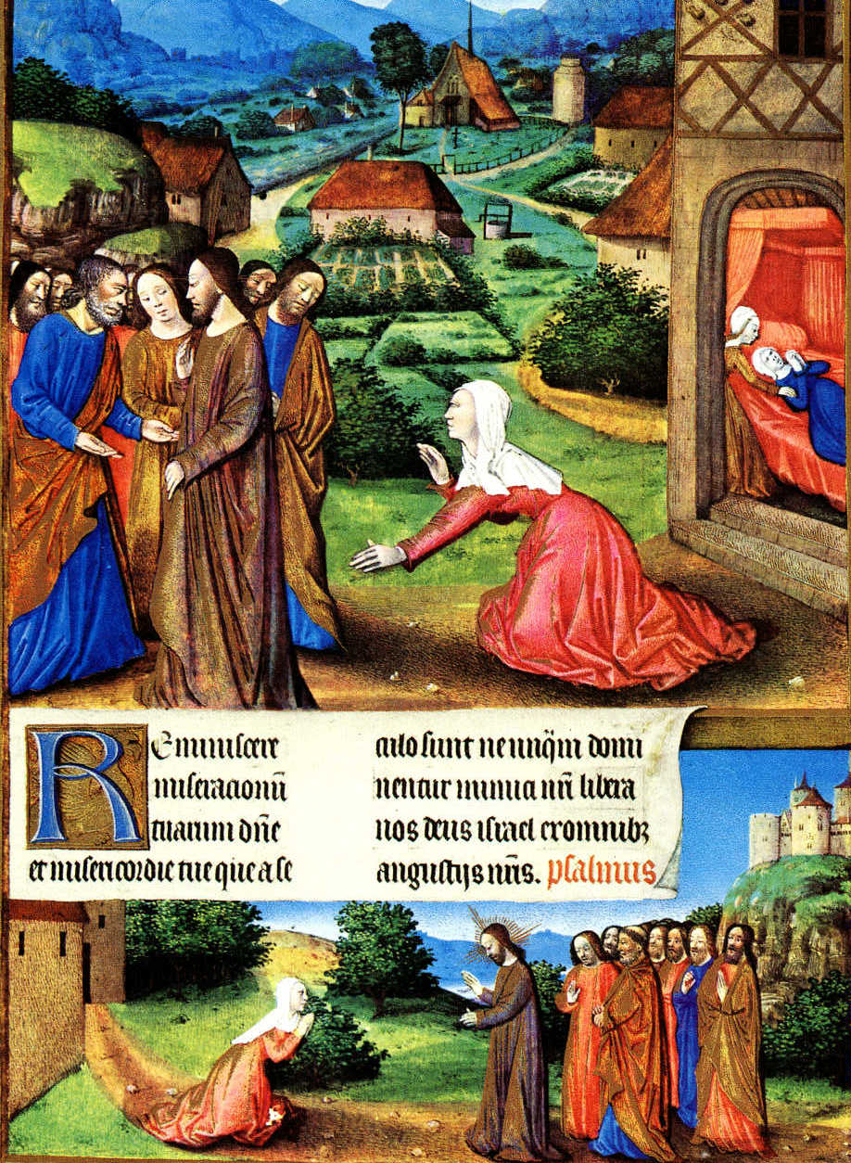
MASS TIMES
Weekend Masses: YANCHEP: 6 p.m. Saturday Vigil, St James Anglican Church,
2 Lagoon Drive. GUILDERTON: 8 a.m. Sunday, Guilderton Community Hall, Wedge Street. LANCELIN: 9.45 a.m. Sunday, 33 Gingin Road, Lancelin.
Confessions: before Mass on request
Weekday Masses: Tuesday, Thursday, Friday 9 a.m. at the presbytery,
Wednesdays 3 p.m. at Bethanie Beachside Aged Care.
Priest: Fr Augustine Puthota, Presbytery: 3 Blaxland Avenue, Two Rocks, Western Australia 6037. Telephone: +61-8-9561 2172
New Website! http://yanchepcatholic.org/ email: yanchepcatholic@gmail.com.
Entrance Antiphon| Ps 84 (83): 10-11 God, our protector, keep us in mind; always give strength to your people. For if we can be with you even one day, it is better than a thousand without you.
Sunday Bulletin

We pray for the sick of our community, especially:
Pat Murphy, Ken and Toni Meek, Delores Servais, Michael Ford, Jim Walsh, Paula Cope, Pat Barone, Joy Jackson, Anita Pitcher, Deanna Burge.

Communion Antiphon | Jn 6: 51-52
I am the living bread from heaven, says the Lord.
If anyone eats this bread he will live for ever.

(…continued) If you were a gentile and you wanted to approach Jesus and ask him for a favor, appealing to his role as the Son of David would definitely make sense.
There are two difficult questions about the Gospel that should be addressed.
First, Jesus insists that he was sent only to "lost sheep of the house of Israel". Did Jesus not care for the inclusion of the gentiles? Michael Bird's excellent book, Jesus and the Origins of the Gentile Mission, does a fine job addressing this. In short, Bird shows that there is ample evidence that Jesus envisioned the inclusion of the gentiles. Most importantly, Jesus cited passages from Isaiah (e.g., like the one in our first reading), which clearly articulated such hopes. Second, we might ask why Jesus appears so harsh--he calls her a "dog" after all! (Actually, literally, he speaks of "little dogs" or "puppies"--yet still an insult in that ancient context.) The woman, of course, from the perspective of the Jewish law, would have been seen as "unclean" since she was a gentile. The language of "dog" probably relates to this status. Dogs were unclean--mostly scavengers in Jesus' day.
However, the woman persists, humbly accepting her status. Again, to quote Aquinas' commentary on this passage:
Here the woman’s marvellous humility and wisdom are mentioned. He seemed to despise her nation, but it is a mark of her humility that she overlooks the insult that was spoken. Hence, she says, Yea, Lord. . . Similarly, the Lord had called the Jews children, but she calls them masters: hence, she says, that fall from the table of their masters. And she knew how to humbly compel the Lord in this way; it is as though she were to say, ‘I do not ask, Lord, that Thou confer so many benefits upon us as Thou didst confer upon the Jews, but only that you give to us of the crumbs’.
Thomas then cites the Vulgate of Psalm 101:18: "[The Lord] hath regard for the prayer of the humble." (read more at http://www.thesacredpage.com/)
Christ and the Canaanite Woman, Jean Colombe, illuminated manuscript, folio 164r of Les Tres Riches Heures du Duc de Berry, 1412-1490, Chateau de Chantilly, Picardy, France.

First Reading Isaiah 56:1,6-7
I will lead the foreigners to my holy mountain.
Thus says the Lord: Have a care for justice, act with integrity, for soon my salvation will come and my integrity be manifest.
Foreigners who have attached themselves to the Lord to serve him and to love his name and be his servants – all who observe the sabbath, not profaning it, and cling to my covenant – these I will bring to my holy mountain. I will make them joyful in my house of prayer. Their holocausts and their sacrifices will be accepted on my altar, for my house will be called a house of prayer for all the peoples.
The word of the Lord.
Thanks be to God.

Gospel Matthew 15:21-28
Woman, you have great faith.

Jesus left Gennesaret and withdrew to the region of Tyre and Sidon. Then out came a Canaanite woman from that district and started shouting, ‘Sir, Son of David, take pity on me. My daughter is tormented by a devil.’ But he answered her not a word. And his disciples went and pleaded with him. ‘Give her what she wants,’ they said ‘because she is shouting after us.’ He said in reply, ‘I was sent only to the lost sheep of the House of Israel.’ But the woman had come up and was kneeling at his feet. ‘Lord,’ she said ‘help me.’ He replied, ‘It is not fair to take the children’s food and throw it to the house-dogs.’ She retorted, ‘Ah yes, sir; but even house-dogs can eat the scraps that fall from their master’s table.’ Then Jesus answered her, ‘Woman, you have great faith. Let your wish be granted.’ And from that moment her daughter was well again.

The Gospel of the Lord.
Praise to you, Lord Jesus Christ!

Responsorial Psalm Ps 66: 2-3, 5-6, 8. R. v.8

R. O God, let all the nations praise you!

O God, be gracious and bless us
and let your face shed its light upon us.
So will your ways be known upon earth
and all nations learn your saving help. R.

Let the nations be glad and exult
for you rule the world with justice.
With fairness you rule the peoples,
you guide the nations on earth. R.

Let the peoples praise you, O God;
let all the peoples praise you.
May God still give us his blessing
till the ends of the earth revere him. R.

Second Reading Romans 11: 13-15, 29-32
The gifts and call of God are irrevocable.

Let me tell you pagans this: I have been sent to the pagans as their apostle, and I am proud of being sent, but the purpose of it is to make my own people envious of you, and in this way save some of them. Since their rejection meant the reconciliation of the world, do you know what their admission will mean? Nothing less than a resurrection from the dead! God never takes back his gifts or revokes his choice.
Just as you changed from being disobedient to God, and now enjoy mercy because of their disobedience, so those who are disobedient now – and only because of the mercy shown to you – will also enjoy mercy eventually. God has imprisoned all men in their own disobedience only to show mercy to all mankind.

The word of the Lord.
Thanks be to God.

Gospel Acclamation Matthew 4:23

Alleluia, alleluia!
Jesus preached the Good News of the kingdom and healed all who were sick. Alleluia!

Commentary on today’s readings from Dr Michael Barber
http://www.thesacredpage.com/2014/08/may-god-have-pity-on-us-readings-for.html#more
The general point made in Romans 11 is that God has shown mercy to the Gentiles.
A key line that I'd highlight here is Romans 11:14, where Paul explains that he seeks to make his own race (i.e., Israel) "jealous" by preaching the Gospel to the nations. You might be asking, What is this all about? Why is Paul trying to make his own people "jealous"?
The besetting sin of Israel in the Old Testament is nothing less than wanting to "be like the nations", something typically linked to idolatry. By bringing the Gospel to the nations and introducing them to the worship of the true God in Christ, the Lord has essentially made it safe for his people now to be "jealous" of the nations.
"You want to be like the gentiles?," God appears to ask. "Fine," he says, "let them receive the Gospel. Now, go knock yourself out."
In today’s Gospel we see the gentile mission of the church anticipated in Jesus' ministry. That Jesus is identified as "son of David" by the Canaanite woman is no coincidence. As we have explained, the Davidic covenant was, unlike the Mosaic covenant, particularly inclusive.
Under Moses, Israel was commanded to defeat the gentiles (especially "Canaanites"!) and remain essentially quarantined from their influence. The Mosaic covenant emphasizes separation from the nations.
The Davidic covenant represented a real advance beyond the nationalistic emphasis of the Mosaic covenant. Indeed, right after God establishes his covenant with David the king responds by speaking about how God has shown him a “a torah for adam”, a "law" for "humanity" (2 Sam 7:19). Not surprisingly, then, under David and Solomon, the kingdom involved the surrounding nations acknowledging the authority of the Davidic king. (Continued over page …)

