18th Sunday in Ordinary Time Year A
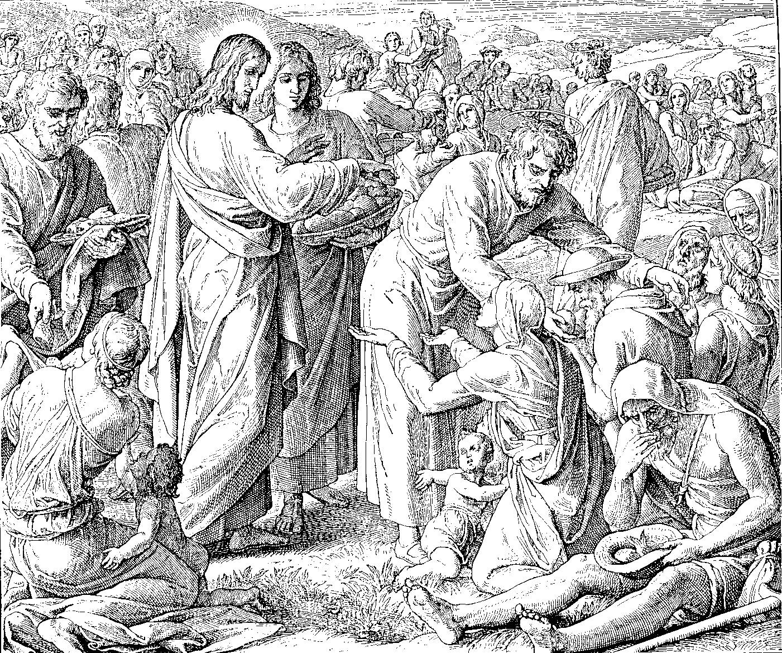
MASS TIMES
Weekend Masses: YANCHEP: 6 p.m. Saturday Vigil, St James Anglican Church,
2 Lagoon Drive. GUILDERTON: 8 a.m. Sunday, Guilderton Community Hall, Wedge Street. LANCELIN: 9.45 a.m. Sunday, 33 Gingin Road, Lancelin.
Confessions: before Mass on request
Weekday Masses: Tuesday, Thursday, Friday 9 a.m. at the presbytery,
Wednesdays 3 p.m. at Bethanie Beachside Aged Care.
Priest: Fr Augustine Puthota, Presbytery: 3 Blaxland Avenue, Two Rocks, Western Australia 6037. Telephone: +61-8-9561 2172
New Website! http://yanchepcatholic.org/ email: yanchepcatholic@gmail.com.
Sunday Bulletin

We pray for the sick of our community, especially:
Pat Murphy, Ken and Toni Meek, Delores Servais, Michael Ford, Jim Walsh, Paula Cope, Pat Barone, Joy Jackson, Anita Pitcher, Deanna and Murray Burge.

Communion Antiphon
You gave us bread from heaven, Lord: a sweet-tasting bread that was very good to eat.

Your Bible Questions Answered: “A little while ago, we had the feast of St Joachim and St Anne – the parents of Mary. Where do we find these names in the Bible?” For the answer, or to submit your own Bible question, visit www.thebiblicalfoundation.org.au. You can also like us on Facebook!

Archbishop Costelloe and Bishop Sproxton are keen to send a personal letter of invitation to couples from our parishes who this year are celebrating 25, 40, 50, 55, or 60 years of marriage (or more even!) to attend the National Marriage Day Mass at St Mary’s Cathedral on Tuesday 12th August at 7:00pm. If you wish to attend, please send your full names/address/email address to communications@perthcatholic.org.au by Tuesday 5 August and an invitation will be forwarded to you.

Feeding of the Five Thousand, Julius Schnorr von Carolsfeld, 1794-1872, die Bibel in Bildern

Commentary on the Second Reading (continued)
In fact, "eternal security" is clearly at odds with Jesus' teaching in John 15, where Jesus identifies himself as a "vine" and believers as "branches". Specifically, Jesus explains that branches that bear no fruit will be cut off from the vine and "thrown into the fire and burned" (John 15:6). 1 John 5:15-17 likewise makes it clear that there is such a thing as "mortal sin". Finally, we might also mention that Paul himself hardly sounds like he affirms eternal security in 2 Corinthians:
But with me it is a very small thing that I should be judged by you or by any human court. I do not even judge myself. I am not aware of anything against myself, but I am not thereby acquitted. It is the Lord who judges me. Therefore do not pronounce judgment before the time, before the Lord comes, who will bring to light the things now hidden in darkness and will disclose the purposes of the heart. Then every man will receive his commendation from God. (1 Cor 4:3-5)

Entrance Antiphon
God, come to my help. Lord, quickly give me assistance. You are the one who helps me and sets me free: Lord do not be long in coming.

First Reading Isaiah 55:1-3
Hasten and eat.

Thus says the Lord:
Oh, come to the water all you who are thirsty;
though you have no money, come!
Buy corn without money, and eat,
and, at no cost, wine and milk.
Why spend money on what is not bread,

The word of the Lord.
Thanks be to God.

Gospel Acclamation Mt 4:4b

Alleluia, alleluia!
No one lives on bread alone,
but on every word that comes from the mouth of God.
Alleluia!

Gospel Matthew 14:13-21
They all ate and were satisfied.

When Jesus received the news of John the Baptist’s death he withdrew by boat to a lonely place where they could be by themselves. But the people heard of this and, leaving the towns, went after him on foot. So as he stepped ashore he saw a large crowd; and he took pity on them and healed their sick.
When evening came, the disciples went to him and said, ‘This is a lonely place, and the time has slipped by; so send the people away, and they can go to the villages to buy themselves some food.’ Jesus replied, ‘There is no need for them to go: give them something to eat yourselves.’ But they answered ‘All we have with us is five loaves and two fish.’ ‘Bring them here to me’ he said. He gave orders that the people were to sit down on the grass; then he took the five loaves and the two fish, raised his eyes to heaven and said the blessing. And breaking the loaves handed them to his disciples who gave them to the crowds. They all ate as much as they wanted, and they collected the scraps remaining; twelve baskets full. Those who ate numbered about five thousand men, to say nothing of women and children.

The Gospel of the Lord.
Praise to you, Lord Jesus Christ!

your wages on what fails to satisfy?
Listen, listen to me, and you will have good things to eat
and rich food to enjoy.
Pay attention, come to me;
listen, and your soul will live.
With you I will make an everlasting covenant
out of the favours promised to David.

The word of the Lord.
Thanks be to God.

Responsorial Psalm Ps 144:8-9, 15-18. R. v.16

R. The hand of the Lord feeds us;
he answers all our needs.

The Lord is kind and full of compassion,
slow to anger, abounding in love.
How good is the Lord to all,
compassionate to all his creatures. R.

The eyes of all creatures look to you
and you give them their food in due time.
You open wide your hand,
grant the desires of all who live. R.

The Lord is just in all his ways
and loving in all his deeds.
He is close to all who call him,
call on him from their hearts. R.

Second Reading Romans 8:35, 37-39
No creature can separate us from the love of God, which is in Christ.

Nothing can come between us and the love of Christ, even if we are troubled or worried, or being persecuted, or lacking food or clothes, or being threatened or even attacked. These are the trials through which we triumph, by the power of him who loved us.
For I am certain of this: neither death nor life, no angel, no prince, nothing that exists, nothing still to come, not any power, or height or depth, nor any created thing, can ever come between us and the love of God made visible in Christ Jesus our Lord.

Commentary on the Second Reading by Dr Michael Barber from http://www.thesacredpage.com.
Whereas the First Reading looks forward to the day of the eschatological banquet, i.e., the day of God's ultimate victory over evil, the Second Reading explains how this has occurred in Christ.
It bears mentioning here that some Protestant readers use this passage to support the idea of "eternal security", that is, the belief that once a person is saved that salvation can never be lost ("once-saved-always-saved"). A close reading of this text, though, reveals that no such idea is present. Paul says no trial or thing can separate us from Christ but he does not say that sin won't separate us from him.
(Continued over page)

