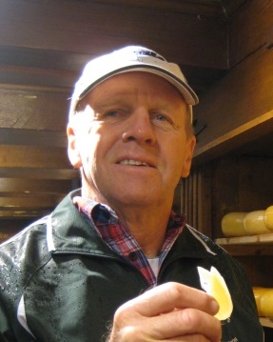
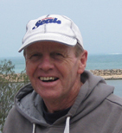
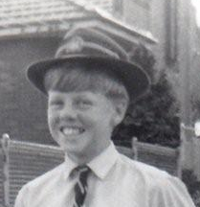
open the gates of paradise to your servant
and help us who remain
to comfort one another with assurance of faith,
until we all meet in Christ
and are with you and with our brother for ever.

We ask this through Christ our Lord.
Amen.

PROCESSION TO THE PLACE OF COMMITTAL

In peace, let us take our brother to his place of rest.

RECESSIONAL HYMN MAY THE CHOIRS OF ANGELS

REFRAIN:
May the choirs of angels come to greet you.
May they speed you to paradise.
May the Lord enfold you in His mercy.
May you find eternal life.
The Lord is my light and my help;
It is he who protects me from harm.
The Lord is the strength of my days;
Before whom should I tremble with fear?
There is one thing I ask of the Lord;
That He grant me my heartfelt desire.
To dwell in the courts of our God
Every day of my life in His presence.

Please proceed to Pinnaroo Memorial Park for the Rite of Committal.

The Committal will be followed by a wake at the Kingsley Tavern, Kingsley Drive.

Deirdre, Wilson, Elinor and Alistair Fleming would like to thank you for your kindness in attending today.
Page 12

REQUIEM MASS

in loving memory of

William Peter Fleming

born into this life: 22 July 1950

called to eternal life: 13 March 2014

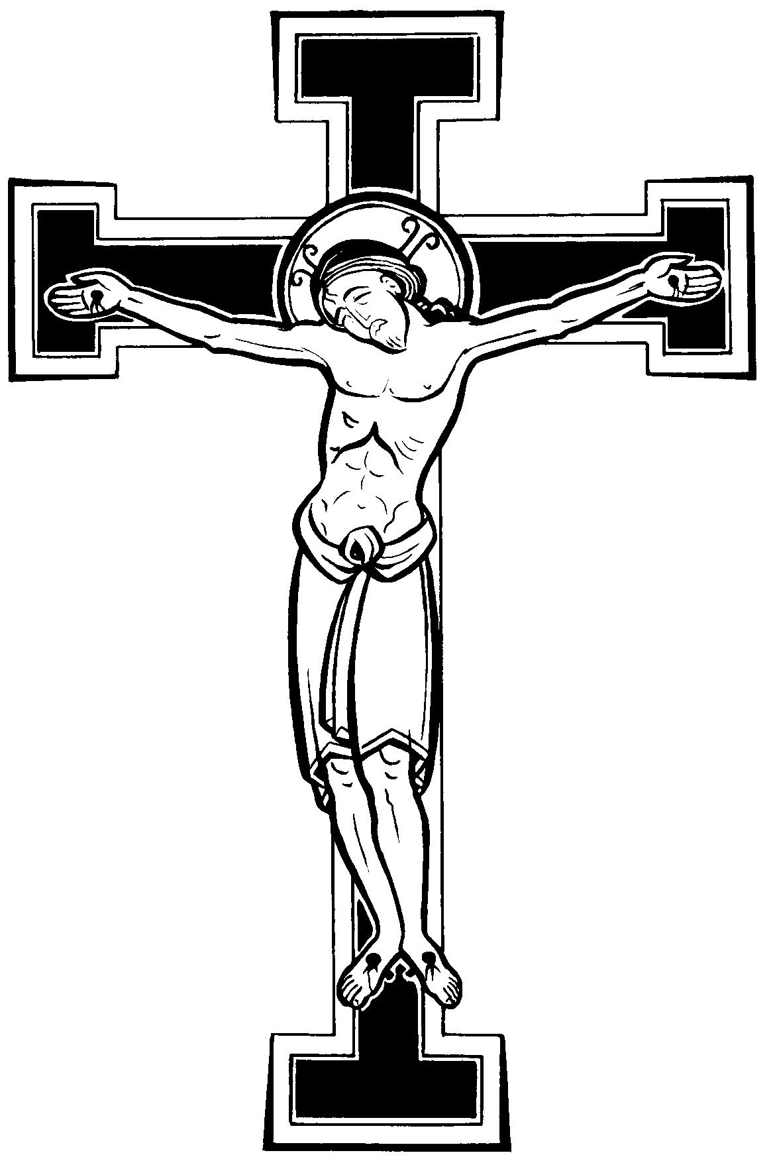
21 March 2014

St Luke’s Catholic Church
Woodvale

Celebrants: Fr Francisco Mascarhenas
Fr Augustine Puthota

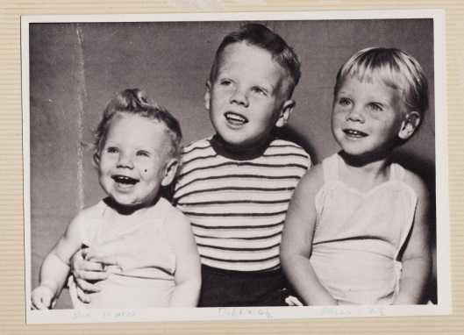

Page 11
There will be no more weeping or mourning, nevermore;
And God will dwell with his holy people evermore.
How blessed are they who are called to the banquet of the Lord.

REFRAIN: When we eat this bread and we drink this cup,
we proclaim your death until you come.

All praise to the Father, Creator most holy, praise to him.
All praise to the Son, our Saviour and brother, praise to him;
All glory and praise to the Spirit of God who makes us one.

FINAL COMMENDATION
Trusting in God, we have prayed together for Bill and now we come to the last farewell. There is sadness in parting, but we take comfort in the hope that one day we shall see Bill again and enjoy his friendship. Although this congregation will disperse in sorrow, the mercy of God will gather us together again in the joy of his kingdom. Therefore let us console one another in the faith of Jesus Christ.

INCENSING OF THE COFFIN.

SONG OF FAREWELL
Priest: Saints of God, come to his aid!
Hasten to meet him, angels of the Lord!
R. Receive his soul and present him to God the Most High.

Priest: May Christ, who called you, take you to himself;
may angels lead you to the bosom of Abraham. R.

Priest: Eternal rest grant unto him, O Lord,
and let perpetual light shine upon him. R.

PRAYER OF COMMENDATION
Into your hands, Father of mercies,
we commend our brother Bill
in the sure and certain hope
that, together with all who have died in Christ,
he will rise with him on the last day.

We give you thanks for the blessings
which you bestowed upon Bill in this life:
they are the signs to us of your goodness
and of our fellowship with the saints in Christ.

Merciful Lord,
turn toward us and listen to our prayers:
Bill’s Spiritual Journey by Deirdre Fleming
I would like to describe for you an aspect of Bill’s life that may not be touched on at the wake: that is, his Spiritual Journey. Although Bill was baptised and confirmed into the Church, he had difficulties with religion, largely as a result of the cruelty he had suffered at his Catholic high school, CBC Burwood. He was regularly given – without any provocation on his part - at least six cuts a day with a cane or strap on his bare buttocks. I was told by him that these disciplines were carried out with some enjoyment by the perpetrators. You can imagine the effect this had on a boy in his impressionable years. Images of Christ came to be associated with sadism, and this led to his walking away from his faith in his teenage years. This was of course, in the bad old days of the sixties, when perverts and sadists started to infiltrate the Church, and ordinary people would have been incredulous that this was occurring – even his parents didn’t understand the extent and nature of what was happening.
His mother, Myra, however, was a devout Catholic who always hoped Bill would return to his faith. When she and Bill senior came to Perth in 1985 to meet me prior to the wedding, she was mightily relieved to find a “Mass Times” booklet on the hall table, and I suspect she regarded me as something of an answer to her prayers. In fact, she died only two months after we were married, and I always felt she was handing me the baton to look after Bill’s temporal spiritual welfare.
Over the years, I tried to persuade Bill to return to prayer, even to ask God for a sign that He existed! And God gave him a reason to pray when the business in its early stages was having cash flow problems. It was the early 1990s and wages were due to be paid the next day, without there being enough money in the bank! He took my advice and prayed, ‘God, if you’re really there and you are a loving father, I desperately need some money to pay our employees – about $8,000 would cover our debts for now.’ Bill was astonished and amazed when exactly $8,000.00 came in from Comgroup Supplies the very next day. That was the beginning of his opening up to God, and he grew into a habit of praying during the long drives to work from Two Rocks, or while sitting on the balcony or in the garden having a beer. He started to talk to God, in the same way as he would have had a chat with his own Dad, had he still been alive – not asking for material possessions or wealth, but just shooting the breeze and telling God about his day, his hopes and his fears.
When Bill was diagnosed with oesophageal cancer in 2012, he started allowing me to pray with him. Every night before sleep, we would say a few prayers together. And everything went well for a while: Bill was among the one in five who could be operated on; his tumour shrank to the extent that the excision didn’t need to be as extensive as previously predicted and the tumour turned out to be a T1 – the least invasive type. The operation went successfully and he was out of hospital in record time.
But soon, more problems started to plague him: he developed gastric dumping syndrome, and then thrombocytopenia, which put him at risk of dangerous bleeding, and required a splenectomy in March. Then, in April 2013, his fishing buddy, Paul, drowned next to him.

We shake hands, saying ‘Peace be with you’ to the people near us.

BREAKING OF THE BREAD
Priest: May this mingling of the Body and Blood of our Lord Jesus Christ
bring eternal life to us who receive it.

(kneel)
Priest: Behold the Lamb of God, behold him who takes away the sins of the world.
Blessed are those called to the supper of the Lamb.
R. Lord I am not worthy
that you should enter under my roof,
but only say the word
and my soul shall be healed.
COMMUNION PROCESSION
Please come forward to receive Holy Communion if you are a Catholic who is suitably prepared to receive the Body and Blood of Christ. If you are not Catholic, or not prepared, you may instead receive a blessing by crossing your arms over your chest.

THANKSGIVING HYMN WHEN WE EAT THIS BREAD

REFRAIN: When we eat this bread and we drink this cup,
we proclaim your death until you come.

Where two or three are gathered together in my name,
Where two or three are gathered together, there am I.
How blessed are they who are called to the banquet of the Lord.

Come, you blessed of my Father, come to me,
Enter into God’s holy kingdom, full of joy.
How blessed are they who are called to the banquet of the Lord.

I saw the city Jerusalem come from God,
All clothed and adorned as a bride for her husband, filled with love.
How blessed are they who are called to the banquet of the Lord.
Page 10
While all this was happening, Bill made sure his affairs were all in order, should he be taken from us. He gave our daughter, Elinor, who had just graduated from Murdoch with a degree in Physics and Mathematics, an opportunity to work with Wisemate Foods for three months to test whether she might want to take over the business and lead it into the future. She quickly mastered the sachet machines and started to learn the financial structures of the business. She accompanied Bill on a trip to Melbourne and Sydney to attend the Auspack Exhibition and visit potential customers and machinery suppliers.
In the meantime, Bill had been developing a chronic cough. It must have prompted some soul searching, because during this period he started accompanying our youngest son, Mungo, to Mass on Sundays.
In October 2013, Bill went for a six-monthly checkup and was told that he had secondary tumours in his lungs and that he would be ineligible for chemotherapy because of his low platelet count. He was given six to nine months to live.
At this point, Bill allowed me to pray with him again every evening and he was trying several alternative therapies in the hope that something might be successful. We had a lovely Christmas with Wilson and Katya flying over from the Gold Coast to join us and enjoy swimming and wave-skiing together.
But Bill eventually saw the need not only to get his financial affairs in order, but also his spiritual affairs. On January 17th, he made an appointment with Father Bogoni from All Saints Chapel in the city, for a life confession. Fr Bogoni kindly made things easier for Bill by turning the confession into a question and answer session: he read out a list of every sin under the sun, and all Bill had to do was say yes or no as to whether he had ever committed them. Then Fr Bogoni, acting in persona Christi, was able to give Bill forgiveness and absolution for every wrong action he had committed in his life. Bill was able now to receive Holy Communion, and attended Mass with the family for several weeks before he became too ill to do so.
Prior to his death, Bill was prayed for by people from across the globe. We organised a Rosary Chain so that he was covered with prayer throughout the day. He received the Sacrament of Anointing of the Sick from three different priests in the last weeks of his life. When he died, it was between 3 and 4 a.m. in Australia, which was at exactly the time three of my brothers and their families were praying for him in England and South Africa. He was in no pain for two days before he died, and went peacefully after telling us all that he loved us.
Bill was well aware of the many blessings he has had in his life from God, – he was so grateful for his family, for his loyal employees, for the success of his business, for the times God had rescued him from dangerous situations (remember when the roof of the Mini Moke was ripped off! Or when he broke his spine at Scarborough beach and almost became a paraplegic!) He never blamed God for his cancer, but rather regarded it as ‘just one of those things’. He wouldn’t want you to say God’s taking him was unfair. After all, Bill’s final healing will occur when he gets to meet the Incarnate Son of God and realises he’s not cruel, but the All-loving Friend he has always been waiting to meet without knowing it!

Lamb of God,
you take away the sins of the world.
Have mercy on us.
Lamb of God,
you take away the sins of the world.
Have mercy on us.
Lamb of God,
you take away the sins of the world.
Grant us peace.
Agnus Dei,
qui tollis peccata mundi:
miserere nobis.
Agnus Dei,
qui tollis peccata mundi:
miserere nobis.
Agnus Dei,
qui tollis peccata mundi:
dona nobis pacem.

Page 9
Sanctus, Sanctus Sanctus Dominus
Deus Sabaoth.
Pleni sunt caeli et terra Gloria tua.
Hosanna in excelsis.
Benedictus qui venit in nomine Domini.
Hosanna in excelsis.

Holy, Holy, Holy Lord
God of Hosts.
Heaven and earth are full of your glory.
Hosanna in the highest.
Blessed is he who comes in the name of the Lord.
Hosanna in the highest.
The priest prays the
PREFACE FOR THE DEAD
at the end of which we sing the Sanctus:

(kneel)
The Institution Narrative follows, in which the priest, using the words of Christ at the Last Supper, transforms the substance (but not the appearance) of the bread and wine into the Body and Blood of Christ.
Priest: The mystery of faith.
R: We proclaim your Death, O Lord,
and profess your Resurrection
until you come again.
THE ANAMNESIS
We now enter into remembering Jesus’ sacrifice on the cross and bring its power into the present. In this way we fulfil Jesus’ command to ‘do this in memory of me’. The prayer calls the faithful to join in Christ’s self-offering to the Father and the Holy Spirit. In doing so, we are drawn into ever more perfect union with the Father and with each other. The great prayer concludes with a doxology. The people confirm the entire prayer with a final
Amen.

THE COMMUNION RITE
THE LORD’S PRAYER
Our Father, who art in heaven,
Hallowed be thy name;
Thy kingdom come,
Thy will be done
On earth as it is in heaven.
Give us this day our daily bread,
and forgive us our trespasses,
as we forgive those who trespass against us;
and lead us not into temptation,
but deliver us from evil.
…
For the kingdom, the power and the glory are yours
now and for ever.

THE PEACE
Priest: The peace of the Lord be with you always.
R: And with your spirit.

Page 4
ENTRANCE HYMN AMAZING GRACE
Amazing Grace, how sweet the sound,
That saved a wretch like me.
I once was lost but now am found,
Was blind, but now I see.

T'was Grace that taught my heart to fear.
And Grace, my fears relieved.
How precious did that Grace appear
The hour I first believed.

Through many dangers, toils and snares
I have already come;
'Tis Grace that brought me safe thus far
and Grace will lead me home.

The Lord has promised good to me.
His word my hope secures.
He will my shield and portion be,
As long as life endures.

When we've been there ten thousand years
Bright shining as the sun.
We've no less days to sing God's praise
Than when we've first begun.

Pr. In the name of the Father, and of the Son, and of the Holy Spirit.
R. Amen.

Pr. The grace of our Lord Jesus Christ and the love of God and the fellowship of the Holy Spirit be with you all.
R. And with your spirit.

SPRINKLING WITH HOLY WATER
In the waters of baptism Bill died with Christ
and rose with him to new life.
May he now share with him eternal glory.

OPENING PRAYER
O God,
to whom mercy and forgiveness belong,
hear our prayers on behalf of your servant, Bill,
whom you have called out of this world;

Holy water reminds us that we who have been baptised into Christ will rise with him if we have striven to follow His will to the best of our ability.

Page 8
Page 5
We listen to what God is saying to us through his holy Word.
and because he put his hope and trust in you,
command that he be carried safely home to heaven
and come to enjoy your eternal reward.
We ask this through our Lord Jesus Christ, your Son,
who lives and reigns with you and the Holy Spirit,
one God, for ever and ever.
R. Amen.

LITURGY OF THE WORD
A reading from the book of Wisdom Wisdom 3:1-9

But the souls of the virtuous are in the hands of God, no
torment shall ever touch them.
In the eyes of the unwise,they did appear to die,
their going looked like a disaster,
their leaving us, like annihilation; but they are in peace.
If they experienced punishment as men see it, their hope
was rich with immortality;
Slight was their affliction, great will their blessings be. God has put them to the
test and proved them worthy to be with him;
He has tested them like gold in a furnace, and accepted them as a holocaust.
When the time comes for his visitation they will shine out;
As sparks run through stubble, so will they.
They shall judge nations, rule over peoples, and the Lord will be their king for ever.
They who trust in him will understand the truth, those who are faithful will
live with him in love:
Because grace an mercy are with his holy ones,
and his care is with his elect.

The Word of the Lord
Thanks be to God.

Responsorial Psalm Ps 26:1, 4, 7-9, 13-14. R. v.13

R. I am sure I shall see the Lord’s goodness
in the land of the living.

The Lord is my light and my help;
whom shall I fear?
The Lord is the stronghold of my life;
before whom shall I shrink? R.

There is one thing I ask of the Lord,
for this I long,
to live in the house of the Lord,

The Eucharistic prayer is modelled on the Jewish Berakah or blessing prayer, which praises and blesses God for all the wonderful gifts of creation. The priest on behalf of all thanks God for Christ and asks the Holy Spirit to come down.
While the Liturgy of the Word focused upon the table of the Lord’s word (the Lectern), the Eucharistic Liturgy centres upon the altar – both a place of sacrifice as well as the table from which we as Christians are fed.
By my sins I have deserved
Death and endless misery,
Hell with all its pains and torments,
And for all eternity.
REFRAIN
Jesus, Lord, I ask for mercy;
Let me not implore in vain;
All my sins, I now detest them,
Never will I sin again.
By my sins I have abandoned
Right and claim to heav'n above.
Where the saints rejoice forever
In a boundless sea of love.
(Refrain)
See our Savior, bleeding, dying,
On the cross of Calvary;
To that cross my sins have nail'd Him,
Yet he bleeds and dies for me.
(Refrain)

THE LITURGY OF THE EUCHARIST

Priest: Pray, brothers and sisters,
that my sacrifice and yours
may be acceptable to God,
the almighty Father.
R: May the Lord accept the sacrifice at
your hands
for the praise and glory of his name,
for our good
and the good of all his holy Church.

PRAYER OVER THE OFFERINGS
The priest says the Prayer over the Offerings, at the end of which the people acclaim:
R. Amen.
THE EUCHARISTIC PRAYER
Priest: The Lord be with you.
R: And with your spirit.
Priest: Lift up your hearts.
R: We lift them up to the Lord.
Priest: Let us give thanks to the Lord our God.
R: It is right and just.

Page 7
GENERAL INTERCESSIONS

Reader: For Bill, who in baptism was given the pledge of eternal life, that he may now be admitted to the company of saints.
Let us pray to the Lord.
Response Lord, hear our prayer.

Reader: For our deceased relatives and friends and for all who have helped us, that they may have the reward of their goodness.
Let us pray to the Lord.
Response Lord, hear our prayer.

Reader: For the family and friends of our brother, Bill, that they may be consoled in their grief by the Lord, who wept at the death of his friend Lazarus.
Let us pray to the Lord.
Response Lord, hear our prayer.

Reader: For all of us assembled here to worship in faith, that we may be gathered together again in God’s kingdom.
Let us pray to the Lord.
Response Lord, hear our prayer.

Priest: God, our shelter and strength,
you listen in love to the cry of your people:
hear the prayers we offer for our departed brothers and sisters.
Cleanse them of their sins
and grant them the fullness of redemption.
We ask this through Christ our Lord.
R. Amen.

OFFERTORY HYMN GOD OF MERCY AND COMPASSION

God of mercy and compassion,
Look with pity upon me,
Father, let me call Thee Father,
'Tis Thy child returns to Thee.
REFRAIN
Jesus, Lord, I ask for mercy;
Let me not implore in vain;
All my sins, I now detest them,
Never will I sin again.

Page 6
A homily is now given to allow God to speak to the people through the priest’s interpretation of the Sacred Scriptures that have just been heard. (Eulogies will be left for the wake after the burial.)
all the days of my life,
to savour the sweetness of the Lord,
to behold his temple. R.

O Lord, hear my voice when I call;
have mercy and answer.
It is your face, O Lord, that I seek;
hide not your face. R.

I am sure I shall see the Lord’s goodness
in the land of the living.
Hope in him, hold firm and take heart.
Hope in the Lord! R.
(Please Stand)
Gospel Acclamation John 3:16
Praise and honour to you, Lord Jesus!
God loved the world so much that he gave his only Son;
everyone who believes in him has eternal life.
Praise and honour to you, Lord Jesus!

A reading from the holy Gospel according to Luke 23:33, 39-43

Today you will be with me in paradise.

When they reached the place called The Skull, they crucified him there and the criminals also, one on the right, the other on the left.
One of the criminals hanging there abused him. ‘Are you not the Christ?’ he said. ‘Save yourself and us as well.’ But the other spoke up and rebuked him. ‘Have you no fear of God at all?’ he said. ‘You got the same sentence as he did, but in our case we deserved it: we are paying for what we did. But this man has done nothing wrong. ‘Jesus,’ he said, ‘remember me when you come into your kingdom.’
‘Indeed, I promise you,’ he replied, ‘today you will be with me in paradise.’

The Gospel of the Lord.
Praise to you, Lord Jesus Christ!
(Please sit)
HOMILY

GENERAL INTERCESSIONS

Priest: God, the almighty Father,
raised Christ his Son from the dead; with confidence we ask him to save all his people, living and dead:

The people express their participation by making an offering, bringing forward bread and wine for the celebration of the Eucharist. During this time a hymn is sung.

