17th Sunday in Ordinary Time Year A
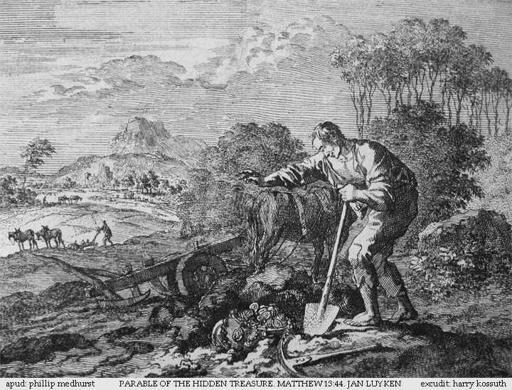
MASS TIMES
Weekend Masses: YANCHEP: 6 p.m. Saturday Vigil, St James Anglican Church,
2 Lagoon Drive. GUILDERTON: 8 a.m. Sunday, Guilderton Community Hall, Wedge Street. LANCELIN: 9.45 a.m. Sunday, 33 Gingin Road, Lancelin.
Confessions: before Mass on request
Weekday Masses: Tuesday, Thursday, Friday 9 a.m. at the presbytery,
Wednesdays 3 p.m. at Bethanie Beachside Aged Care.
Priest: Fr Augustine Puthota, Presbytery: 3 Blaxland Avenue, Two Rocks, Western Australia 6037. Telephone: +61-8-9561 2172
New Website! http://yanchepcatholic.org/ email: yanchepcatholic@gmail.com.
Sunday Bulletin

We pray for the sick of our community, especially:
Pat Murphy, Ken and Toni Meek, Delores Servais, Michael Ford, Jim Walsh, Paula Cope, Pat Barone, Joy Jackson, Anita Pitcher, Deanna and Murray Burge.

Communion Antiphon
O, bless the Lord, my soul, and remember all his kindness.

Our former Altar Boy is ordained!
On Saturday 2nd of August, Christian Irdi will be ordained at St Mary's Cathedral. The ceremony will start at 10.00 AM. Christian and his brother Adrian were Altar boys here in Yanchep, during the 1990s, with Fr. Pat Lim and then with Fr. Philip, when we were part of St. Andrew's Parish. Congratulations from all of us to Christian and all the Irdi family!

“I will tell your Mother” (submitted by Gianni Mazzella)
In Lourdes, a priest was using the monstrance to trace the sign of the cross over disabled children. He had just finished blessing one and was about to move on to the next child, when he was stopped in his tracks by the cry of the child staring at the Eucharist: “You didn't heal me! I will tell your Mother!”
The priest was dumbfounded for an instant, but came back to the child to bless him again. Right after the blessing, the child was healed.
Brother Albert Pflerger, Fioretti de la Vierge Marie, Editions Ephèse Diffusion, 1997

Parable of the Hidden Treasure, Jan Luyken, 1795, etching, Bowyer Bible, Bolton, England.

Entrance Antiphon
God is in his holy dwelling; he will give a home to the lonely, he gives power and strength to his people.

Commentary by Dr John Bergsma (continued) he causes all things to contribute to our ultimate good - even sickness, failure, persecutions, and death itself (cf. Rom 8:35). By virtue of the covenant with David his father, Solomon enjoyed the privilege of being a Son of God (see 2 Samuel 7:14). Indeed, he was reckoned as God’s Firstborn among the kings of the earth (Psalm 89:27). The royal privileges that Jesus the Christ enjoys as Son of David and Son of God are extended to all who join themselves to him. In a mysterious way, a way known only to God, those who freely “choose God” actually find that, all along, they were chosen by him. This is the mystery of predestination. It is not something we will comprehend fully in this life, but in this part of Romans, St. Paul means to reassure us: God is working in us and through us. His plans will be accomplished.

First Reading 1 Kings 3:5, 7-12
You have asked for wisdom.
The Lord appeared to Solomon in a dream and said, ‘Ask what you would like me to give you.’ Solomon replied, ‘O Lord my God, you have made your servant king in succession to David my father. But I am a very young man, unskilled in leadership. Your servant finds himself in the midst of this people of yours that you have chosen, a people so many its number cannot be counted or reckoned. Give your servant a heart to understand how to discern between good and evil, for who could govern this people of yours that is so great?’

Gospel Acclamation cf. Mt 11:25

Alleluia, alleluia!
Blessed are you, Father, Lord of heaven and earth;
you have revealed to little ones the mysteries of the kingdom.
Alleluia!

Gospel Matthew 13:44-52
He sells everything he owns, and buys the field.

Jesus said to the crowds, ‘The kingdom of heaven is like treasure hidden in a field which someone has found; he hides it again, goes off happy, sells everything he owns and buys the field.
‘Again, the kingdom of heaven is like a merchant looking for fine pearls; when he finds one of great value he goes and sells everything he owns and buys it.
‘Again, the kingdom of heaven is like a dragnet cast into the sea that brings in a haul of all kinds. When it is full, the fishermen haul it ashore; then, sitting down, they collect the good ones in a basket and throw away those that are no use. This is how it will be at the end of time: the angels will appear and separate the wicked from the just to throw them into the blazing furnace where there will be weeping and grinding of teeth.
‘Have you understood all this?’ They said, ‘Yes.’ And he said to them, ‘Well then, every scribe who becomes a disciple of the kingdom of heaven is like a householder who brings out from his storeroom things both new and old.’

The Gospel of the Lord.
Praise to you, Lord Jesus Christ!

It pleased the Lord that Solomon should have asked for this. ‘Since you have asked for this’ the Lord said, ‘and not asked for long life for yourself or riches or the lives of your enemies, but have asked for a discerning judgement for yourself, here and now I do what you ask. I give you a heart wise and shrewd as none before you has had and none will have after you.’

The word of the Lord.
Thanks be to God.

R. Lord, I love your commands.

My part, I have resolved, O Lord,
is to obey your word.
The law from your mouth means more to me
than silver and gold. R.

Let your love be ready to console me
by your promise to your servant.
Let your love come to me and I shall live
for your law is my delight. R.

That is why I love your commands
more than the finest gold.
That is why I rule my life by your precepts:
I hate false ways. R.

Your will is wonderful indeed;
therefore I obey it.
The unfolding of your word gives light
and teaches the simple. R.

Second Reading Romans 8:28-30
He predestined us to become true images of his Son.

We know that by turning everything to their good, God co-operates with all those who love him, with all those he has called according to his purpose. They are the ones he chose specially long ago and intended to become true images of his Son, so that his Son might be the eldest of many brothers. He called those he intended for this; those he called he justified, and with those he justified he shared his glory.

The word of the Lord.
Thanks be to God.

Commentary on the Second Reading by Dr John Bergsma from http://www.thesacredpage.com/2014/07/getting-wisdom-17th-sunday-of-ot.html#more
The Second Reading promises that God’s providence attends those who love him, as Solomon did. When I was a kid, I thought this verse said “all things work out good for those who love God.” I figured that if I obeyed God’s laws, I would always be successful. Of course, that’s not what the verse means, which I discovered the hard way in my mid-twenties through a series of personal crises.
This is one verse that we want to translate correctly. Here is the Greek, in English characters:
Oidamen de hoti tois agapoœsin ton theon panta synergei eis agathon, tois kata prothesin kleœtois ousin.
Translating woodenly, it reads:
We know that, for those who love God, all things work together unto good, for those being called according to his purpose.
Not all things are good or work out well, but for those who love God, (continued …)

