16th Sunday in Ordinary Time Year A
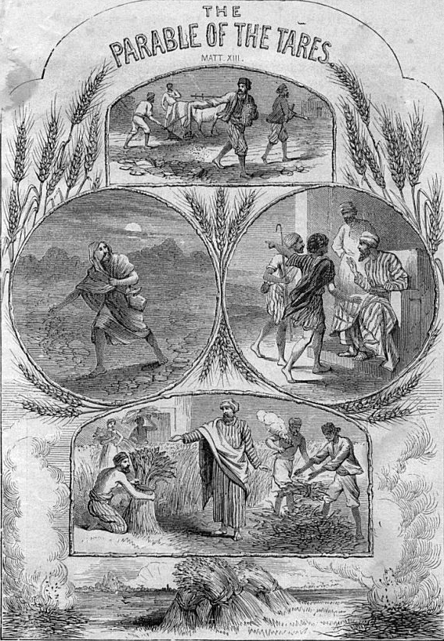
Entrance Antiphon
God himself is my help. The Lord upholds my life. I will offer you a willing sacrifice; I will praise your name, O Lord, for its goodness.
MASS TIMES
Weekend Masses: YANCHEP: 6 p.m. Saturday Vigil, St James Anglican Church,
2 Lagoon Drive. GUILDERTON: 8 a.m. Sunday, Guilderton Community Hall, Wedge Street. LANCELIN: 9.45 a.m. Sunday, 33 Gingin Road, Lancelin.
Confessions: before Mass on request
Weekday Masses: Tuesday, Thursday, Friday 9 a.m. at the presbytery,
Wednesdays 3 p.m. at Bethanie Beachside Aged Care.
Priest: Fr Augustine Puthota, Presbytery: 3 Blaxland Avenue, Two Rocks, Western Australia 6037. Telephone: +61-8-9561 2172
New Website! http://yanchepcatholic.org/ email: yanchepcatholic@gmail.com.
Sunday Bulletin

We pray for the sick of our community, especially:
Pat Murphy, Ken and Toni Meek, Delores Servais, Michael Ford, Jim Walsh, Paula Cope, Pat Barone, Joy Jackson, Anita Pitcher, Deanna and Murray Burge.

Communion Antiphon
The Lord keeps in our minds the wonderful things he has done. He is compassion and love; he always provides for his faithful.
First Reading

Wisdom 12:13, 16-19
In the place of sin, you give repentance.

There is no god, other than you, who cares for everything,
to whom you might have to prove that you never judged unjustly;
Your justice has its source in strength,
your sovereignty over all makes you lenient to all.
You show your strength
when your sovereign power is questioned

Commentary by Dr John Bergsma (continued)
God permits sinners within the Church to allow them the opportunity of repentance. Were He to execute judgment in this age, some destined for repentance would be judged prematurely. The Church Fathers typically understood this parable as counseling against too quickly and rashly condemning the imperfect believer:

For room for repentance is left, and we are warned that we should not hastily cut off a brother, since one who is to-day corrupted with an erroneous dogma, may grow wiser tomorrow, and begin to defend the truth; wherefore it is added, Lest in gathering together the tares ye root out the wheat also. (St. Jerome, Catena Aurea ad loc.)

The Parable of the Mustard Seed
Here our Lord makes an allusion to several passages of the Old Testament where a king or a dynasty is likened to a great tree that provides shelter and food to the beasts of the field and the birds of the sky: Nebuchadnezzar in Daniel 4; Pharaoh in Ezekiel 31; and the Son of David in Ezekiel 17. Of particular importance is Ezek 17:22-25, which predicts a coming time when God will replant the royal house of Israel (i.e. the House of David) and it shall become a great, life-giving “tree” (international kingdom or empire). We can understand Jesus himself to be the “mustard seed,” the “smallest of seeds” in the sense that he is the humblest of men, “despised and rejected” by men, ignored by his own people to whom he comes. He is “sowed in the field” of this world through his death and burial, yet “sprouts” in the resurrection to become—through his mystical body—the largest and longest-lived kingdom the world has ever known: a spiritual and sacramental kingdom that still boasts over a billion adherents, even if many of these be “weeds” spoken of in the earlier parable.

and you expose the insolence of those who know it;
but, disposing of such strength, you are mild in judgement,
you govern us with great lenience,
for you have only to will, and your power is there.
By acting thus you have taught a lesson to your people
how the virtuous man must be kindly to his fellow men,
and you have given your sons the good hope
that after sin you will grant repentance.
The word of the Lord.
Thanks be to God.

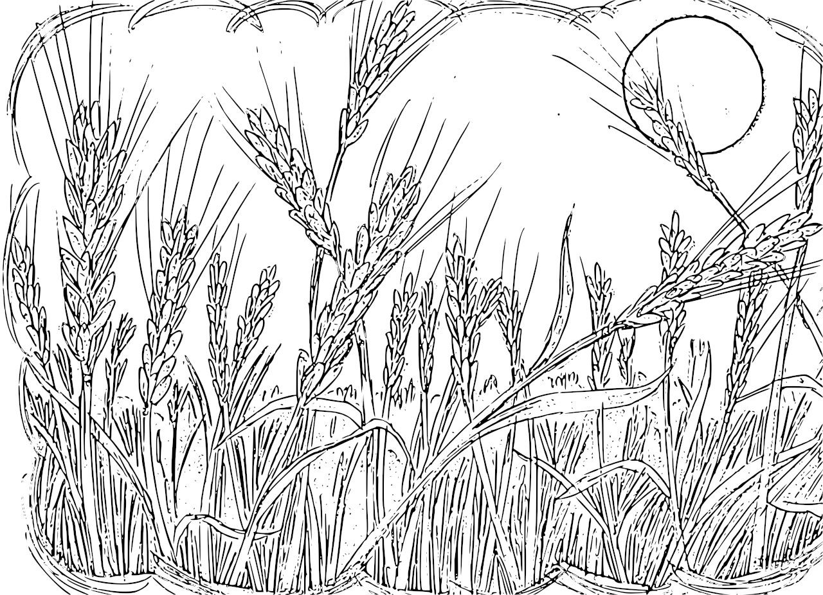
field? If so, where does the darnel come from?” “Some enemy has done this” he answered. And the servants said, “Do you want us to go and weed it out?” But he said, “No, because when you weed out the darnel you might pull up the wheat with it. Let them both grow till the harvest; and at harvest time I shall say to the reapers: First collect the darnel and tie it in bundles to be burnt, then gather the wheat into my barn.”’
He put another parable before them, ‘The kingdom of heaven is like a mustard seed which a man took and sowed in his field. It is the smallest of all the seeds, but when it has grown it is the biggest shrub of all and becomes a tree so that the birds of the air come and shelter in its branches.’
He told them another parable, ‘The kingdom of heaven is like the yeast a woman took and mixed in with three measures of flour till it was leavened all through.’
In all this Jesus spoke to the crowds in parables; indeed, he would never speak to them except in parables. This was to fulfil the prophecy:
I will speak to you in parables
and expound things hidden since the foundation of the world.
Then, leaving the crowds, he went to the house; and his disciples came to him and said, ‘Explain the parable about the darnel in the field to us.’ He said in reply, ‘The sower of the good seed is the Son of Man. The field is the world; the good seed is the subjects of the kingdom; the darnel, the subjects of the evil one; the enemy who sowed them, the devil; the harvest is the end of the world; the reapers are the angels. Well then, just as the darnel is gathered up and burnt in the fire, so it will be at the end of time. The Son of Man will send his angels and they will gather out of his kingdom all things that provoke offences and all who do evil, and throw them into the blazing furnace, where there will be weeping and grinding of teeth. Then the virtuous will shine like the sun in the kingdom of their Father. Listen, anyone who has ears!’

The Gospel of the Lord.
Praise to you, Lord Jesus Christ!

R. Lord, you are good and forgiving.

O Lord, you are good and forgiving,
full of love to all who call.
Give heed, O Lord, to my prayer
and attend to the sound of my voice. R.

All the nations shall come to adore you
and glorify your name, O Lord:
for you are great and do marvellous deeds,
you alone are God. R.

But you, God of mercy and compassion,
slow to anger, O Lord,
abounding in love and truth,
turn and take pity on me. R.

Second Reading Romans 8:26-27
The Spirit himself pleads for us in a way that could never be put into words.

The Spirit comes to help us in our weakness. For when we cannot choose words in order to pray properly, the Spirit himself expresses our plea in a way that could never be put into words, and God who knows everything in our hearts knows perfectly well what he means, and that the pleas of the saints expressed by the Spirit are according to the mind of God.

The word of the Lord.
Thanks be to God.

Gospel Acclamation
Alleluia, alleluia!
Blessed are you, Father, Lord of heaven and earth;
you have revealed to little ones the mysteries of the kingdom.
Alleluia!

Gospel Matthew 13:24-43
Let them grow together until the harvest.

Jesus put another parable before the crowds, ‘The kingdom of heaven may be compared to a man who sowed good seed in his field. While everybody was asleep his enemy came, sowed darnel all among the wheat, and made off. When the new wheat sprouted and ripened, the darnel appeared as well. The owner’s servants went to him and said, “Sir, was it not good seed that you sowed in your

Commentary on the Gospel by Dr John Bergsma from http://www.thesacredpage.com/2014/07/hypocrites-in-church-16th-sunday-of-ot.html#more.
In Matthew 13, Jesus tells seven parables about the Kingdom of Heaven. All of them are important to ponder, because they teach us about the nature of the Church. The Church is both the Kingdom of David (since ruled by Jesus the Son of David) and the Kingdom of God/Heaven (since ruled by God). The Parables of the Kingdom help us to understand that the Kingdom is truly present in the Church, despite appearances to the contrary.
One of the reasons we may disbelieve that the Church is the manifestation of the Kingdom of Heaven is the presence of hypocrites and other wilful sinners within the visible Church. In the parable of the Weeds and the Wheat, Jesus addresses and explains why God permits this to be the case.

