The Most Holy Trinity Year A
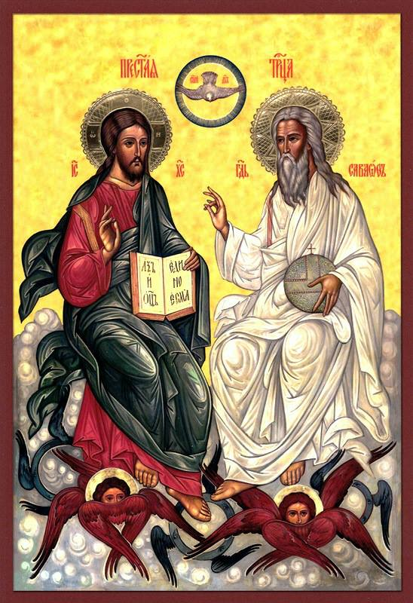
MASS TIMES
Weekend Masses: YANCHEP: 6 p.m. Saturday Vigil, St James Anglican Church,
2 Lagoon Drive. GUILDERTON: 8 a.m. Sunday, Guilderton Community Hall, Wedge Street. LANCELIN: 9.45 a.m. Sunday, 33 Gingin Road, Lancelin.
Confessions: before Mass on request
Weekday Masses: Tuesday, Thursday, Friday 9 a.m. at the presbytery,
Wednesdays 3 p.m. at Bethanie Beachside Aged Care.
Priest: Fr Augustine Puthota, Presbytery: 3 Blaxland Avenue, Two Rocks, Western Australia 6037. Telephone: +61-8-9561 2172
New Website! http://yanchepcatholic.org/ email: yanchepcatholic@gmail.com.
Sunday Bulletin

The Most Holy Trinity, Icon
We pray for the sick of our community, especially:
Pat Murphy, Ken and Toni Meek, Delores Servais, Michael Ford, Jim Walsh, Paula Cope, Pat Barone, Joy Jackson, Anita Pitcher, Deanna and Murray Burge.

Communion Antiphon:
You are the sons of God, so God has given you the Spirit of his Son to form your hearts and make you cry out: Abba, Father.



Commentary on the First Reading (continued)
This does relate to the Trinity, which has meaning for our redemption. Several facts follow from the realization that the Son and the Spirit are God Himself. First, it dawns on us that God did not send some other creature to suffer and die for us, but paid the penalty for our sins by himself (the Son). Secondly, it becomes apparent that God does not merely share his energies or power with us, but shares with us his very life and self (the Spirit).

For if God is not a Trinity, then Jesus the Son is a creature, and God sent a creature to work our redemption rather than doing it himself. And if God is not a Trinity, the Holy Spirit is not God, but some active force or emanation from the almighty. Therefore through faith and the sacraments we do not receive into our hearts the true God, but something else that radiates from him.

Furthermore, the Trinity reveals that God is, in himself, a circle of self-giving love. Prior to the creation of the universe, God did not exist as a self-aggrandizing sole individual, but he existed as a communion of persons bound by the gift of self in love. A possible way to imagine this: the Father continually gives himself to the Son, and the Son gives himself to the Father, and the Self they exchange is the Holy Spirit. Thus, the gift of self in love, which is the essence of hesed, belongs to God’s nature from all time. It is not an accidental feature of God’s character that arises when he creates other beings to be loved.
So doctrine of the Trinity enables us to understand that faithful love (hesed) is at the heart of God’s nature, and he shares himself with us in a way more profound and intimate than we would ever have imagined. God's hesed is on display in this First Reading, because God remains faithful to his covenant with Israel even when they have broken their covenant with him by worshiping other gods.

Entrance Antiphon
Blessed be God the Father and his only begotten Son and the Holy Spirit: for he has shown that he loves us.

Why are you standing her looking into the sky? Jesus has been taken into heaven.

First Reading: Exodus 34:4-6, 8-9
The Lord God, ruler of all, merciful and loving.

With the two tablets of stone in his hands, Moses went up the mountain of Sinai in the early morning as the Lord had commanded him. And the Lord descended in the form of a cloud, and Moses stood with him there.
He called on the name of the Lord. The Lord passed before him and proclaimed, ‘The Lord, a God of tenderness and compassion, slow to anger rich in kindness and faithfulness.’ And Moses bowed down to the ground at once and worshipped. ‘If I

Gospel John 3:16-18
God sent his Son to save the world through him.

Jesus said to Nicodemus:

‘God loved the world so much that he gave his only Son,
so that everyone who believes in him may not be lost
but may have eternal life.
For God sent his Son into the world
not to condemn the world,
but so that through him the world might be saved.
No one who believes in him will be condemned;
but whoever refuses to believe is condemned already,
because he has refused to believe in the name of God’s only Son.’

The Gospel of the Lord.
Praise to you, Lord Jesus Christ!

have indeed won your favour, Lord,’ he said ‘let my Lord come with us, I beg. True, they are a headstrong people, but forgive us our faults and our sins, and adopt us as your heritage.’

The word of the Lord.
Thanks be to God.

Responsorial Psalm Daniel 3:52-56 R. v.52

You are blest, Lord God of our fathers.
R. Glory and praise for ever.
Blest your glorious holy name.
R. Glory and praise for ever.

You are blest in the temple of your glory.
R. Glory and praise for ever.
You are blest on the throne of your kingdom.
R. Glory and praise for ever.

You are blest who gaze into the depths.
R. Glory and praise for ever.
You are blest in the firmament of heaven.
R. Glory and praise for ever.

Second Reading 2 Corinthians 13:11-13
The grace of our Lord Jesus Christ and the love of God and the fellowship of the Holy Spirit be with you all.

Brothers, we wish you happiness; try to grow perfect; help one another. Be united; live in peace, and the God of love and peace will be with you.
Greet one another with the holy kiss. All the saints send you greetings.
The grace of the Lord Jesus Christ, the love of God and the fellowship of the Holy Spirit be with you all.

The word of the Lord.
Thanks be to God.

Gospel Acclamation cf. Apoc 1:8
Alleluia, alleluia!
Glory to the Father, the Son and the Holy Spirit:
to God who is, who was, and who is to come.
Alleluia!

Commentary on the First Reading by Dr John Bergsma at
http://www.thesacredpage.com/2014/06/the-solemnity-of-most-holy-trinity.html#more
The context of this passage is very important, and hopefully the celebrant will explain in the homily. This is not Moses’ first visit up the mountain. It is his return visit after the debacle with the Golden Calf. Moses had descended the mountain, interrupting his reception of the instructions for the Tabernacle, in order to regain control of the people, who were running wild in a pagan ritual-orgy in worship of the Egyptian bull god Apis. He now returns to the mountain to intercede for the people and plead for forgiveness and covenant renewal. God accepts his intercessions on behalf of Israel and agrees to forgive and renew the covenant, but Moses has an additional request: he wishes to see the face of God. God cannot reveal his “face” (unmediated revelation) to Moses in this life, but he condescends to show his “back” (mediated or indirect revelation) to Moses on the mountain. So God makes his presence pass before Moses while Moses is hid in a cleft in the rocks. While his presence passes by, the LORD proclaims his “name,” that is, declares what his essence is:
"The LORD, the LORD, a merciful and gracious God,
slow to anger and rich in kindness and fidelity."
The term translated “kindness” here is that very freighted word “hesed,” which specifically connotes faithfulness and love in a covenant relationship.

So why is this text read on Trinity Sunday? On this day, we reflect on God’s very nature, and this is one of the most important texts of the Old Testament that addresses the issue of what God is. The answer given is that God’s nature consists primarily in mercy, grace, forgiveness, truth, and especially covenant fidelity.(Continued over page.)

