Pentecost Year A
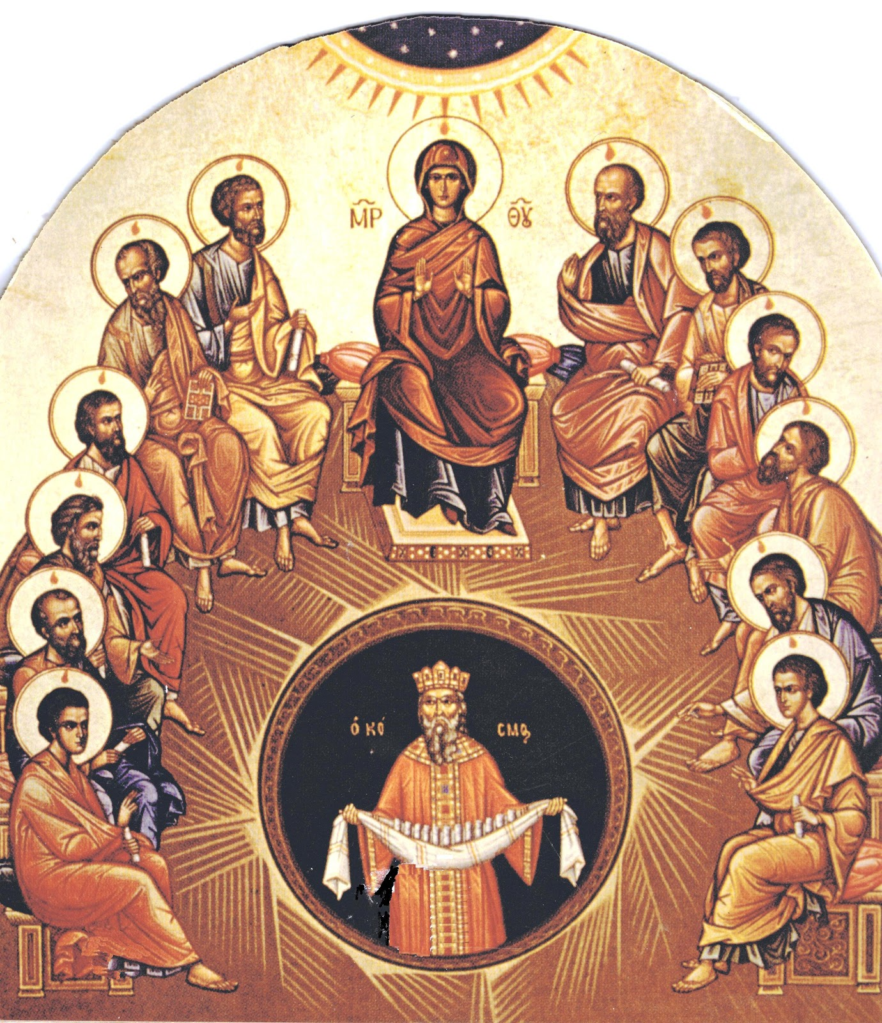
Page 8
MASS TIMES
Weekend Masses: YANCHEP: 6 p.m. Saturday Vigil, St James Anglican Church,
2 Lagoon Drive. GUILDERTON: 8 a.m. Sunday, Guilderton Community Hall, Wedge Street. LANCELIN: 9.45 a.m. Sunday, 33 Gingin Road, Lancelin.
Confessions: before Mass on request
Weekday Masses: Tuesday, Thursday, Friday 9 a.m. at the presbytery,
Wednesdays 3 p.m. at Bethanie Beachside Aged Care.
Priest: Fr Augustine Puthota, Presbytery: 3 Blaxland Avenue, Two Rocks, Western Australia 6037. Telephone: +61-8-9561 2172
New Website! http://yanchepcatholic.org/ Please email your contributions for the Sunday Bulletin or the website to: yanchepcatholic@gmail.com.
Sunday Bulletin

The Descent of the Holy Spirit, Icon

We pray for the sick of our community, especially:
Pat Murphy, Ken and Toni Meek, Delores Servais, Michael Ford, Jim Walsh, Paula Cope, Pat Barone, Joy Jackson, Anita Pitcher, Deanna and Murray Burge.

Communion Antiphon (Vigil Mass):
On the last day of the festival, Jesus stood and cried aloud: If anyone is thirsty, let him come to me and drink, alleluia.

Communion Antiphon (Mass during the day):
They were all filled with the Holy Spirit, and they spoke of the great things God had done, alleluia.

Entrance Antiphon
The love of God has been poured into our hearts by his Spirit living in us, alleluia.

Commentary on Acts by Dr Michael Barber (continued)
The story of Acts 2 also seems to highlight the fulfilment of the vision from Ezekiel mentioned above. God has inaugurated the ingathering of his people by giving them his Spirit. Furthermore, as Ezekiel described the future cleansing of Israel and their reception of the spirit as taking place through the sprinkling of water, Peter tells the people what they must do to be saved: “Repent and be baptized” (Acts 2:38). The restoration takes place not through a political decree or action but through a sacramental act.
Finally, we should point out Paul’s concern to bring an offering to Jerusalem from the Gentile Christians at Pentecost (Acts 20:16; 1 Cor 16:18). Paul understood his ministry to the Gentiles in connection with the eschatological ingathering of the tribes of Israel (cf. Rom 9-11; Acts 26:7). The offering he took up from them to bring to Jerusalem at Pentecost may have been in some way connected with Isaiah’s description of the restoration of Israel mentioned above (cf. Rom 15:16, 25-29).

Read more at http://www.thesacredpage.com/2014/06/receive-holy-spirit-readings-for-feast.html#more.

VIGIL MASS of Saturday Evening

First Reading: Genesis 11:1-9
It was named Babel because there the Lord confused the language of the whole earth.

Throughout the earth men spoke the same language, with the same vocabulary. Now as they moved eastwards they found a plain in the land of Shinar where they settled. They said to one another, ‘Come, let us make bricks and bake them in the fire.’ (For stone they used bricks, and for mortar they used bitumen). ‘Come,’ they said ‘let us build ourselves a town and a tower with its top reaching heaven. Let us make a name for ourselves, so that we may not be scattered about the whole earth.’

Pentecost in Acts 2: commentary by Dr Michael Barber
from http://www.thesacredpage.com/2014/06/receive-holy-spirit-readings-for-feast.html#more.
Luke describes the coming of the Spirit at Pentecost as the fulfillment of God’s restoration promises; the eschatological “ingathering” of Israel has arrived. Thus, in Acts 2 Peter quotes directly from Joel’s prophecy of the restoration of Jerusalem, a prophecy he sees as now fulfilled (cf. Joel 2:28-29; Acts 2:17-21). Notably, then, the restoration is not political but spiritual—literarily the restoration of Israel is accomplished in the Spirit.
Luke thus paints the picture of Pentecost with colors of the eschatological ingathering of Israel with the nations. This is evident in the following:

- The episode is preceded by the selection of a replacement of Judas, thus restoring the apostles to the number twelve, most likely a sign of the eschatological re-gathered twelve tribes (cf. Acts 1:15-26).
- Luke mentions of the presence of the scattered of Israelites in the city (Acts 2:5-13);
- Peter explains that the Spirit’s coming fulfills Joel’s prophecy of the eschatological day of the Lord’s coming (Joel 2:28-29; Acts 2:17-21);
- Peter’s use of the term “house of Israel” (cf. Acts 2:36) suggests a reference to the lost northern tribes, since it was most usually used applied to them. It may also be a reference to prophetic visions of their restoration (cf. Ezek 20:40; 36:10; 37:11, 16; 39:25; 45:6);
- Peter’s invitation to baptism, “For the promise is to you and to your children and to all that are far off, every one whom the Lord our God calls to him” (Acts 2:39), also draws from the Isaianic vision of the New Exodus (cf. Isa 57:19).

All of this takes place in Jerusalem, thus fulfilling the hope that such an eschatological ingathering would take place there (cf. Isa 2:2). In this, Luke shows the continuity between God’s covenant with Israel and the New Covenant.
We should also notice that Luke describes the event in terms similar to the giving of the Law at Sinai. In Exodus 19:16-19 we read about the Lord’s coming to Sinai, which occurs with a loud sound (v. 16, 19, like a “trumpet blast”), the Lord’s “descent” in fire (v. 18) and miraculous but unintelligible speech (v. 19, God speaks “in thunder”). Likewise, in Acts 2, we read about the Lord’s coming in a “sound” like mighty wind (2:2), a vision of fire (2:3), and miraculous speech (2:4). As the Lord descended in fire on Mt. Sinai in Exodus 19, the Lord descends on Mt. Zion in fire here. Luke also tells us that on Pentecost “three thousand souls” accepted the word of Peter and were added to the early Christian community. Here again we have imagery taken from Exodus—three thousand fell at the hands of the Levites after they worshipped the golden calf (Exod 32:28). (Continued over page …)

Now the Lord came down to see the town and the tower that the sons of man had built. ‘So they are all a single people with a single language!’ said the Lord. ‘This is but the start of their undertakings! There will be nothing too hard for them to do. Come, let us go down and confuse their language on the spot so that they can no longer understand one another.’ The Lord scattered them thence over the whole face of the earth, and they stopped building the town. It was named Babel therefore, because there the Lord confused the language of the whole earth. It was from there that the Lord scattered them over the whole face of the earth.

The word of the Lord.
Thanks be to God.

Responsorial Psalm Ps 103: 1-2, 24, 27-30, 35 R. v.30

R. Lord, send out your Spirit
and renew the face of the earth.

Bless the Lord, my soul!
Lord God, how great you are.
clothed in majesty and glory,
wrapped in light as in a robe! R.

How many are your works, O Lord!
In wisdom you have made them all.
The earth is full of your riches.
Bless the Lord, my soul. R.

All of these look to you
to give them their food in due season.
You give it, they gather it up:
you open your hand, they have their fill. R.

You take back your spirit, they die,
returning to the dust from which they came.
You send forth your spirit, they are created;
and you renew the face of the earth. R.

Second Reading Romans 8:22-27
The Spirit himself pleads for us in a way that could never be put into words.

From the beginning till now the entire creation, as we know has been groaning

Page 2
Page 7

Page 3
in one great act of giving birth; and not only creation, but all of us who possess the first-fruits of the Spirit, we too groan inwardly as we wait for our bodies to be set free. For we must be content to hope that we shall be saved – our salvation is not in sight, we should not have to be hoping for it if it were – but, as I say, we must hope to be saved since we are not saved yet – it is something we must wait for with patience.
The Spirit too comes to help us in our weakness. For when we cannot choose words in order to pray properly, the Spirit himself expresses our plea in a way that could never be put into words, and God who knows everything in our hearts knows perfectly well what he means, and that the pleas of the saints expressed by the Spirit are according to the mind of God.

The word of the Lord.
Thanks be to God.

Gospel Acclamation
Alleluia, alleluia!
Come, Holy Spirit, fill the hearts of your faithful;
and kindle in them the fire of your love.
Alleluia!

Gospel John 7:37-39
From his breast shall flow fountains of living waters.

On the last day and greatest day of the festival, Jesus stood there and cried out:
‘If any man is thirsty, let him come to me!
Let the man come and drink who believes in me!’
As scripture says: From his breast shall flow fountains of living water.
He was speaking of the Spirit which those who believed in him were to receive; for there was no Spirit as yet because Jesus had not yet been glorified.

The Gospel of the Lord.
Praise to you, Lord Jesus Christ!
Sequence (continued)

Thou, on us who evermore
Thee confess and thee adore,
With thy sevenfold gifts descend:

Give us comfort when we die
Give us life with thee on high
Give us joys that never end.

Gospel Acclamation
Alleluia, alleluia!
Come, Holy Spirit, fill the hearts of your faithful;
and kindle in them the fire of your love.
Alleluia!

Gospel John 20:19-23
As the Father sent me, so I send you. Receive the Holy Spirit.

In the evening of the first day of the week, the doors were closed in the room where the disciples were, for fear of the Jews. Jesus came and stood among them. He said to them, ‘Peace be with you’, and showed them his hands and his side. The disciples were filled with joy when they saw the Lord, and he said to them again, ‘Peace be with you.

‘As the Father sent me,
so am I sending you.’

After saying this he breathed on them and said:

‘Receive the Holy Spirit.
For those whose sins you forgive,
they are forgiven;
for those whose sins you retain,
they are retained.’

The Gospel of the Lord.
Praise to you, Lord Jesus Christ!

Page 6

MASS DURING THE DAY

First Reading: Acts 2:1-11
They were all filled with the Holy Spirit and began to speak different languages.

When Pentecost day came round, they had all met in one room, when suddenly they heard what sounded like a powerful wind from heaven, the noise of which filled the entire house in which they were sitting; and something appeared to them

way in which the Spirit is given to each person is for a good purpose.
Just as a human body, though it is made up of many parts, is a single unit because all these parts, though many, make one body, so it is with Christ. In the one Spirit we were all baptised, Jews as well as Greeks, slaves as well as citizens, and one Spirit was given to us all to drink.

The word of the Lord.
Thanks be to God.

Sequence

Holy Spirit, Lord of Light,
From the clear celestial height
Thy pure beaming radiance give.

Come, thou Father of the poor,
Come with treasures which endure
Come, thou light of all that live!

Thou, of all consolers best,
Thou, the soul’s delightful guest,
Dost refreshing peace bestow

Thou in toil art comfort sweet
Pleasant coolness in the heat
Solace in the midst of woe.

Light immortal, light divine,
Visit thou these hearts of thine,
And our inmost being fill:

If thou take thy grace away,
Nothing pure in man will stay
All his good is turned to ill.

Heal our wounds, our strength renew
On our dryness pour thy dew
Wash the stains of guilt away:

Bend the stubborn heart and will
Melt the frozen, warm the chill
Guide the steps that go astray.
Page 4
Page 5

that seemed like tongues of fire; these separated and came to rest on the head of each of them. They were all filled with the Holy Spirit, and began to speak foreign languages as the Spirit gave them the gift of speech.
Now there were devout men living in Jerusalem from every nation under heaven, and at this sound they all assembled, each one bewildered to hear these men speaking his own language. They were amazed and astonished. ‘Surely’ they said ‘all these men speaking are Galileans? How does it happen that each of us hears them in his own native language? Parthians, Medes and Elamites; people from Mesopotamia, Judaea and Cappadocia, Pontus and Asia, Phrygia and Pamphylia, Egypt and the parts of Libya round Cyrene; as well as visitors from Rome – Jews and proselytes alike – Cretans and Arabs; we hear them preaching in our own language about the marvels of God.’

The word of the Lord.
Thanks be to God.

Responsorial Psalm Ps 103: 1, 24, 29-31, 34 R. v.30

R. Lord, send out your Spirit
and renew the face of the earth.

Bless the Lord, my soul!
Lord God, how great you are.
How many are your works, O Lord!
The earth is full of your riches. R.

You take back your spirit, they die,
returning to the dust from which they came.
You send forth your spirit, they are created;
and you renew the face of the earth. R.

May the glory of the Lord last for ever!
May the Lord rejoice in his works!
May my thoughts be pleasing to him.
I find my joy in the Lord. R.

Second Reading 1 Corinthians 12:3-7, 12-13
In the one Spirit we were all baptised, making one body.
No one can say, ‘Jesus is Lord’ unless he is under the influence of the Holy Spirit.
There is a variety of gifts but always the same Spirit; there are all sorts of service to be done, but always to the same Lord; working in all sorts of different ways in different people, it is the same God who is working in all of them. The particular

