St Peter and Paul, Apostles Year A
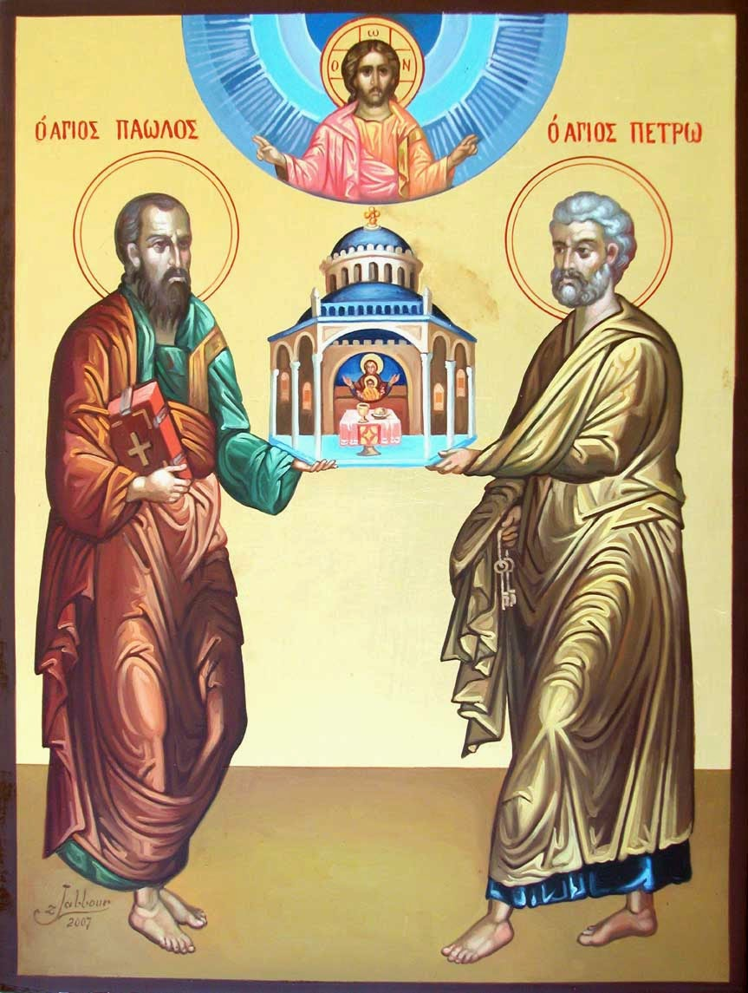
MASS TIMES
Weekend Masses: YANCHEP: 6 p.m. Saturday Vigil, St James Anglican Church,
2 Lagoon Drive. GUILDERTON: 8 a.m. Sunday, Guilderton Community Hall, Wedge Street. LANCELIN: 9.45 a.m. Sunday, 33 Gingin Road, Lancelin.
Confessions: before Mass on request
Weekday Masses: Tuesday, Thursday, Friday 9 a.m. at the presbytery,
Wednesdays 3 p.m. at Bethanie Beachside Aged Care.
Priest: Fr Augustine Puthota, Presbytery: 3 Blaxland Avenue, Two Rocks, Western Australia 6037. Telephone: +61-8-9561 2172
New Website! http://yanchepcatholic.org/ email: yanchepcatholic@gmail.com.
Sunday Bulletin

St Peter and St Paul, Byzantine Icon

We pray for the sick of our community, especially:
Pat Murphy, Ken and Toni Meek, Delores Servais, Michael Ford, Jim Walsh, Paula Cope, Pat Barone, Joy Jackson, Anita Pitcher, Deanna and Murray Burge.

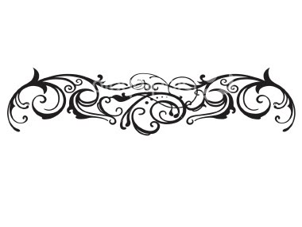

Employment Opportunity
The Catholic Archdiocese of Perth seeks a Full-time Archdiocesan Safeguardian Officer to work within the Professional Standards Office of WA. The position will be responsible for coordinating, overseeing and monitoring the Church’s fundamental obligation to ensure the proper safeguarding of children, young people and vulnerable adults in parishes and other Catholic Institutions under the jurisdiction of the Archdiocese of Perth. For further information please contact Terry Wilson at the AFO on 9427 0300.
If you think and feel that the Lord may be calling you to dedicate yourself to a life of fruitful service of God's holy people as his Priest then do not delay.
Vocations Enquiry Evening
St Charles Seminary at 30 Meadow Street Guildford will once more host its annual Vocations Enquiry Eveningon Sunday 17 August 2014 starting at 4.00 pm. Come and meet our Seminarians and join other young and not so young men who are also discerning a possible call to the Priesthood in a serene and prayerful setting.
To register your interest, please call St Charles Seminary on 9279-1310.
Fr Jean-Noel Marie (Vocations Director)

Entrance Antiphon

These men, conquering all human frailty, shed their blood and helped the Church to grow. By sharing the cup of the Lord’s suffering, they became the friends of God.

Dr Michael Barber on the Instrumentum Laboris.
The Instrumentum Laboris (i.e., the working document) for the upcoming Synod on the Family called by Pope Francis has finally been released. The document highlights challenges facing the family today and offers thoughts toward advancing pastoral solutions. I encourage people to read it themselves.
It begins with a discussion of the biblical teaching on the family (no. 1-3). After also calling for a greater familiarity with the teaching of the Church (nos. 4-7), it then launches into a discussion of what is needed to address the pastoral challenges facing the Church. First and foremost, the document calls for careful instruction about the teaching of Scripture (no. 9) ...
To read more, go to our webpage and click on the links. If you don’t have a computer, your local public library will show you how to connect.
First Reading: Acts 12:1-11
Now I know it is indeed true: the Lord has saved me from the power of Herod.

King Herod started persecuting certain members of the Church. He beheaded James the brother of John, and when he saw that this pleased the Jews he decided to arrest Peter as well. This was during the days of Unleavened Bread, and he put Peter in prison, assigning four squads of four soldiers each to guard him in turns. Herod meant to try Peter in public after the end of Passover week. All the time Peter was under guard the Church prayed to God for him unremittingly.

Second Reading 2 Timothy 4:6-8, 17-18.
All that remains now is the crown of righteousness.

My life is already being poured away as a libation, and the time has come for me to be gone. I have fought the good fight to the end; I have run the race to the finish; I have kept the faith; all there is to come now is the crown of righteousness reserved for me, which the Lord, the righteous judge, will give to me on that Day; and not only to me but to all those who have longed for his Appearing.
The Lord stood by me and gave me power, so that through me the whole message might be proclaimed for all the pagans to hear; and so I was rescued from the lion’s mouth. The Lord will rescue me from all evil attempts on me, and bring me safely to his heavenly kingdom. To him be glory for ever and ever. Amen.

The word of the Lord.
Thanks be to God.

Gospel Acclamation Mt 16:18
Alleluia, alleluia!
You are Peter, the rock on which I will build my Church;
the gates of hell will not hold out against it.
Alleluia!

Gospel Matthew 16:13-19
You are Peter, and I will give you the keys of the kingdom of heaven.

When Jesus came to the region of Caesarea Philippi he put this question to his disciples, ‘Who do people say the Son of Man is?’ And they said, ‘Some say he is John the Baptist, some Elijah, and others Jeremiah or one of the prophets.’ ‘But you,’ he said ‘who do you say I am?’ Then Simon Peter spoke up, ‘You are the Christ,’ he said ‘the Son of the living God.’ Jesus replied, ‘Simon son of Jonah, you are a happy man! Because it was not flesh and blood that revealed this to you but my Father in heaven. So I now say to you: You are Peter and on this rock I will build my Church. And the gates of the underworld can never hold out against it. I will give you the keys of the kingdom of heaven: whatever you bind on earth shall be considered bound in heaven; whatever you loose on earth shall be considered loosed in heaven.’

The Gospel of the Lord.
Praise to you, Lord Jesus Christ!

On the night before Herod was to try him, Peter was sleeping between two soldiers, fastened with double chains, while guards kept watch at the main entrance to the prison. Then suddenly the angel of the Lord stood there, and the cell was filled with light. He tapped Peter on the side and woke him. ‘Get up!’ he said ‘Hurry!’ – and the chains fell from his hands. The angel then said, ‘Put on your belt and sandals.’ After he had done this, the angel next said, ‘Wrap your cloak round you and follow me.’ Peter followed him, but had no idea that what the angel did was all happening in reality; he thought he was seeing a vision. They passed through two guard posts one after the other, and reached the iron gate leading to the city. This opened of its own accord; they went through it and had walked the whole length of one street when suddenly the angel left him. It was only then that Peter came to himself. ‘Now I know it is all true’ he said. ‘The Lord really did send his angel and has saved me from Herod and from all that the Jewish people were so certain would happen to me.’

The word of the Lord.
Thanks be to God.

Responsorial Psalm Ps 33:2-9 R. v. 5

R. The Lord set me free from all my fears.

I will bless the Lord at all times,
his praise always on my lips;
in the Lord my soul shall make its boast.
the humble shall hear and be glad. R.

Glorify the Lord with me.
Together let us praise his name.
I sought the Lord and he answered me;
from all my terrors he set me free. R.

Look towards him and be radiant.
let your faces not be abashed.
This poor man called; the Lord heard him
and rescued him from all his distress. R.

The angel of the Lord is encamped
around those who revere him, to rescue them.
Taste and see that the Lord is good.
He is happy who seeks refuge in him. R.

Communion Antiphon
Peter said: You are the Christ, the Son of the living God. Jesus answered: You are Peter, the rock on which I will build my Church.

