The Ascension of the Lord Year A
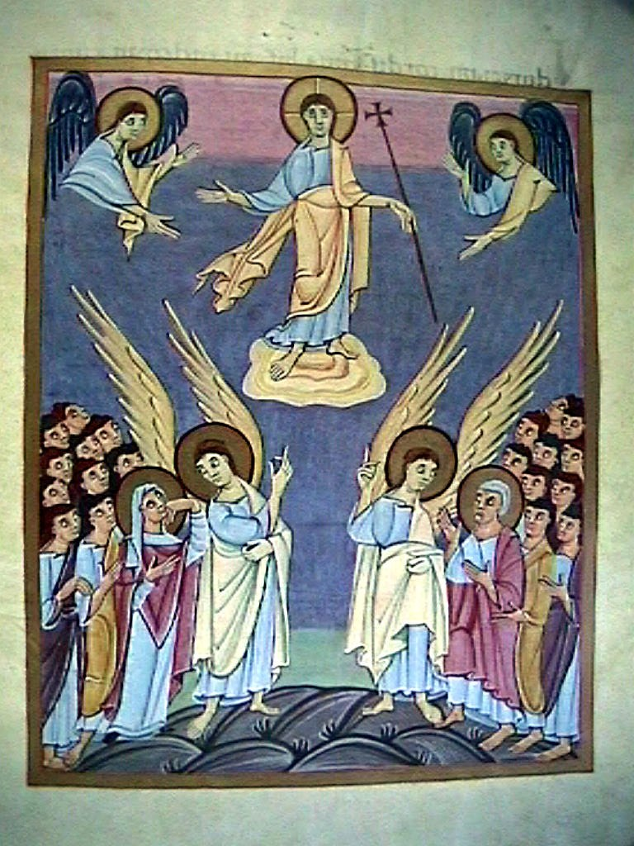
MASS TIMES
Weekend Masses: YANCHEP: 6 p.m. Saturday Vigil, St James Anglican Church,
2 Lagoon Drive. GUILDERTON: 8 a.m. Sunday, Guilderton Community Hall, Wedge Street. LANCELIN: 9.45 a.m. Sunday, 33 Gingin Road, Lancelin.
Confessions: before Mass on request
Weekday Masses: Tuesday, Thursday, Friday 9 a.m. at the presbytery,
Wednesdays 3 p.m. at Bethanie Beachside Aged Care.
Priest: Fr Augustine Puthota, Presbytery: 3 Blaxland Avenue, Two Rocks, Western Australia 6037. Telephone: +61-8-9561 2172
New Website! http://yanchepcatholic.org/ email: yanchepcatholic@gmail.com.
Sunday Bulletin

The Ascension,
a page from the Gospel Lectionary portion of the Bamberg Apocalypse, 11th century Staatsbibliothek, MS A. II. 42, Bamberg, Germany.

We pray for the sick of our community, especially:
Pat Murphy, Ken and Toni Meek, Delores Servais, Michael Ford, Jim Walsh, Paula Cope, Pat Barone, Joy Jackson, Anita Pitcher, Deanna and Murray Burge.

Communion Antiphon:
I, the Lord, am with you always, until the end of the world, alleluia.

Commentary on the Gospel (continued)
Jesus words in the Great Commission (“All authority in heaven and earth has been given to me ...”) reflect the theology of Psalm 2, the Royal Coronation Hymn of the Son of David. Let us note that the Commission is not simply to “preach me as Lord and personal Saviour,” as admirable as that may be, but it is “to make disciples”—which is a long-term process of formation involving self-denial (it took Jesus three years with the twelve)—and “to baptize,” a reference to the sacramental ministry of the Church. Finally, the Commission is “to teach them all that I have commanded you,” which seems to refer to a considerably large catechetical undertaking, instructing all the nations in the halakha (interpreted Divine Law) of the Messiah, the Son of David. Jesus commission to “teach them all that I have commanded you,” means that the Church needs to instruct the nations in a complete Christian lifestyle, because Jesus' teachings touch on every aspect of human life, even mundane, everyday tasks. Therefore, it is not possible to reduce the Gospel to three or four propositions or truths about Jesus that must be believed in order to go to heaven, and leave all the rest of Christ's teachings as optional. Because the faith is a harmony, all the truths of the faith are inter-related. None can be dismissed or ignored without eventually damaging the others. For example, since marriage is an icon of the Trinity, and the marriage covenant an icon of the covenant between Christ and his people, the Church's teaching on openness to life in the marital act is directly related to our understanding of the central mystery of the faith, the Holy Trinity and the flow of life-giving love exchanged among the Persons. Moreover, the family unit is an ecclesia domestica, a “domestic church,” an icon of the universal church. Therefore, how we live out family life relates to how we understand the nature of the Church. It is all of a piece, like the seamless robe of Christ. Therefore Jesus says, “teach them all that I have commanded you.”
The Great Commission is not satisfied by knocking on doors and passing out tracts—as good as those things may be. It is a description of the entire mission and action of the Church—evangelistic, sacramental, catechetical.

Entrance Antiphon
Men of Galilee, why do you stand looking in the sky? The Lord will return, just as you have seen him ascend, alleluia.

First Reading: Acts 1:1-11.
Why are you standing her looking into the sky? Jesus has been taken into heaven.

In my earlier work, Theophilus, I dealt with everything Jesus had done and taught from the beginning until the day he gave his instructions to the apostles he had chosen through the Holy Spirit, and was taken up to heaven. He had shown himself alive to them after his Passion by many demonstrations: for forty days he had continued to appear to them and tell them about the kingdom of God. When he had been at table with them, he had told them not to leave Jerusalem, but to wait there for what the Father had promised. ‘It is’ he had said ‘what you have heard me speak about: John baptised with water but you, not many days from now, will be baptised with the Holy Spirit.’

from the strength of his power at work in Christ, when he used it to raise him from the dead and to make him sit at his right hand, in heaven, far above every Sovereignty, Authority, Power, or Domination, or any other name that can be named not only in this age but also in the age to come. He has put all things under his feet and made him, as the ruler of everything, the head of the Church; which is his body, the fullness of him who fills the whole creation.

The word of the Lord.
Thanks be to God.

Gospel Acclamation Mt 28:19-20
Alleluia, alleluia!
Go and teach all people my gospel.
I am with you always, until the end of the world.
Alleluia!

Gospel John 14:15-21
All authority in heaven and on earth has been given to me.

The eleven disciples set out for Galilee, to the mountain where Jesus had arranged to meet them. When they saw him they fell down before him, though some hesitated. Jesus came up and spoke to them. He said, ‘All authority in heaven and on earth has been given to me. Go, therefore, make disciples of all the nations; baptise them in the name of the Father and of the Son and of the Holy Spirit, and teach them to observe all the commands I gave you. And know that I am with you always; yes, to the end of time.’
and

The Gospel of the Lord.
Praise to you, Lord Jesus Christ!

Now having met together, they asked him, ‘Lord, has the time come? Are you going to restore the kingdom to Israel?’ He replied, ‘It is not for you to know times or dates that the Father has decided by his own authority, but you will receive power when the Holy Spirit comes on you, and then you will be my witnesses not only in Jerusalem but throughout Judaea and Samaria, and indeed to the ends of the earth.’
As he said this he was lifted up while they looked on, and a cloud took him from their sight. They were still staring into the sky when suddenly two men in white were standing near them and they said, ‘Why are you men from Galilee standing here looking into the sky? Jesus who has been taken up from you into heaven, this same Jesus will come back in the same way as you have seen him go there.’

The word of the Lord.
Thanks be to God.

Responsorial Psalm Ps 46:2-3, 6-9. R. v.6

R. God mounts his throne to shouts of joy;
a blare of trumpets for the Lord.

All peoples, clap your hands,
cry to God with shouts of joy!
For the Lord, the Most High, we must fear,
great king over all the earth. R.

God goes up with shouts of joy;
the Lord goes up with trumpet blast.
Sing praise for God, sing praise,
sing praise to our king, sing praise. R.

God is king of all the earth.
Sing praise with all your skill.
God is king over the nations;
God reigns on his holy throne. R.

Second Reading Ephesians 1:17-23
He made Jesus to sit at his right hand in heaven.

May the God of our Lord Jesus Christ, the Father of glory, give you a spirit of wisdom and perception of what is revealed, to bring you to full knowledge of him. May he enlighten the eyes of your mind so that you can see what hope his call holds for you, what rich glories he has promised the saints will inherit and how infinitely great is the power that he has exercised for us believers. This you can tell

Commentary on the Gospel by Dr John Bergsma at
http://www.thesacredpage.com/2014/05/god-mounts-his-throne-with-shouts-of.html#more
The Gospel is the famous “Great Commission” (Matt 28:16-20), often jokingly referred to as the “Great Omission,” in reference to our frequent failures as believers in spreading the Gospel. Actually, although great human failures have marked the spread of the Church, it still is to be found present and active on every continent, in every nation. One third of human beings identify as Christians, one sixth as Catholics. Even from a merely natural perspective of cultural history, the Church is a remarkable and singular phenomenon, the oldest and largest human institution in continuous existence.

